Affiliate Content Planner (w.Template)
Your Blog’s Strategy HQ: Create. Track. Grow.
COPYRIGHT NOTICE
Copyright © 2025 Teo Chin Tee. All rights reserved.
Published by Peter Teo | BloggerSuccessBlueprint.com.
This product and its contents are protected under copyright law.
No part of this publication — including but not limited to text, graphics, templates, designs, videos, audios, or any other content — may be reproduced, distributed, transmitted, stored in a retrieval system, or shared in any form or by any means (electronic, mechanical, photocopying, recording, or otherwise) without the prior written permission of the publisher, except in the case of brief quotations used in reviews, scholarly works, or as otherwise permitted under applicable copyright law.
This product is licensed for individual use only. Unauthorized copying, sharing, distribution, resale, or reproduction is strictly prohibited and constitutes a violation of international copyright laws.
For licensing or permission requests, please contact:
support@bloggersuccessblueprint.com

LEGAL DISCLAIMER
The information contained in this product is provided by BloggerSuccessBlueprint.com, operated by Teo Chin Tee (also known as Peter Teo), for general informational and educational purposes only.
It is not intended to serve as professional, legal, financial, business, health, or medical advice, and should not be relied upon as such.
While every effort has been made to ensure the accuracy and reliability of the information at the time of publication, the author and publisher make no representations or warranties of any kind, express or implied, about the completeness, accuracy, suitability, or availability of the information, products, services, or related graphics contained within this product for any purpose.
Any reliance you place on such information is strictly at your own risk.
Use or misuse of this product and its contents is at your own discretion. The author and publisher disclaim any liability for any loss, damage, injury, or disruption caused — directly or indirectly — by errors, omissions, or reliance on the information provided herein.
The inclusion of links to external websites or third-party tools does not imply endorsement, affiliation, or guarantee of their content or services.
Individual results will vary based on effort, circumstances, and market conditions. No income claims or performance guarantees are made.
By using this product, you acknowledge that you have read, understood, and agreed to these terms and conditions.

Need help or have questions?
Contact: support@bloggersuccessblueprint.com
Visit: www.bloggersuccessblueprint.com
Running an affiliate blog isn’t just about writing clever posts and sprinkling links. It’s about building a system that helps you stay focused, stay creative, and—yep—get paid.
This planner is designed to be your blog's personal GPS. It points you in the right direction, helps you steer around potholes (like inconsistent posting or lost links), and keeps your earnings engine humming month after month.
Let’s walk through how to use it like a pro—without the overwhelm.

Section 1: Monthly Dashboard
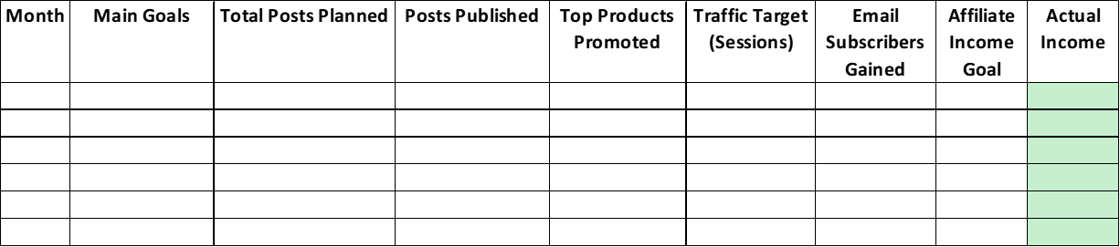
You can find this template in the member's area.
Think of this like your command center. At a glance, you'll know:
- How many posts you’re publishing this month
- What affiliate products you’re promoting
- Your top 3 goals (e.g., build traffic, increase conversions, grow list)
- Your projected income vs. actual earnings
Pro Tip: Color code your goals. Green for traffic, blue for email growth, orange for sales. Makes it easy to scan and adjust as needed.

Section 2: Blog Post Planner
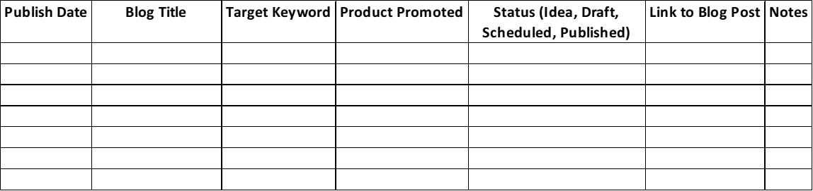
You can find this template in the member's area.
Each post gets its own row. You’ll log:
- Title and draft status
- Keyword focus (because SEO = free traffic!)
- Affiliate product(s) to mention
- Type of content: listicle, tutorial, review, etc.
- CTA (Call-to-action) — what do you want the reader to do?
Friendly Reminder: Add a reminder to check your affiliate links before publishing. Nothing’s worse than a broken link on a post that’s gaining traction.

Section 3: Affiliate Link Tracker
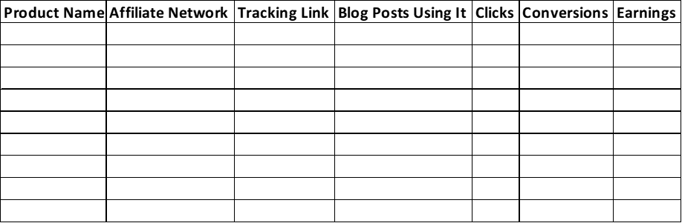
You can find this template in the member's area.
Here’s where you keep your golden nuggets organized:
- Product name
- Unique tracking link
- Commission rate
- Categories or tags (like “Evergreen,” “High Ticket,” or “Seasonal”)
- Posts where the link is used
Magic Tip: Add a column for “Last Clicked.” Every month, update this to see which links are getting love and which ones are snoozing.

Section 4: Results + Insights
It’s like your blog is whispering, “Here’s what’s working. Do more of this.”
Analytics don’t have to be scary. This section is your simple scoreboard:
A. Monthly Performance Overview
Metric | Total
Blog Post Clicks | (Auto Sum)
Affiliate Link Clicks | (Auto Sum)
Conversions | (From links)
Estimated Revenue | (Manual/Auto)
Conversion Rate (%) | =Conversions/Clicks

B. Top-Performing Posts
Blog Title | Clicks | Conversions | Revenue | Notes
Example Post 1 | 450 | 32 | $240 | Add to promo emails

C. Posts to Tweak (High Traffic, Low Clicks)
Blog Title | Views | Clicks | Click Rate | Suggested Fix
Example Post 2 | 1200 | 28 | 2.3% | Update CTA or headline

D. A/B Test Summary
Test Item | Variant A Result | Variant B Result | Winner | Notes
CTA Text | 2.5% CTR | 4.1% CTR | B | "Start Here" outperformed
Use simple color-coding (green = high, red = low) for quick insights.

Section 5: Quarterly Review
Every 3 months, sit down with a cup of something cozy and answer:

Sheet 5: Quarterly Review

A. Top Affiliate Product Conversions
Product Name | Clicks | Conversions | Conversion Rate | Revenue Generated | Notes
ExampleProduct Pro | 500 | 60 | 12% | $720 | Add more CTAs

B. Top Traffic-Driving Posts
Blog Title | Views | Avg. Time on Page | Traffic Source | Notes
“How to Start an AI Blog” | 5,200 | 3 min | Pinterest, SEO | Add follow-up content

C. Audience Insights & Surprises
What I Learned This Quarter
Readers love checklist-style posts more than long guides.
My email opt-in spiked when I used casual headlines.

D. Ideas for Next Quarter
Idea | Goal | Expected Outcome
Create a “mini course” lead magnet | Grow email list | +200 new subs
Test affiliate bundle page | Increase conversions | Boost by 20%
Your blog is alive—let it evolve with you!

- What affiliate products are converting best?
- What type of posts are driving the most traffic?
- What surprises did I learn about my audience this quarter?
- What do I want to try next?
Because your blog should grow with you—not get stuck in the same old loops.

How to Use This in Notion or Google Sheets
You don’t need to be a tech wizard. Here’s the basic setup:
In Google Sheets:
- Use tabs for each section
- Freeze headers so you can scroll easily
- Use conditional formatting for progress tracking (yes, emojis are encouraged!)
In Notion:
- Use databases with filters for products and posts
- Link your Post Planner to your Link Tracker using “Relation” fields
- Add checkboxes for completion status and notes for inspiration

Final Word: Why This Matters
The real magic of affiliate blogging isn’t just writing or even selling—it’s about building a rhythm. This planner isn’t just another tool. It’s a clarity compass, income map, and focus anchor all rolled into one.
You’re not just making content. You’re building a business.
And this planner? It’s the backstage pass to help you run the show.

