Content Repurposing System
10X Content Reach Without More Effort
COPYRIGHT NOTICE
Copyright © 2025 Teo Chin Tee. All rights reserved.
Published by Peter Teo | BloggerSuccessBlueprint.com.
This product and its contents are protected under copyright law.
No part of this publication — including but not limited to text, graphics, templates, designs, videos, audios, or any other content — may be reproduced, distributed, transmitted, stored in a retrieval system, or shared in any form or by any means (electronic, mechanical, photocopying, recording, or otherwise) without the prior written permission of the publisher, except in the case of brief quotations used in reviews, scholarly works, or as otherwise permitted under applicable copyright law.
This product is licensed for individual use only. Unauthorized copying, sharing, distribution, resale, or reproduction is strictly prohibited and constitutes a violation of international copyright laws.
For licensing or permission requests, please contact:
support@bloggersuccessblueprint.com

LEGAL DISCLAIMER
The information contained in this product is provided by BloggerSuccessBlueprint.com, operated by Teo Chin Tee (also known as Peter Teo), for general informational and educational purposes only.
It is not intended to serve as professional, legal, financial, business, health, or medical advice, and should not be relied upon as such.
While every effort has been made to ensure the accuracy and reliability of the information at the time of publication, the author and publisher make no representations or warranties of any kind, express or implied, about the completeness, accuracy, suitability, or availability of the information, products, services, or related graphics contained within this product for any purpose.
Any reliance you place on such information is strictly at your own risk.
Use or misuse of this product and its contents is at your own discretion. The author and publisher disclaim any liability for any loss, damage, injury, or disruption caused — directly or indirectly — by errors, omissions, or reliance on the information provided herein.
The inclusion of links to external websites or third-party tools does not imply endorsement, affiliation, or guarantee of their content or services.
Individual results will vary based on effort, circumstances, and market conditions. No income claims or performance guarantees are made.
By using this product, you acknowledge that you have read, understood, and agreed to these terms and conditions.

Need help or have questions?
Contact: support@bloggersuccessblueprint.com
Visit: www.bloggersuccessblueprint.com

Now for my favorite part: turning one piece of content into 10+ pieces.
This is where you truly multiply your reach without multiplying your work. Think of your blog post as a whole chicken dinner — with the right approach, you’ll have chicken soup, sandwiches, and salads (content pieces) for days.

Who This Guide Is For
Not sure if this guide is your match made in marketing heaven? Quick check:
- Have you ever poured your heart into one blog post… only for it to feel like a one-and-done?
- Do you have folders full of content collecting dust (and zero clicks)?
- Or maybe your brain is spinning faster than your content calendar, and you're thinking, “There has to be an easier way.”
This guide is made for you if you're:
- A solo content creator who wants to do more with less.
- A time-strapped marketer juggling deadlines and dreams.
- A coach, blogger, or expert with knowledge to share but not enough hours to keep saying it all from scratch.
- Or honestly—just someone who’d love to feel like a content superhero without the burnout cape.
If you've ever stared at your screen thinking, “Didn’t I already write this somewhere?”—you’re in exactly the right place.

What You’ll Get From This Guide
By the end of this, you’ll feel like a repurposing ninja—flipping one solid piece of content into a dozen new ones with half the stress.
Here’s what you’ll learn—and love:
- How to transform a blog post, podcast, or video into 5+ snackable content pieces.
- The exact steps to build your own “repurposing flywheel” (aka, your new content BFF).
- Real examples and easy-to-follow workflows that work for your schedule.
- Tools that make it faster and better—without needing to learn a whole new platform.
Wave goodbye to the “content hamster wheel” and say hello to a system that respects your time, boosts your visibility, and keeps your audience coming back for more.
Ready to dive in? Let’s get this content working overtime for you.

Why Content Repurposing Is Your Blogging Superpower
Let’s get one thing straight: Your blog post isn’t the finish line. It’s the starting block.
You’ve spent hours crafting something valuable—writing, editing, tweaking your headline, obsessing over the perfect CTA. You hit publish. You share it once. And then? Crickets.
But what if I told you that same post could turn into an Instagram carousel, a podcast episode, a Reel, a newsletter, a SlideShare, a tweet thread—and still have energy left over?
That’s the magic of content repurposing. It’s not about doing more. It’s about stretching what you already have.
In other words, one blog post can be repackaged into many formats, extending its life and value. Let’s break down a simple system to repurpose blog content and squeeze every drop of goodness out of it.
Sounds like magic? It’s not. It's a strategy.
This is how smart bloggers multiply their reach—without multiplying their effort.

Feeling Burnt Out? You’re Not Alone.
If you've ever felt like you're on a never-ending treadmill of content creation... you’re in good company.
One week it's “write a post.” Next week it’s “post more on Instagram.” Then “don’t forget YouTube Shorts, email newsletters, Pinterest pins, and—oh wait, you haven’t posted to your Facebook page in two weeks?!”
It's enough to make even the most passionate blogger question their life choices.
Here’s the truth: You don’t need more content. You need more impact from the content you’ve already created. Content repurposing is the shortcut no one taught you in Blogging 101. It gives you breathing room, a break from the pressure—and a powerful way to work smarter, not harder.

The Invisible Advantage of Top Bloggers
Ever wonder how the top bloggers seem to be everywhere at once?
They’re not wizards (though sometimes it seems like it). They’re repurposers.
What looks like superhuman consistency is often one well-written blog post, broken down and transformed into dozens of snackable, shareable content pieces.
That deep-dive tutorial on your site? It’s a three-part LinkedIn series.
That case study? It’s a short video plus a Twitter thread.
That listicle? It’s now a Reels script and a lead magnet.
The difference is in the strategy. Top bloggers know that when you write something great, you milk it. They’re not starting over every time—they’re playing smart with what they’ve already made.

The Secret Sauce to Working Less and Creating More
Here’s a little mindset shift: repurposing isn’t recycling—it’s reinventing.
You’re not just reusing content—you’re retelling the story in a way that fits the platform, the audience, and the moment. That’s how one blog post can live twelve lives.
For example:
- A blog post on “How to Monetize a Niche Blog” can become:
  - A 15-second TikTok with one killer tip
  - An Instagram carousel breaking down 5 strategies
  - A Pinterest graphic linked back to the full post
  - A voiceover podcast episode walking through the steps
  - A downloadable checklist as a lead magnet
That’s not double the work. That’s double the return on what you’ve already done.
And yes—you can do this even if you’re a one-person team.

What Is Content Repurposing, Really?
Content repurposing isn’t just a buzzword—it’s your best friend when you’re short on time but big on ideas.
At its core, repurposing means taking one piece of content—like a blog post—and transforming it into multiple formats. Not repeating. Not rehashing. Reinventing. You give your message new legs, new reach, and new life, without starting from zero every time.
Let’s break it down further...

Repurposing Isn’t Recycling — It’s Reinvention
If you’re picturing copy-paste with a new headline, think again.
Recycling is what you do with yesterday’s coffee cup. Repurposing is what you do with your best-performing blog post that deserves way more attention than it got the first time around.
It’s not “lazy.” It's a smart strategy. You’re turning your core content into platform-native gold:
- Blog post → Instagram carousel
- Podcast interview → Tweet thread
- Long-form article → LinkedIn Pulse piece
Each version speaks the same truth—but in a language your audience actually listens to.

Think of Your Blog Posts Like LEGO Bricks
Imagine every blog post as a bucket of colorful LEGO bricks.
You can build one sturdy castle (aka a great article)…
Or you can take those same bricks and build a tower, a spaceship, a car, or a dragon—depending on the platform, format, and audience.
That’s what content repurposing is all about. It’s creative, playful, and scalable.
Just like with LEGO, you don’t need more bricks. You just need to rebuild with purpose.

Why Repurposing Works
Here’s why repurposing isn’t going anywhere:
- People consume content in different ways. Some scroll Instagram. Others binge YouTube. Your job? Meet them where they are.
- Algorithms love fresh formats. Even if your message is the same, posting it in new ways boosts your reach.
- Content fatigue is real. If you’re always creating from scratch, burnout is inevitable. Repurposing keeps you consistent—without draining your creativity.
- SEO and discoverability improve. You multiply keyword opportunities and backlink potential by spreading your message in various formats and platforms.
In short? Repurposing is no longer optional. It’s essential.
So the next time you finish a blog post, don’t just hit “publish” and walk away. Ask yourself: How many more ways can I share this same message?
That’s when the magic starts.

The Big Benefits
(Beyond Just Saving Time)
Saving time is great. But it’s just the beginning. Content repurposing isn’t just a productivity hack. It’s a strategic move that multiplies your blog’s impact, authority, and visibility without draining your energy.
Here’s how smart bloggers are winning the game with content repurposing.

Reach New Audiences on Multiple Platforms
Not everyone hangs out in the same digital neighborhood. Some folks scroll Instagram. Others read emails, binge YouTube, or hang out on LinkedIn. Repurposing lets you show up everywhere—without starting from scratch.
That one blog post? Turn it into:
- A video script for TikTok
- A carousel for Instagram
- A LinkedIn thought piece
- A snippet in your newsletter
- A thread on X (Twitter)
Every format is a new door to reach someone you’d otherwise miss.

Make Your Message Stick (Through Repetition & Variety)
People need to hear a message multiple times in multiple ways before it truly sinks in.
By sharing your message in different formats and tones—text, visuals, audio—you boost retention and connection. It’s like telling the same joke at different parties, with just the right twist for each crowd.
Suddenly, you’re not just visible—you’re memorable.

Maximize the Lifespan of Every Blog Post
Most blog posts get 80% of their traffic in the first week—and then fade into the void.
Repurposing extends their shelf life. You keep your best content alive by:
- Refreshing it with new stats
- Turning it into evergreen social content
- Including it in automated email sequences
It’s not about reinventing the wheel. It’s about keeping the wheels spinning—long after you hit “publish”.

Build Authority Without Extra Burnout
When you show up consistently across platforms—delivering value in different formats—you naturally build trust and authority.
But here’s the kicker: you don’t have to create more. You just have to be smarter with what you’ve already made.
This is how thought leaders scale. This is how beginners look like pros. And this is how you grow without burning out

What Content Should You Repurpose First?
If you’re staring at a mountain of blog posts and wondering, “Where the heck do I even begin?”—don’t worry. You don’t need to repurpose everything. You just need to start with the right pieces. The goal isn’t to do more work—it’s to get more mileage out of the content that already works hard for you.

The “Golden 10%” Rule: Find Your Evergreen Winners
Think of your blog like a classroom. Most posts are decent students. But a handful—the top 10%—are honor roll material. These are the posts that consistently bring in traffic, shares, or search visibility. They're timeless, useful, and high-value.
These “Golden 10%” posts are perfect for repurposing because:
- They’re already proven
- They’re still relevant
- They offer depth you can slice and dice into multiple formats
Start there. Turn that evergreen tutorial into a YouTube series. Break that ultimate guide into quote cards or micro-posts for social. Let your top posts lead the way.

Start With What’s Working: High-Performing Posts
Peek into your analytics. Which blog posts are getting the most:
- Pageviews?
- Time on page?
- Comments or shares?
These are your MVPs. Repurposing them helps you amplify success without reinventing the wheel. Create a carousel from your best how-to post. Record a podcast inspired by a blog that sparked lots of feedback. When something works, lean in.
Repurposing helps you get that content in front of even more people who may have missed it the first time.

Low-Hanging Fruit: Posts That Deserve More Love
Some content is great—but buried. Maybe the headline didn’t pop. Maybe you posted it during a quiet week. Maybe the algorithm just didn’t care that day.
Don’t let that good content go to waste.
Give it a second chance by:
- Turning it into a short-form video
- Rewriting it with a better hook
- Turning the key takeaways into a Twitter thread
Great ideas deserve more than one shot. Repurposing gives them a second wind—and maybe even a breakthrough moment.

The 10X Repurposing Method
You don’t need more content—you need to do more with the content you already have. That’s where the 10X Repurposing Method comes in. It’s how smart bloggers squeeze every drop of value from a single blog post—turning one piece into a dozen or more engaging assets across formats and platforms.
Let’s walk through this, step by step.

Step 1: Choose Your Core Piece of Content
Start with a post that has depth, heart, and relevance. It could be:
- A how-to guide that solved a real pain point
- A list post packed with actionable tips
- A personal story that resonated deeply
- A trending topic you nailed before it peaked
This core piece is your “hero content”—the foundation for every repurposed version to follow. Think of it like the trunk of a tree. Every branch you create—video, tweet, graphic—stems from this strong, rooted piece.
Example:
Let’s say you wrote a blog post titled:
“7 Ways to Grow Your Email List Without Paid Ads”
This post is detailed, evergreen, and packed with actionable advice. It has a catchy headline, clear sections, and speaks to a real challenge your audience faces.
Why this works as a “core” piece:
- Evergreen topic (email list building is always relevant)
- Step-by-step breakdown = easy to split into bite-sized content
- Already performed well on your blog = signals interest

Step 2: Identify New Angles and Audiences
Now that you have your base, it’s time to reimagine it.
Ask:
- What’s one story or stat I can highlight in a standalone post?
- Can this become a video tutorial, a quote card, or a Reel?
- Would a condensed version work better for beginners?
- Can I retell this with humor, emotion, or urgency?
Different formats serve different purposes—and speak to different people. Your blog readers might skim. Your podcast audience wants depth.
Instagram followers love visuals. Repurposing isn’t duplication—it’s adaptation. And that’s how you unlock the full value of your ideas.
Example repurposing ideas:
- YouTube video – Walk through 3 tips from the post with examples
- Instagram carousel – “Swipe to learn 7 email list growth tips”
- Tweet thread – Share each method with a call to action
- Podcast segment – Share the story of how YOU used tip #5
- Email newsletter – “Here’s how I got 100 new subs in 7 days”
- Lead magnet checklist – Turn the 7 methods into a downloadable PDF
Each version tailors the message to how people consume content on that platform.

Step 3: Break It Down into Bite-Sized Nuggets
Now that you’ve picked your hero content and identified new angles, it’s time to slice and dice. Think of this step like prepping veggies: you're not changing the ingredients—just cutting them into easier, tastier bites for every plate.

Turn Blog Posts into Social Captions
That long-form post you poured your heart into? It’s a goldmine for social content.
Example:
From a section titled “Build Trust with Consistent Emails”, you could turn this into:
- Facebook post: “Showing up in inboxes weekly builds trust. Don’t ghost your readers.”
- Instagram caption: “Email your list like you’d message a friend. Consistency > Perfection.”
- Twitter/X: “Consistency isn’t sexy—but it builds email list trust like nothing else.”
Repurpose with intention—match the tone and format to the platform.

Turn Sections into Email Newsletter Segments
Instead of writing a new email from scratch, lift a section straight from your blog.
Example:
Turn “Tip #4: Use Exit-Intent Popups” into a solo newsletter with a subject like:
“The One Tool That Saved My Bounce Rate”
Add a short intro, a value-packed tip, and a call to reply.
Email your list with snack-sized insights that link back to the full post.

Turn Quotes into Visuals (Instagram, Pinterest, etc.)
You probably dropped at least one truth bomb or memorable line in your post.
Example:
“Blogging without repurposing is like whispering in a crowd.”
Use free tools like Canva to turn that into an eye-catching graphic.
Post it on Pinterest, Instagram, or Facebook with a short hook and link.
Better yet? Create a whole series of quote cards from a single article.

Step 4: Turn Text into Other Formats
Your blog post isn’t just a blog post. It’s a script, a voiceover, a visual story waiting to happen. Repurposing your content into different formats helps you meet people where they are—whether they’re watching, listening, or scrolling.

Blog to Video
Turn your blog into an engaging video to capture eyeballs on YouTube, TikTok, Instagram, or your sales page.
Example:
Start with a how-to blog titled “5 Ways to Build an Email List.”
You can turn that into:
- A narrated PowerPoint-style explainer
- An animated step-by-step video using tools like Powtoon or HeyGen
- A face-to-camera video if you're the brand
Keep it short, punchy, and use visuals to complement the key points.

Blog to Audio
Don’t underestimate the power of people listening on the go.
Example:
Record yourself reading your blog post with a conversational tone.
Add it to:
- A podcast episode
- Your blog as a “Listen to this post” feature
- Audiograms for social platforms
Bonus: Tools like Descript can auto-edit filler words and generate transcripts.

Blog to Infographic
Visual learners rejoice! Infographics simplify complex info and are perfect for Pinterest, LinkedIn, and blog summaries.
Example:
From a blog titled “Content Repurposing Strategy”, create an infographic with:
- A 5-step visual flow
- Icons representing each step
- Color-coded sections for clarity
Use Canva or tools like DWS’s ChatGPT-assisted process to create attractive visuals quickly.

Step 5: Platform-Specific Repurposing Strategies
You don’t speak the same way to your best friend as you do to your boss—and your content shouldn’t either. That’s why platform-specific repurposing matters.
Each platform has its own personality. Repurposing isn’t just resharing—it’s reformatting your content to fit where it’s going. Like dressing for the weather, you tailor your message for each digital environment.
Here’s how:

1. Twitter: Turn Your Blog into a Series of Tweets
Twitter is great for breaking down long-form content into bite-sized insights.
How to do it:
- Twitter thread: Take the main points or steps from your post and create a threaded tweet for each. Start with a hook:
  - “I just discovered 5 tricks to plan blog content consistently. 🧵 Here’s what I learned…”
  - Then, break each tip into a separate tweet and link to the full post at the end with: “Details in my blog 👉 [link].
- Single tweets: You can also pull multiple tweets from one post.
  - One day: Share a strong quote or statistic from your article.
  - Another day: Ask a question that your post answers (e.g., “Struggling to stick to a blog schedule? What’s your biggest challenge? Here’s what helped me: [link]”).
Why this works:
- Multiple tweets = multiple chances for people to discover your content.
- Engages readers in a conversation rather than just broadcasting a link.

2. Instagram: Create a Carousel or Story
Instagram thrives on visual content, so turn your blog into snackable posts.
Design a simple graphic or infographic highlighting key info (tools, steps, or a memorable quote from your blog). Use free tools like Canva to make it visually appealing. Post it on Instagram with a caption that gives context and invites readers to check out your blog for the full scoop.
You can also talk on Instagram Stories about the topic (“This week I wrote about scaling your blog... here’s a quick tip from it!”) and direct people to your link.
How to do it:
- Carousel post: Each slide features a key takeaway. Use Canva to make them visually appealing.
  - Example: A blog post on “How to Write a Great Headline” could be a 5-slide carousel:
    - Slide 1: “5 Headline Hacks That Get More Clicks”
    - Slide 2: Hack #1: Use numbers (Example: 10 Ways to…)”
    - Slide 3: Hack #2: Ask a question (Example: Want More Traffic?)
- Stories & Reels: Talk about your blog post in a short video. Give one quick tip, then say, “Full details on my blog—link in bio!”
Why this works:
- Instagram posts have longer shelf life than a tweet.
- Engages visual learners who prefer graphics over text.

3. LinkedIn: Publish a Short Version as an Article or Post
LinkedIn loves thoughtful, professional insights—so don’t just drop a link, summarize your post. Treat it almost like a mini-blog entry.
At the end, say “For more details, read the full article here: [link].” This way, even if people don’t click, they get value — but many will click if they want the depth.
How to do it:
- Write a mini version of your blog post (about 300-500 words).
- End with a CTA: “Want the full guide? Read it here: [link]”
- Or, turn the main takeaways into a list-style post and invite engagement.
  - “These 3 productivity hacks saved me hours each week. Which one would you try? #blogging #contentmarketing”
Why this works:
- Your blog reaches LinkedIn’s built-in audience.
- People engage more with valuable insights vs. just a plain link.

4. Pinterest Pin: Create a Shareable Infographic
Pinterest is a search engine, not just a social media platform. If your post is how-to, list-based, or visual, Pinterest can drive traffic for months or even years as they get re-shared
If your audience uses Pinterest, turn your post (especially if it’s a how-to or list) into a vertical Pinterest-friendly image. This could be an infographic or even just your blog title and tips on a nice background.
How to do it:
- Create a vertical pin summarizing your post’s key points.
- Use bold fonts and a clean design so it stands out.
- Link it back to your blog post.
Example:
A post titled “10 Easy SEO Tips for Beginners” can become a Pinterest infographic showing all 10 tips at a glance.
Why this works:
- Evergreen—pins resurface long after they’re posted.
- Drives search-based traffic back to your blog.

5. Facebook: Post a Short, Engaging Summary
Facebook thrives on personal, relatable content, making it a great place to repurpose your blog post in a way that feels conversational rather than promotional. Instead of just dropping a link, craft a short, engaging summary that hooks your audience and invites them to read more.
How to do it:
- Write a story-driven summary of your blog post.
- Example: “Last year, I struggled with content planning. Every week felt like a scramble. Then I found a simple 3-step system that changed everything. If you want to stop feeling overwhelmed, here’s what worked for me: [link]”
Why this works:
- Emotional, story-based content gets more shares.
- Feels personal—not just another link drop.

6. Video: Create a Quick Clip for Reels, TikTok, or YouTube
Short videos get massive reach across Instagram Reels, TikTok, and YouTube Shorts.
Record a short video of you highlighting the main points. It could be a talking-head video, a voiceover on slides, or even a fun TikTok. Keep it 30-60 seconds, just enough to tease the content. In the video or caption, invite viewers to read the full post (if the platform allows a link, share it; if not, mention your blog name).
How to do it:
- Record a 30-60 second video summarizing your blog post.
- Use text overlays for engagement.
- Example: A post on “How to Beat Writer’s Block” could become a quick video tip:
  - “Staring at a blank page? Try this…” (then give a tip and point them to the full blog).
Why this works:
- Video boosts engagement and trust.
- Put your face and voice behind your brand.

7. Email: Turn Your Post into a Newsletter
Your blog content is perfect for email subscribers.
If you have an email list (even a small one), repurpose your blog content into an email. Write a friendly note about why this topic matters, share a couple of the best insights from your post, and then link to the full article for readers who want more. This keeps your email subscribers engaged and drives traffic to your blog.
How to do it:
- Write a short email summarizing the biggest takeaways.
- Example: “Want to write faster? Here’s a trick that shaved hours off my blog writing. (Spoiler: It’s content batching!) Read the full breakdown here: [link]”
Why this works:
- Keep your audience engaged without writing new content.
- Converts readers into loyal subscribers.

8. Forums & Q&A Sites: Answer Related Questions
People on Quora, Reddit, and niche forums actively look for answers.
Find someone asking a question that your blog post answers. Provide a helpful answer based on your post’s insights, then mention “I actually wrote a detailed guide on this – feel free to check it out here [link].” Be genuine and not spammy. You’re repurposing your knowledge to help someone, and the link is there if they want more.
How to do it:
- Search for questions related to your post’s topic.
- Give a concise, helpful answer and link to your blog for full details.

Example:
- Someone asks, “How do I come up with blog topics?”
- You reply with 2-3 quick tips, then say:
  - “I wrote a full guide on this—check it out here: [link]”
Why this works:
- Taps into an audience actively searching for your expertise.
- Build authority in your niche.

9. Podcast or Audio Snippet: Repurpose Your Blog into Engaging Audio Content
If you have a podcast (or want to start a simple one), use your blog content as a script or discussion topic. No podcast? No problem — you could also use a platform like Twitter Spaces or Clubhouse to talk about the topic live. It’s another way to re-use the content by speaking it instead of writing it.
How to do it:
- Use your blog post as a script and record a short podcast episode.
- Go live on Twitter Spaces, Clubhouse, or LinkedIn Audio Events to discuss your blog topic.
- Share an audio snippet on social media summarizing a key takeaway from your post.
Example:
You wrote a blog post on "10 Ways to Repurpose Content."
- Record a 5-minute podcast episode summarizing the top 3 methods.
- Host a Twitter Space discussion: “Let’s talk about content repurposing—what’s working for you?”
Why this works:
- Expand your audience—some people prefer audio over text.
- Builds credibility—hearing your voice establishes a personal connection.
- Requires minimal extra effort—you already have the content; now you’re just speaking it.

10. Compile Into an eBook or Ultimate Guide
After you’ve written a bunch of posts, you might notice a theme. You can combine several related blog posts into a single free eBook or ultimate guide.
This is more of a long-term repurposing strategy, but it’s great for offering as a download to grow your email list or to establish your authority on a topic. It’s like recycling content on a bigger scale.
This is a smart way to repurpose existing content into something valuable, shareable, and evergreen.
How to do it:
- Identify blog posts with a common theme (e.g., content marketing, productivity, or SEO).
- Organize them into sections or chapters for a natural flow.
- Add a new introduction and conclusion to tie everything together.
- Offer it as a PDF download or a lead magnet to grow your email list.
Example:
You’ve written multiple posts on content repurposing strategies, including:
- How to Repurpose Blog Content for Social Media
- How to Turn a Blog Post Into a Video
- How to Syndicate Blog Content for Maximum Reach
Now, combine them into:
- “The Ultimate Guide to Content Repurposing” (a downloadable PDF)
- A freebie for email subscribers (“Sign up and get the full guide!”)
- A Kindle eBook published on Amazon
Why this works:
- Increases perceived value—an eBook feels premium.
- Boosts brand authority—guides position you as an expert.
- Expands content reach—people love free, downloadable resources.

Step 6: Plan and Schedule and Batch Like a Pro
Batching content is your secret weapon against chaos. Instead of scrambling daily to create something new, carve out a few focused hours a week—or a dedicated “content day” each month—to create multiple posts at once.
- Start with a content calendar: Use tools like Google Calendar, Notion, or Trello to map out your blog, email, and social posts.
- Batch by format: Write all your blog intros in one go. Then, film all your Reels. Then, design your quote graphics. Grouping tasks saves brainpower and time.
- Example: On Monday, write 4 blog posts. Tuesday, record 4 short-form videos from those blogs. Wednesday, draft 4 emails promoting them.
This system keeps you consistent—and frees you up for everything else life throws your way.

Step 7: Track What Works and Tweak the Rest
Creating content is only half the game—tracking is how you win it.
- Start with your goals: Want more traffic? Email signups? Shares? Choose metrics that matter.
- Check your numbers: Use Google Analytics, email open rates, or social media insights to see what’s hitting home—and what’s falling flat.
- Look for patterns: Are certain blog topics getting more clicks? Do videos outperform posts on Tuesdays?
Then tweak. Repurpose the winners again. Improve the underperformers or retire them. Let the data guide your next content sprint.

Conclusion: Make Your Content Work Harder for You
So, here’s the big takeaway: Your content deserves a longer, more exciting life. Instead of publishing a blog post and hoping for the best, you now have a repeatable system to extend its reach, boost engagement, and attract more readers—without doubling your workload.
Think of each post as a seed. When you repurpose it across platforms—whether as a tweet, a podcast snippet, an Instagram carousel, or a LinkedIn post—you’re planting that seed in different soils. Some will sprout quickly, others may take time, but over time, your brand visibility will grow exponentially.
You don’t need to be on every platform. You don’t need to repurpose every single post in 10 different ways. Start small. Experiment. Find what works best for your audience.
Now, it’s your turn. Pick one blog post right now and repurpose it into at least two new formats. A quick tweet? A short LinkedIn update? A newsletter blurb? The choice is yours. What matters is that you take action and watch your content work for you long after you hit ‘publish.’

Recycling Old Blog Content for Fresh Engagement
Have you ever poured your heart into a blog post, only to watch it collect digital dust a year later? You’re not alone. The good news is that those old posts can shine again with a little love. In this guide, we’ll explore how to repurpose and refresh your existing blog content to captivate readers all over again.

Why Repurposing Old Content Matters
Dusting off old content isn’t just a lazy shortcut – it’s a smart marketing move. Revitalizing an older post can drive new traffic, boost SEO, and save you the effort of reinventing the wheel.
In fact, seasoned marketers often find that a significant chunk of their blog traffic comes from older articles. For example, HubSpot found 76% of their blog views (and 92% of leads) came from posts more than a month old. Let that sink in: your archives are basically a content goldmine waiting to be rediscovered.
Refreshing content also improves ROI and engagement over time. Instead of letting good posts fade away, updating them can keep your audience interested and attract newcomers.
Revamped content often performs even better than it did initially – HubSpot saw a 106% average increase in organic traffic on posts they republished with updates. Why create from scratch when polishing up a proven piece can double your results? It’s about working smarter, not harder, and making every word you’ve written count.
Pro Tip: Keep an eye on Google Analytics and Search Console to identify high-performing old posts. These are your best candidates for repurposing—capitalize on what’s already working!
Key Benefits of Repurposing Content:
- Boost Traffic & SEO: Updated posts can climb back up search rankings, bringing in more visitors (one company saw over double the organic traffic after refreshing old articles).
- Save Time & Effort: It’s quicker to update an existing post than to write a new one. You already have the foundation, so a few tweaks can yield big results.
- Better User Experience: No one likes stumbling on outdated info. Refreshing content ensures readers get current, accurate value (no more 2016 stats in 2024 posts!).
- Maintain Brand Consistency: Keep your voice and facts aligned with your current brand. Updating old posts ensures they match your latest style, tone, and messaging.
- Increase Conversions: Up-to-date posts can include current calls-to-action or offers. (HubSpot’s content updates led to a whopping 240% increase in conversion rates for some posts.)
Old content doesn’t have to smell like mothballs. Think of your blog archive as a garden that needs tending. Neglecting your archive is “a bit like a nice garden” that grows wild and uninviting when left uncared for. Trim those weeds (outdated references), plant new seeds (fresh examples), and watch your content garden bloom again.
For example, imagine you wrote a “Social Media Trends 2018” post. By revisiting and updating it as “Social Media Trends 2025,” you can add the latest insights (hello, TikTok and Reels) and re-share it to attract a whole new wave of readers. Suddenly, that 2018 article is relevant, timely, and driving fresh engagement instead of sitting forgotten. That’s the power of repurposing!

Ways to Refresh and Repurpose Old Content
So how do you actually breathe new life into an old blog post? Let’s roll up our sleeves and explore some creative strategies. As content marketing pro Derek Halpern wisely noted, “You don’t have to create content day in and day out. You just have to work on getting the content you already have in the hands of more people.”
In other words, repurposing is about leveraging what you’ve got. Here are some effective ways to refresh your content and give it a second wind:

Update and Re-publish
One of the simplest tactics is to update your old post with current information and re-publish it. Add recent data, new insights, and relevant keywords that reflect today’s trends. Maybe your 2019 article on SEO tactics needs a 2025 update with the latest Google algorithm changes. Go ahead and update the title, adjust the intro, and insert a few fresh examples or case studies.
Once you’ve revamped it, mark it as updated (many bloggers add a note like “Updated on [Date]”) and push it live again. This signals to both readers and search engines that your content is fresh and worth checking out.
Practical example: A marketing blogger took an old “Top Email Marketing Tips” post from 2017, added recent stats and GDPR updates, and re-published it. The result? The post started ranking higher and getting shared all over again – a true resurrection!
Pro Tip: When updating an old post, don’t just tweak a few sentences—add new insights, fresh examples, and updated SEO keywords to make it feel brand new.

Re-share on Social Media
Just because you shared a post two years ago doesn’t mean everyone saw it (or remembers it). Dig up those evergreen pieces and re-share them on social media with a new twist. Craft a fresh caption or create a new graphic to highlight a different angle of the content.
For instance, if you have a timeless blog about productivity, tweet a catchy quote from it or share a behind-the-scenes story on LinkedIn about why you wrote it.
Timing matters too – if a topic in your old post becomes trending news, that’s your cue to resurface it on social media. By resharing, you tap into new audiences and remind long-time followers of your best insights.
Pro Tip: Don’t just copy-paste the old promo text. Spice it up! Pose a question, tag relevant influencers or use an updated hashtag to give that old content a contemporary shine on people’s feeds.

Expand or Break Up Content
Sometimes your old content just needs a change in scope. You can expand a short post into a comprehensive guide, or break a long post into a series.
Look for posts that felt a bit brief or just touched the surface of a big idea – these are great candidates for expansion.
For example, that 500-word post on “5 Quick Blogging Tips” could be expanded into a detailed “Ultimate Guide to Blogging” with step-by-step sections.
On the flip side, if you have a meaty 3,000-word article, consider splitting it into a themed series (Part 1, Part 2, etc.) or extracting a section that can stand alone as its own post. Readers love deep dives when a topic warrants it, and they also appreciate bite-sized pieces if the info is dense. Repurposing in this way lets you cater to both preferences.
Practical example: A blogger had a lengthy “Complete Social Media Handbook” post. She broke it into a four-part blog series (covering Facebook, Twitter, Instagram, LinkedIn separately) and saw readers binge the series one post after another. The shorter, focused posts were more digestible, and she got four times the content out of one big idea!
Pro Tip: If expanding a post, use real-world case studies or new research to add depth. If breaking it up, turn each section into its own standalone post for more content mileage.

Create Round-Up Posts
Another great idea is to compile older posts into a new round-up.
Think of it like curating a “best of” collection for your readers. If you’ve written on a similar theme over the years, bring those pieces together into one super-resource.
For instance, if you run a marketing blog, you might compile “10 Evergreen SEO Tips (From 2015 to Today)” by linking and summarizing insights from several past posts. Add an intro and conclusion to tie it all together and highlight how each piece fits into the bigger picture.
Readers get value from a one-stop resource, and you get to showcase content that might not surface on its own anymore. It’s also fantastic for internal linking – you’ll guide readers to all those older articles through the round-up.
Storytime: one experienced blogger noticed she had written multiple posts about remote work over the years (home office setup, managing remote teams, productivity hacks, etc.). She created a round-up titled “The Remote Work Survival Kit: 5 Years of Tips” featuring short takeaways from each post and links to read more. That round-up became a hit, and each linked old post saw a bump in traffic too. Win-win!
Pro Tip: Add an introduction and a conclusion that tie your round-up together, making it feel like a curated experience rather than just a list of links.

Transform into New Formats
Why limit your content to just text? A blog post can be reborn in a totally new format to reach a wider audience.
That tutorial you wrote could become a step-by-step video. Your research-heavy article could morph into an engaging infographic. A personal story post might translate well into an audio podcast episode where you chat about the experience.
By changing formats, you breathe new life into the same ideas and connect with people who prefer watching or listening instead of reading.
Repurposing content into different formats is a powerful way to reach new audiences. The graphic above illustrates seven creative formats – from infographics to podcasts to videos – that can spring from a single blog post.
Think about it: some folks would rather watch a 2-minute animated video than read a full article, while others might enjoy a slideshow or a colorful Pinterest graphic.
For example, a blogger took her well-performing post “10 Healthy Recipes” and turned it into a bright infographic for Instagram and Pinterest. It visually summarized each recipe, drawing in thousands of viewers (many of whom later clicked through to the full blog).
Another example: if you have a compelling opinion piece, consider recording it as a short podcast episode or an audio post – listeners can now enjoy your content during their commute. The key is to package your existing insights in a new wrapper. This not only extends your reach but also reinforces your message, as people encounter it in multiple ways.
Pro Tip: Not every format works for every audience—test different formats (videos, infographics, podcasts) and track engagement to see what resonates most with your readers.

Leverage User Engagement
Your audience’s reactions can be a content treasure trove.
Pay attention to comments, questions, and FAQs that pop up on your blog posts (or social media discussions about them). Often, readers will ask for clarification or more info on a topic – which is a golden opportunity for a follow-up piece.
For instance, if an old post on content marketing has dozens of comments asking how to actually start a content calendar, take that as inspiration to write a new post like “How to Build Your First Content Calendar (Your Questions Answered).” You’re directly addressing your audience’s needs by repurposing the discussion into content.
Similarly, a lively debate in the comments could spark an idea for “My Response to [Topic] – Based on Your Comments.” This makes readers feel heard and keeps the engagement loop going.
You can also turn frequently asked questions into an FAQ article or a series of quick-tip posts.
Let’s say you notice multiple emails or forum questions about a tutorial you posted – compile those questions (and your answers) into a neat Q&A-style blog update.
Not only does this repurpose existing content (your answers), but it also provides value to anyone else wondering the same things.
Example: A tech blogger noticed people kept asking how to troubleshoot a step in an old guide he wrote. He updated the original post with a new “Common Questions” section and also published a standalone FAQ post addressing all those points in detail.
Both the updated guide and the FAQ post gained traction, since people love when you anticipate their needs.
Pro Tip: Pay attention to recurring questions in your blog comments, social media, and email replies. These can spark new content ideas or updates for existing posts.

Advanced Repurposing Strategies
Once you’ve mastered the basics, you can take repurposing to the next level. These advanced strategies help you squeeze even more value from your content and reach audiences beyond your blog’s regular readership. It’s like giving your content a world tour after a successful hometown gig. Here are a few ideas:

Email Newsletters
Turn your high-performing blog content into an email newsletter or sequence. Email subscribers might not see every blog post you publish, so repackaging content into their inbox can boost engagement.
For example, if you have a comprehensive post like “20 Days to Improve Your SEO,” consider breaking it into a weekly email series (Week 1 tip, Week 2 tip, etc.). Each email can feature a snippet or summary from your blog, plus a link to read the full post if they want more. This keeps your subscribers engaged over multiple weeks using content you’ve already written.
Even a single blog post can become a one-off newsletter edition: share the key points in a conversational email, perhaps with a personal story or update, and invite readers to check out the full post for details.
By doing this, you give your content a second life with an audience that prefers email – all while driving traffic back to your site. And the tone can be more intimate or fun (like you’re writing to a friend) which many readers appreciate in their inbox.
Pro Tip 1: If you maintain a regular newsletter, make a habit of featuring one “From the Archives” piece. You’d be surprised how many subscribers will click on a valuable post they missed the first time around.
Pro Tip 2: Don’t just copy and paste your blog post into an email—reframe it into a personal story, a behind-the-scenes look, or a mini case study to engage your subscribers.

Medium & LinkedIn Articles
Publishing platforms like Medium and LinkedIn can massively expand your reach. They already have built-in audiences hungry for good content. You can republish your blog posts on these platforms to tap into new readership.
The key is to do it strategically: don’t just copy-paste without context. Instead, consider updating the opening paragraph for the new audience or adding a note like “(This article was originally published on my blog).”
Both Medium and LinkedIn allow you to indicate or link to the original source. Medium, for instance, has an Import tool that automatically credits the original and sets a canonical link (so Google knows it’s not a plagiarized duplicate). This means you get the benefit of Medium’s audience without hurting your own SEO. Pretty neat, right?
On LinkedIn, you can publish articles through your profile which notify your connections. Imagine taking an insightful post from your blog and giving it a slight tweak for LinkedIn’s professional tone – suddenly all your business contacts and followers can read it within LinkedIn’s platform.
This could attract new followers who prefer reading on LinkedIn and ultimately drive them to discover your blog. Always include a call-to-action or link back to your site (“For more details, I’ve written about this on my blog here [link].”) so that interested readers know where the content originated and can find more.
Advanced Tip: Some bloggers even use Medium publications or LinkedIn newsletters to regularly syndicate their content, effectively running a parallel channel for visibility. It’s all about meeting your audience where they are.
Pro Tip: Republish only your top-performing blog posts and always include a call-to-action leading back to your website to capture new traffic.

Community Engagement
Don’t underestimate the power of Q&A communities and groups. Platforms like Reddit, Quora, Facebook Groups, or industry-specific forums are where people ask questions – many of which your blog content can answer.
Repurposing here means using your existing content to provide valuable answers or discussion points. If someone asks, “How do I get started with email marketing?” and you happen to have a blog post or section of a post covering that, you can respond with a helpful summary of your advice. You might say, “I wrote about this in my blog recently – here are the key steps: ...,” and then share the link if it’s allowed by the community rules. Even if you don’t drop a link, you’ve essentially repurposed your content by turning it into an answer format.
This not only establishes you as a helpful expert, but it can indirectly draw people to your content. Many will check your profile or message you for more info, which is when they find your blog.
You can also take popular community questions and turn them into new blog posts (which is like reverse repurposing!). For instance, if you notice a question like “What’s the best way to recycle blog content?” gets asked often, you could create a blog post around answering that question – hey, maybe that’s how this very guide was born.
Engage genuinely: share insights from your posts, learn what problems people are facing, and tailor your next content refresh to solve those exact problems. By weaving your blog content into community interactions, you extend its life and usefulness far beyond your own site.
Pro Tip: Instead of dropping links in Reddit or Quora posts, provide a value-packed response first. Then, subtly mention your blog post as a resource for deeper insights.

SEO Considerations for Repurposing Content
Whenever you repurpose and reshare content, it’s important to keep SEO in mind. You want to gain search traffic, not accidentally hurt it. Here are some SEO best practices to follow as you give old posts new life:

Avoiding Duplicate Content Issues
When republishing content on external sites (like Medium or LinkedIn), be careful about duplicate content. Google’s algorithm “frowns upon duplicate content”​, which means if the exact same article appears in multiple places, search engines might get confused about which one to rank.
The solution: use canonical tags or the proper import tools. Medium’s import feature, for example, automatically adds a canonical link pointing back to your original blog. This tells search engines that your blog’s version is the primary one, so you won’t get penalized.
If you manually republish, always include a line like “Originally published at [Your Blog Name]” with a link to the original post. Not only does this avoid SEO issues, but it also drives readers from that platform back to your site. In short, repurpose safely by giving credit to the original source (which is you!) in a way search engines understand.
Pro Tip: Always use a canonical link when republishing on Medium, LinkedIn, or other sites to ensure search engines recognize your original post as the primary source.

Internal Linking Strategy
Don’t republish or update in isolation – link your content together. When you refresh an old post, look for opportunities to link to newer posts on related topics, and vice versa. This creates a network of content on your site that guides readers to more of your material.
From an SEO standpoint, internal links help search engine crawlers discover content and understand which pages are related or important.
For instance, if you update a 2018 post, you might add a link in it to a popular 2025 post for further reading. Similarly, edit some recent posts to insert links pointing to your newly updated piece – “As I explained in my updated guide on XYZ, ...”
This way, anyone reading your latest stuff can stumble onto your refreshed older content naturally.
Internal linking also increases the time people spend on your site (they hop between posts instead of leaving), which can indirectly boost SEO signals. Think of internal links as bridges connecting the islands of your content archipelago, making it easy for visitors (and Google) to navigate and find value everywhere.
Pro Tip: Update internal links when you refresh old content—this strengthens your site’s SEO and ensures visitors always find the most relevant information.

Optimizing for Search Intent
When updating old content, take a moment to ensure it aligns with the current search intent of your target keywords. Over time, what people search for – and how they phrase it – can change.
An old headline like “Ultimate Guide to Facebook Pages” might do better in 2025 as “How to Manage a Facebook Page: Ultimate Guide” if you realize many search queries are “how to manage a Facebook page.” Do some quick keyword research or use your Google Search Console data to see what terms are bringing people to that old post. Then adjust your content accordingly.
You might find new subtopics to add that match what readers are looking for now. Update your title tag and headers to be clear and keyword-friendly (but still human-friendly – no awkward stuffing).
Essentially, make sure your refreshed content answers today’s questions, not yesterday’s. By realigning your content with what your audience currently wants to know, you’ll improve its relevancy and chance to rank.
Remember, a small tweak in wording can make a big difference: if users these days search “email marketing trends 2025” and your old post was titled “Email Marketing Trends 2020,” a quick update to include “2025” and modern context will capture that traffic.
Pro Tip 1: Run a quick Google search for your topic before updating your post. Look at the top-ranking articles to see how search intent has evolved and adjust your content accordingly.
Pro Tip 2: Stay relevant to searchers’ intent and you’ll greatly extend the lifespan of your content in the search results.

Conclusion
Finally, keep a creative mindset and have fun with it. Repurposing is an opportunity to experiment with formats you might not usually use, and to reinforce your message in different ways. It can breathe new life into content you thought was “old news.”
As you get into a rhythm, you’ll likely find it rewarding to see one idea spread across multiple mediums. Your audience will benefit too – they’ll catch valuable content they might have missed otherwise, and they’ll engage with you on more than one platform, deepening their connection to your blog/brand.
An effective content repurposing workflow is all about strategy and consistency. You plan smart, use tools to lighten the load, adapt content creatively, and keep the cycle going. As a beginner, start small: pick one piece and repurpose it in one or two new ways.
Then build from there. Use the checklist and schedule provided here as a framework, and tweak it to fit your style. Soon, you’ll have a smooth-running system where yesterday’s blog post becomes today’s infographic and tomorrow’s podcast – and your content marketing will run like a well-oiled (and enjoyable) machine. Happy repurposing!

Effective Content Repurposing Workflow
The Beginner’s Step-by-Step Guide.
Repurposing shouldn’t be a one-time thing – the real magic happens when you make it a consistent part of your content strategy.
Without a structured workflow, repurposing can feel random, inconsistent, or even like an afterthought. But when done systematically, it becomes a seamless part of your content strategy, ensuring that every blog post, video, or podcast you create continues to work for you long after it’s published.
A solid repurposing workflow allows you to:
- Identify content with the highest potential for repurposing.
- Streamline the process so you can repurpose without extra stress.
- Automate distribution across multiple platforms for maximum impact.
Instead of treating repurposing as an occasional task, this guide will help you build a workflow that fits naturally into your content routine.
Whether you’re refreshing old content, turning blog posts into bite-sized social media snippets, or scheduling a structured content rollout, you’ll have a system in place that keeps your content alive and expanding its reach over time.
Building a workflow means you’ll regularly identify content to refresh, update it, and redistribute it systematically.
Now, let’s break it down into an actionable step-by-step workflow that will transform the way you create and distribute content.
In this guide, we’ll walk through a friendly, step-by-step process to build a content repurposing workflow. We’ll blend automation (using handy tools to streamline repetitive tasks) with manual creativity (the human touch that makes content engaging).
You’ll learn how to repurpose various formats – blog posts, videos, podcasts, and social media updates – and get a sample weekly schedule to keep your content recycling continuously.

Tools to Blend Automation & Manual Processes
Part of an effective workflow is using the right tools to save time. As a blogger, you likely wear many hats – writer, editor, social media manager, maybe even video producer. The good news is there are plenty of tools (many free or affordable) that can automate repetitive tasks and help organize your process, while you focus on the creative work. Here are some tool categories and how to use them in your repurposing workflow:

Notion or Trello – Content Planning & Organization:
- Start by getting organized. Notion and Trello are excellent for managing your content ideas and workflow. You can create a content calendar or Kanban board that tracks each piece of content and all the ways you plan to repurpose it.
- For example, in Trello you might have a card for a blog post, with a checklist of repurposing tasks (e.g. “Write blog > Make 3 social posts > Record video > Update newsletter”)​.
- As you complete each task, check it off. This ensures nothing falls through the cracks.
- Pro Tip: Build a template for your workflow in your tool of choice – list out every step you normally do to repurpose content, then copy that template for each new piece of content​.
- This way, you don’t have to reinvent the process each time; your tool will prompt you with the next step. Notion can also serve as a central content repository – you can store your published posts, notes, transcripts, images, etc., so it’s easy to grab and remix older content when needed.

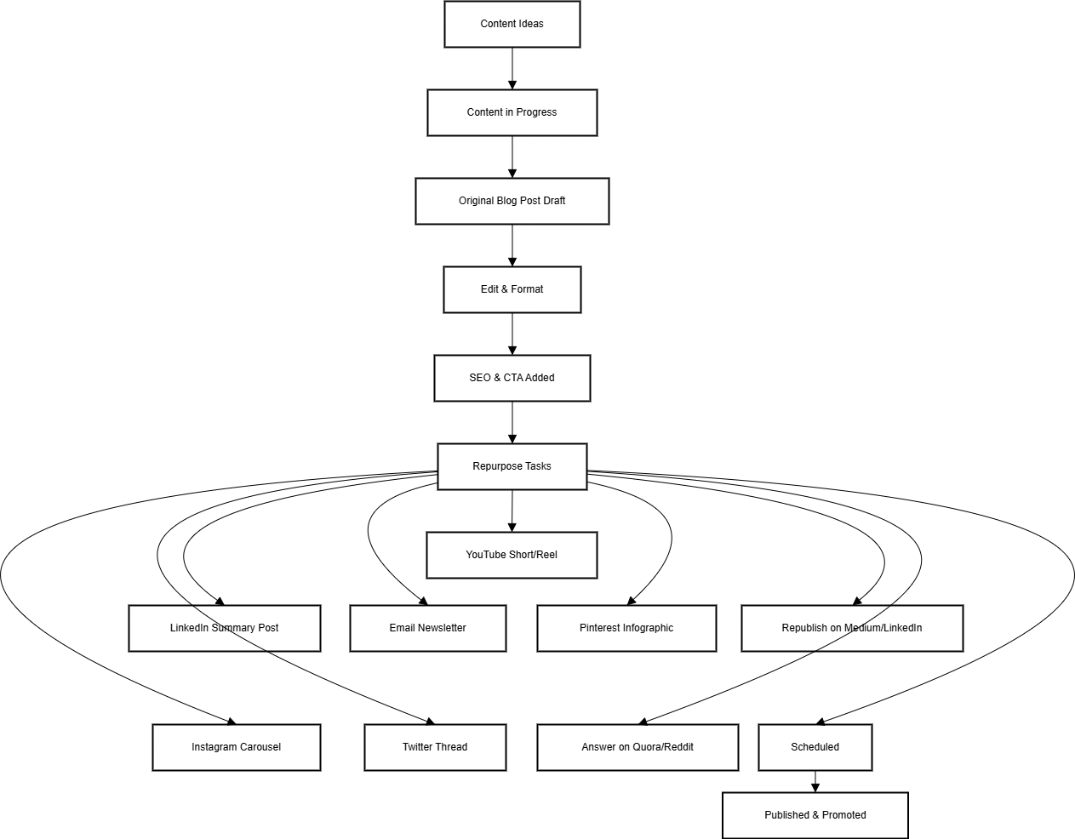
How to Use This Trello Structure
- Set Up Lists in Trello (Idea, In Progress, Repurpose & Distribute, Published, Tracking).
- Create Cards for Each Content Piece (e.g., Blog Post, Video, Podcast).
- Use Checklists to Manage Repurposing Tasks (Social media, newsletters, videos, infographics).
- Move Cards Across Lists as Tasks Progress (From creation to promotion).
- Track Performance in the Final List (Analyze engagement & conversions).

Buffer or Hootsuite – Scheduling & Automation:
- Once you’ve created your repurposed content pieces, scheduling tools like Buffer and Hootsuite become your best friends. They allow you to queue up social media posts across multiple platforms and schedule them to publish at optimal times.
- Instead of manually posting a tweet every day (and risking forgetting), you can spend 30 minutes scheduling a week’s worth of posts in advance​.
- Buffer, for instance, lets you schedule posts for Twitter, Facebook, Instagram, LinkedIn, and more all in one place.
- Hootsuite does similarly and also provides a centralized dashboard for all your social accounts.
- Pro Tip: Take advantage of features like Buffer’s “Share Again” button to effortlessly reshare evergreen content later on​.
- This kind of automation allows continuous recycling – a popular tweet or LinkedIn post from a few months ago can be re-queued with one click, keeping your feeds active without new writing.
- By automating distribution, you free up time to focus on content creation and strategy.

Google Sheets or Excel – Tracking & Analytics:
- To close the loop, you’ll want to track how your repurposed content performs. Spreadsheet tools like Google Sheets or Excel are simple yet powerful for this.
- For example, you can maintain a content tracker spreadsheet that lists each content piece and all its repurposed versions (e.g., Blog post title in one column, then columns for “Facebook post URL,” “Twitter thread URL,” “YouTube video link,” etc., along with performance metrics like views or engagement).
- This helps you see the big picture of your content distribution and spot what formats work best.
- One blogger shares that she keeps a spreadsheet in Google Sheets listing out her content schedule and topics, which lets her see everything at a glance and brainstorm ideas well in advance.
- You can also log metrics here weekly.
- Additionally, don’t forget to review built-in analytics: Google Analytics for your blog traffic, and social platform insights (Twitter Analytics, Instagram Insights, YouTube Studio, etc.) for engagement on those channels.
- These data sources tell you what’s resonating. You might discover, for instance, that your videos get much more engagement than your text posts – that insight could influence what you repurpose more of in the future.
- By combining spreadsheets for custom tracking and native analytics for detailed data, you’ll have a solid handle on your content’s performance.
Remember: Tools should serve your workflow, not complicate it.
Start simple – even a basic spreadsheet and a free Trello board can do wonders to streamline your process.
As you grow more comfortable, you can explore advanced options or integrations (for example, using Zapier to connect tools, or using Notion’s API to feed data to other apps).
The key is to automate where possible (scheduling, reminders, reposting) and use manual effort where it adds value (creating and tailoring content).
Setting Up a Google Sheets or Excel Content Tracker
Content Title | Original Format | Repurposed Format | Platform | Post URL | Date Published | Views | Engagements (Likes, Shares, Comments, etc.) | Traffic/ Conversions | Notes/Insights
How to Grow an Email List | Blog Post | Instagram Carousel | Instagram | [Link] | 3/15/2024 | 1200 | 150 (120 Likes, 30 Shares) | 50 | High engagement, consider making a Reel
How to Grow an Email List | Blog Post | Short-Form Video | TikTok | [Link] | 3/17/2024 | 10000 | 300 (260 Likes, 40 Comments) | 90 | Video format performs better than static images
How to Use This Tracker
- Create a New Row for Each Repurposed Content Piece
  - Track where and how each piece was repurposed.
  - Keep a link to the post for quick reference.
  - Add performance data (views, engagement, clicks, etc.).
- Monitor Weekly Performance
  - Log social media insights (likes, shares, comments).
  - Check Google Analytics for blog traffic.
  - Review email click-through rates for newsletter repurposing.
- Spot Trends & Optimize
  - Identify top-performing formats (e.g., videos may perform better than text).
  - Analyze which platform drives the most traffic to repurpose content strategically.
  - Improve future content creation based on engagement data.

- Tracking with Built-in Analytics
In addition to Google Sheets, use native analytics tools for deeper insights:
- Google Analytics → Track blog traffic & referral sources.
- YouTube Studio → Monitor video watch time & audience retention.
- Twitter Analytics → Measure tweet reach & engagement.
- Instagram Insights → Check post interactions & follower activity.
- Facebook Business Suite → Analyze post performance & ad results.
- LinkedIn Analytics → Evaluate content engagement for professional audiences.
Actionable Insights
- If short-form videos drive more engagement than text posts → Prioritize video repurposing.
- If Pinterest sends the most blog traffic → Double down on Pinterest content repurposing.
- If LinkedIn carousels outperform static posts → Use more carousel-style posts.

Repurposing Across Multiple Content Formats
One piece of content can take on many forms. As a blogger, you likely start with written content, but your ideas don’t have to stay confined to text. Maybe someone in your audience would love to hear your content as a podcast while they commute, or see it as an infographic on Pinterest. In this section, we’ll explore how to repurpose content across the most common formats: blog posts, videos, podcasts, and social media posts. Each format has unique strengths – by recycling content between them, you ensure your message reaches people in the format they prefer.
Let’s break down a few scenarios and ideas for each format:

From Blog Posts to...
Blog articles make great “source” content because they’re rich in information. You can repurpose a single blog post in several ways:

Social Media Posts
Pull out key points, quotes, or tips from your blog and share them as bite-sized social posts.
For example, a list of tips from a blog can become a Twitter thread or a series of LinkedIn updates. You’re essentially distilling the blog’s highlights for quick consumption​. If your blog has an interesting statistic or one-liner, make a quick graphic of it for Instagram or Facebook.

Infographics or Visuals
If your blog contains data or a step-by-step process, consider turning it into an infographic or a simple graphic carousel.
Visual content is highly shareable. Tools like Canva have templates that make it easy to design an infographic summarizing your blog post.

Videos
Create a short video where you talk through the blog’s main points.
This could be a webcam video, a voiceover on slides, or even a quick TikTok/Reel if you can simplify the message. As an example, the team at Visme takes popular blog topics and produces YouTube videos on the same subject – same material, different format​.
By doing so, they reach an audience who prefers watching over reading, without needing a new topic. You can do this on a small scale: film a 2-minute “summary” of your blog or even an animated explainer.

Podcast Episodes
If you have a podcast (or want to start one), use your blog content as the script or talking points for an episode. Simply read the blog in a conversational style or discuss it with a co-host.
You’d be surprised how many people will listen to content that’s already written – it feels new when heard.
Conversely, if you don’t want a full podcast show, you might record an audio version of the blog and offer it as a downloadable MP3 or an embed on your post for those who’d rather listen.
Content Repurpose Work Plan
Content Title | Contentt Name | Checklist | Due Date | Assigned To
Blog Post: 10 Ways to Improve Email Open Rates | Backlog (Ideas & Blog Posts) | Draft blog post, Edit post, Add images, Publish post, Promote via email | 3/25/2024 | Content Writer
Social Media Posts for: 10 Ways to Improve Email Open Rates | Social Media Posts | Write 3 Twitter posts, Create LinkedIn post, Design Instagram carousel, Schedule Facebook post | 3/28/2024 | Social Media Manager
Infographic Creation for: 10 Ways to Improve Email Open Rates | Infographics & Visuals | Extract key stats, Create infographic in Canva, Upload to Pinterest, Share on LinkedIn | 3/29/2024 | Graphic Designer
Video Creation for: 10 Ways to Improve Email Open Rates | Videos | Write video script, Record short explainer video, Edit and add captions, Upload to YouTube | 4/1/2024 | Video Editor
Podcast Episode for: 10 Ways to Improve Email Open Rates | Podcasts | Write podcast script, Record episode, Edit and add music, Publish on Spotify | 4/2/2024 | Podcast Host
Tracking & Analytics for: 10 Ways to Improve Email Open Rates | Tracking & Analytics | Track blog views, Monitor social engagement, Track video views, Analyze podcast downloads | 4/5/2024 | Marketing Analyst

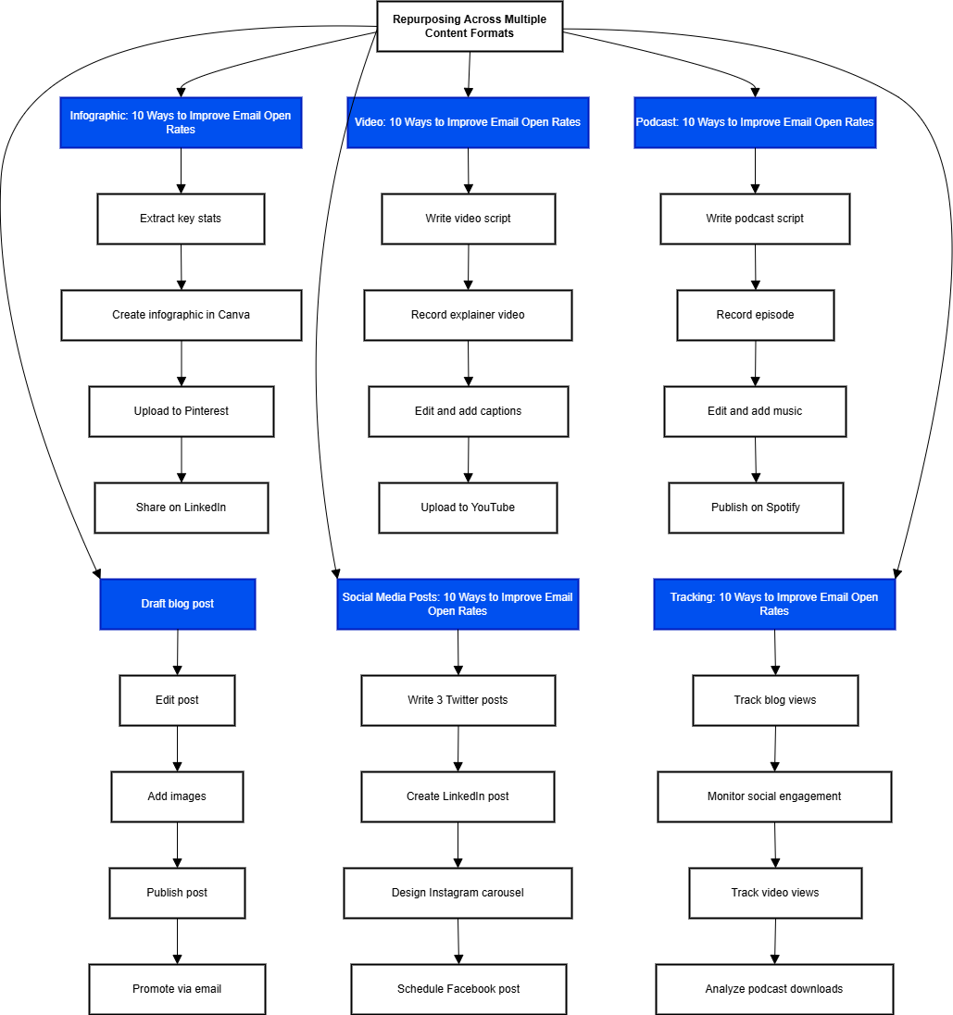

From Videos to...
Video content (like a recorded webinar, a YouTube video, or a live stream) is a goldmine for repurposing. Here’s what you can do with a video:

Text Articles (Blog or Newsletter)
Turn the video into a written piece. Start by getting a transcript of the video – you can use services like Temi or even YouTube’s auto-transcription to get the raw text​.
Then, edit that transcript into a well-structured article or blog post. Add an introduction, polish the language, and include screenshots or images from the video as illustrations.
This way, you suddenly have a blog post that can capture search engine traffic, effectively doubling the content’s reach by making it both visual and textual. (A live video or webinar repurposed into an SEO-optimized blog post can significantly boost your SEO while leveraging work you’ve already done​.)

Podcast
Extract the audio track from the video and publish it as a podcast episode. Many people listen to YouTube interviews or talks without watching the visuals – by offering the audio directly as a podcast, you make it more convenient. Make sure to record in high quality so the audio is clear.
You might need to record a brief intro/outro to make it sound like a standalone audio piece (e.g., “In today’s episode, we’re sharing the audio from our recent video on XYZ topic...”). This way, one recording session yields both a video and an audio asset.

Short Video Clips
Long video content can be sliced into micro-videos for social media.
For instance, take a one-minute insightful clip from a 30-minute webinar and share it on Twitter, LinkedIn, or Instagram (as a Reel/Story).
These act as promotional snippets that drive interest back to the full video or just provide value on their own. There are tools (like Descript or Kapwing) that help trim and caption video clips easily.

Visual Quotes or Graphics
Just like with blog posts, you can pull notable quotes or tips from the video and overlay them on an image.
A snapshot of you speaking with a quote text can be a nice Instagram/Facebook post. It’s another way to atomize a single piece of content into many smaller pieces.
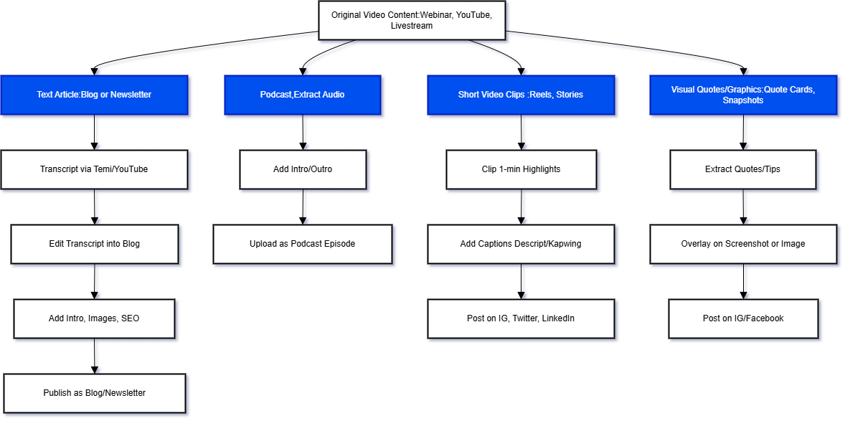

From Podcasts to...
Audio content, like a podcast episode, can also be repurposed widely:

Blog Articles
Similar to video, transcribe the podcast discussion and edit it into a readable article. This is especially useful if your podcast is interview-based or conversational – you can turn each episode into an article highlighting the key insights.
It might read like an interview Q&A or be restructured into a narrative article. Not only does this give you blog content, but it also makes the content more discoverable (since search engines can’t index audio, but they can index your blog).

Videos (Audiograms)
If you don’t have a filmed version of the podcast, you can still create engaging videos by making audiograms – those are waveforms or captioned snippets of the podcast audio, often set to a static background or an image of the speaker.
These short videos can be shared on Twitter, LinkedIn, or Instagram to promote the episode. There are tools like Headliner that generate audiogram videos easily.

Social Media Threads/Posts
Just like with other formats, take the main points or quotable lines from the podcast and share them as text posts.
For example, if your podcast episode is “5 Tips for X,” tweet each tip as part of a thread. You could also share the story of the episode creation or a behind-the-scenes anecdote as a Facebook or LinkedIn post (audiences enjoy glimpses into your process).

Email Newsletter
A podcast episode can double as content for your newsletter. Write a summary of the episode with key takeaways and send it to your email list (with a link to listen). This way, you keep your email subscribers engaged with content you’ve already created in audio form.
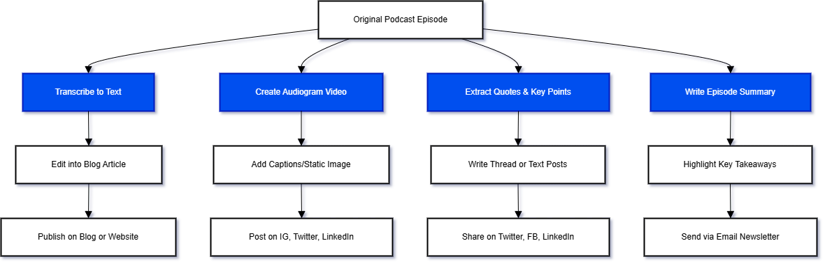

From Social Media Posts to...
Usually we think of repurposing from long-form to short-form, but you can also expand on social media content and turn it into something bigger:

Blog Posts or Guides
If you had a tweet or Facebook post that performed really well or sparked a lot of discussion, consider expanding that idea into a full blog post.
For instance, a Twitter thread that got traction might be essentially an outline for a more fleshed-out article. Take the core idea and elaborate with more examples or research in a blog format.

Videos or Live Streams
Did one of your Instagram posts get tons of comments? Maybe go live on Instagram or do a short video diving deeper into that topic, answering questions your audience asked. Social posts can be great for testing ideas – when one hits a nerve, repurpose it into a richer format like a YouTube video or a podcast discussion.

Compilations
Gather several related social media tips or mini-posts you’ve done and compile them into one “ultimate tips” piece.
For example, if over the past month you shared “Quick Tip Tuesday” posts on LinkedIn, compile those 4 tips into a single article or slideshare (“4 Tips for XYZ”). This gives your bite-sized content a second life and new audience.
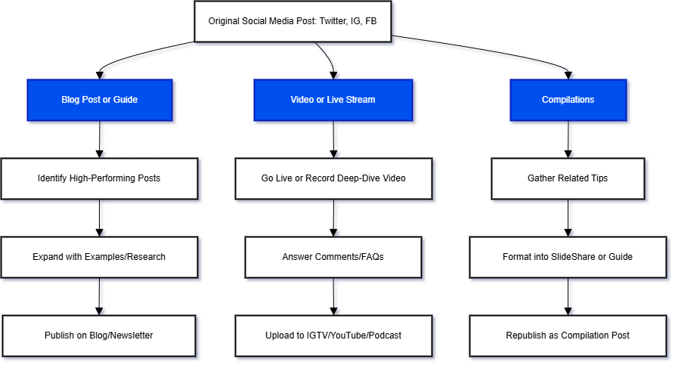

The golden rule
Tailor the content to the platform. Repurposing is not just copy-pasting; you should adapt tone, length, and style for each format.
For example, the way you present an idea on TikTok (quick, trend-aware, visual) will differ from a LinkedIn article (more formal and text-heavy) or a podcast (more conversational and descriptive).
Even if it’s the same core content, always optimize for the channel and audience​. This might mean changing a video’s dimensions, tweaking language, or adding context.
As a pro tip from content experts: a high-performing TikTok video might need editing and a new caption/hashtag strategy to succeed as an Instagram Reel​. Keep the message consistent, but make the format feel native to its platform.
By now, you can see how one piece of content can blossom into many formats. But how do you actually set up a workflow to do this consistently? In the next section, we’ll outline a step-by-step workflow, so you know exactly how to take a piece of content from creation, through repurposing, to distribution and tracking.

10 Pro-Tips Repurposing for Bloggers
Introduction: Why Repurposing Content is a Game-Changer
Blogging is powerful, but creating fresh content constantly can be exhausting. That’s where content repurposing comes in. By transforming a single blog post into multiple formats (videos, social media posts, podcasts, infographics, and more), you can reach a wider audience, extend the life of your content, and save time.
This guide covers 10 expert-level strategies that will help new and experienced bloggers repurpose their content effectively, ensuring maximum impact with minimal effort.

1. Start with Evergreen & High-Value Content
Not sure where to begin? Start by repurposing your best content—the ones that are timeless, valuable, and have long-term relevance.
How to Implement This:
- Identify high-performing blog posts that provide in-depth value (how-to guides, case studies, listicles).
- Avoid repurposing trendy or news-based content that will become irrelevant.
- Focus on pillar content that consistently attracts traffic.
Example: If you wrote a detailed guide on “SEO Strategies for Bloggers,” repurpose it into:
- A LinkedIn carousel post summarizing key takeaways.
- A YouTube video explaining each step visually.
- A Podcast episode discussing SEO mistakes to avoid.
Best Tool to Use: Google Analytics & Ahrefs (to find top-performing blog posts).

2. Don’t Spread Yourself Too Thin – Prioritize Platforms
It’s tempting to repurpose everywhere, but quality beats quantity. Focus on 2-3 core platforms where your audience engages the most.
How to Implement This:
- Research where your target audience is most active (Instagram, LinkedIn, YouTube, etc.).
- If you're a solo creator, master one platform before expanding.
- Tailor each repurposed piece to fit the style and tone of that platform.
Example: A productivity blogger might focus on Twitter (short-form insights) and YouTube (longer tutorials) instead of spreading across all social media.
Best Tool to Use: SparkToro (to find where your audience hangs out).

3. Maintain a Content Repository to Track Repurposed Content
A content repository prevents duplication and helps you track where and when content has been repurposed.
How to Implement This:
- Use Notion, Trello, or Google Sheets to document every blog post and its repurposed formats.
- Track where you’ve shared each piece to prevent redundancy.
- Review your repository every few months for new repurposing opportunities.
Example: A blogger sees that an older "Ultimate Guide to Instagram Growth" was last repurposed six months ago. They update it and turn it into an email series.
Best Tool to Use: Notion (for content tracking & repurposing workflow).

4. Use Data to Find Hidden Repurposing Opportunities
A post that didn’t perform well as a blog might shine on another platform.
How to Implement This:
- Use Google Analytics to find posts with impressions but low clicks.
- Check social media engagement for unexpectedly popular content.
- Repurpose underperforming blog posts with a new format or title.
Example: A blog post with low traffic but great insights might perform better as a Twitter thread or Medium article.
Best Tool to Use: BuzzSumo (for tracking social media performance).

5. Adjust Content to Match Each Platform’s Style
Avoid copy-pasting the same content everywhere—customize it for each platform.
How to Implement This:
- Adjust tone and format to match the platform (casual for Instagram, professional for LinkedIn).
- Reformat content (e.g., turning blog paragraphs into Twitter threads).
- Use platform-specific elements (hashtags on Instagram, carousels on LinkedIn).
Example:
- Instagram post: “5 Blogging Mistakes You’re Probably Making” (with images).
- LinkedIn post: A story-based version with professional insights.
Best Tool to Use: Planable (for cross-platform content scheduling).

6. Turn Your Blog Posts into Engaging Videos & Reels
Short-form and long-form video content is dominating online engagement.
How to Implement This:
- Convert key blog takeaways into short, engaging videos.
- Use AI voice overs or record yourself explaining the post.
- Add captions and animations for better retention.
Example: A blogger turns "Top 10 SEO Tips" into a 60-second Instagram Reel and a 5-minute YouTube summary.
Best Tool to Use: Canva & InVideo (for repurposing text into video).

7. Convert Blogs into Podcast Episodes or Audio Clips
Podcasts are a powerful way to reach audio-focused audiences.
How to Implement This:
- Read your blog post as a podcast episode, adding personal stories.
- Use tools like Anchor to create and distribute episodes.
- Embed podcast episodes back into the original blog for dual engagement.
Example: A blogger repurposes their "Email Marketing Strategies" post into an audio series.
Best Tool to Use: Descript (to convert text into natural-sounding speech).

8. Batch-Schedule Evergreen Reshares to Automate Repurposing
Old content is still valuable—schedule periodic reshares!
How to Implement This:
- Use Buffer, MeetEdgar, or MissingLettr to auto-reshare evergreen content.
- Refresh older content before resharing (update stats, add new insights).
- Set a rotating schedule for top-performing blog posts.
Example: A productivity blog reposts its "Morning Routine Hacks" every 3 months, ensuring new audience members see it.
Best Tool to Use: MeetEdgar (for content recycling).

9. Bundle Old Blog Posts into an eBook or Lead Magnet
Group related blog posts to create premium content (free or paid).
How to Implement This:
- Collect 5-10 blog posts on the same topic.
- Organize them into a cohesive eBook or guide.
- Offer it as a lead magnet to grow your email list.
Example: A food blogger compiles "10 Quick & Easy Dinner Recipes" into a free PDF download.
Best Tool to Use: Canva & Designrr (for creating eBooks from blog posts).

10. Repurpose Content for Email Newsletters
Your email list is one of the best ways to keep repurposing content.
How to Implement This:
- Send weekly newsletters featuring key insights from your best blog posts.
- Include repurposed social media posts as quick tips.
- Repurpose comments & FAQs into a "reader Q&A" newsletter.
Example: A marketing blogger turns their "SEO Guide" into a 4-week email series.
Best Tool to Use: ConvertKit (for automated email sequences).

Final Thoughts & Encouragement
Refreshing and repurposing old content is like giving your beloved past work a second chance to shine. It’s efficient, effective, and yes – even fun. You’ll not only save time but also delight your readers with “new” content that just feels familiar (because it’s built on advice they know works).
Remember all those benefits we talked about: more traffic, better SEO, consistent branding, and higher engagement. They’re all up for grabs when you make your content work harder and longer for you.
So, consider this your friendly nudge to take action. Peek into your archives and pick one post – that one post you know has potential if only it got a makeover – and commit to repurposing it this week. Update it, add a dash of new flavor, and share it with the world again. You might be pleasantly surprised at the reaction. Your future self will high-five you for not letting good content go to waste.
Every blogging superstar you admire is doing the same thing – pruning, tweaking, and reusing their content garden to keep it vibrant. With the tips from this guide, you have a roadmap to do it too. So roll up your sleeves and start recycling an old blog post today. It’s time to unlock fresh engagement from the great content you’ve already created. Happy repurposing, and may your old posts find new life!
Finally, don’t forget about your existing content library. Repurposing isn’t just for new posts. You can give older blog posts new life too:
- Update and re-publish: If you have a post from last year that’s still relevant, refresh it with current info or a new example, and republish it (you can note “Updated on [Date]”). Promoting an updated post is often as effective as a brand new one, but it took half the time.
- Re-share old posts: New followers or readers likely haven’t seen everything you wrote six months ago. It’s perfectly fine to take an evergreen article (one that’s still useful) and share it again on social media. Maybe add a “In case you missed it!” or “Throwback to a useful post from earlier this year!” in your caption.
- Expand or break up content: Turn a short old post into a longer guide by adding more examples (new content + old = a refreshed piece). Or take a longer post and split out one section to expand into its own post. This way you’re not starting from scratch, just building on what you’ve done.
- Round-ups: Create a new post that rounds up your best older content on a topic (“Top 5 tutorials to boost your blog traffic,” linking to your past posts). This not only creates a new piece easily, it drives traffic to those older posts again.
The goal is to get more mileage from everything you create. You worked hard on those posts — don’t let them gather dust after the first publish. By recycling and repurposing, you continually keep your blog content alive and in front of new eyes.
Wrapping up: With a solid plan and a repurposing mindset, you’re no longer stuck on the hamster wheel of always needing “new” content. You’ve learned how to plan with a content calendar, stay consistent with scheduling and batching, scale your reach through smart sharing, and repurpose like a pro.
The Content Planning & Scaling Bundle is really just these pieces working together: plan it, publish it, spread it around, and remake it into something new when you can.
Remember, even the biggest bloggers started small — the difference is they kept at it consistently and found ways to make their content work harder for them. Now you have those same tools in your toolbox.
So go ahead and try these strategies: create your calendar, write that post, share it everywhere, and slice it into micro-content. Over time, you’ll see your organic traffic increase, your audience grow, and your workload feel much lighter. Happy blogging and content planning!

Quick Recap: Your Content Repurposing Cheat Sheet
Before you close the tab (or pour another coffee), here’s your at-a-glance win list:
- ✅ One idea = many formats (think blog → podcast → email → social posts).
- ✅ Repurposing saves time, builds consistency, and multiplies your reach.
- ✅ Use batching + templates to turn chaos into clarity.
- ✅ Keep a system (like Trello or Notion) so you’re not reinventing every time.
- ✅ Let the data guide your next move—resurface what already works.
Bookmark this. Print it. Tattoo it on your brain. (Okay, maybe not that last one.)

