Content Repurposing Workflow
COPYRIGHT NOTICE
Copyright © 2025 Teo Chin Tee. All rights reserved.
Published by Peter Teo | BloggerSuccessBlueprint.com.
This product and its contents are protected under copyright law.
No part of this publication — including but not limited to text, graphics, templates, designs, videos, audios, or any other content — may be reproduced, distributed, transmitted, stored in a retrieval system, or shared in any form or by any means (electronic, mechanical, photocopying, recording, or otherwise) without the prior written permission of the publisher, except in the case of brief quotations used in reviews, scholarly works, or as otherwise permitted under applicable copyright law.
This product is licensed for individual use only. Unauthorized copying, sharing, distribution, resale, or reproduction is strictly prohibited and constitutes a violation of international copyright laws.
For licensing or permission requests, please contact:
support@bloggersuccessblueprint.com

LEGAL DISCLAIMER
The information contained in this product is provided by BloggerSuccessBlueprint.com, operated by Teo Chin Tee (also known as Peter Teo), for general informational and educational purposes only.
It is not intended to serve as professional, legal, financial, business, health, or medical advice, and should not be relied upon as such.
While every effort has been made to ensure the accuracy and reliability of the information at the time of publication, the author and publisher make no representations or warranties of any kind, express or implied, about the completeness, accuracy, suitability, or availability of the information, products, services, or related graphics contained within this product for any purpose.
Any reliance you place on such information is strictly at your own risk.
Use or misuse of this product and its contents is at your own discretion. The author and publisher disclaim any liability for any loss, damage, injury, or disruption caused — directly or indirectly — by errors, omissions, or reliance on the information provided herein.
The inclusion of links to external websites or third-party tools does not imply endorsement, affiliation, or guarantee of their content or services.
Individual results will vary based on effort, circumstances, and market conditions. No income claims or performance guarantees are made.
By using this product, you acknowledge that you have read, understood, and agreed to these terms and conditions.

Need help or have questions?
Contact: support@bloggersuccessblueprint.com
Visit: www.bloggersuccessblueprint.com

Let’s build your content repurposing workflow, stage by stage. This workflow covers everything from selecting the content you’ll repurpose, to transforming it into new formats, scheduling it out, and tracking results. Especially if you’re a beginner, following a clear process like this can turn repurposing into a habit that eventually runs like clockwork. We’ll include examples and tips at each step:

Step 1: Audit Your Content and Choose What to Repurpose
Repurposing starts with picking the right content. Not every piece will be worth repackaging, so you’ll get the best results by being strategic in what you choose to repurpose.

Review Your Content Library
Take stock of your existing content – blog posts, videos, podcast episodes, etc. Identify evergreen pieces (topics that stay relevant over time) and any content that performed really well (high traffic, lots of shares, or engagement)​.
These are prime candidates for repurposing because they’ve proven their value. A quick way to do this is to check your analytics: for blogs, look at Google Analytics to see which posts are landing pages with a lot of views or low bounce rates (indicating people found them useful)​. For social content, think of posts that got above-average likes/comments.
Mark these pieces as “repurpose candidates.”

Pick a Content “Anchor”
Especially if you produce regular content (like a weekly blog or video), decide which piece will be your anchor content for repurposing.
Many bloggers find it efficient to start with a substantial piece of content each week (for example, a detailed blog post or a 20-minute video) and then derive smaller pieces from it throughout the week.
Starting with your longest, most detailed format gives you more to work with​. If you primarily write blogs, use the blog as your anchor. If you’re more of a YouTuber or podcaster, use that.
The idea is to have one core piece that serves as the “source material” each cycle. For instance, imagine you have a tutorial blog post – that is your source; from there you’ll create social posts, maybe a video summary, etc.
Alternatively, if you have a backlog of old posts, you might pick one theme per week (e.g., an older post that’s still relevant) to spotlight and repurpose.

Plan Updates if Needed
As you audit, note if any great content needs a quick refresh before sharing again. Perhaps statistics need updating or you want to add a fresh example.
Repurposing can include refreshing content (sometimes called “remixing” or “upcycling” it) so that it’s polished for a new audience​.
Ensure the piece is accurate and error-free; running it through a grammar check isn’t a bad idea if you’ll be copying text from it​. This way, when you repurpose, you know you’re working with quality material.
By the end of Step 1, you should have one or a few pieces of content chosen as your focus for repurposing. For beginners, start with just one piece per week (or per cycle) so you don’t overwhelm yourself. As you get comfortable, you might increase this, but it’s amazing how far one article or video can stretch when you repurpose creatively.

Step 2: Plan Your Repurposing Strategy
Now that you’ve picked content to repurpose, make a game plan for how you’ll transform and distribute it. This planning stage will save you time later and ensure you cover all the bases.

Brainstorm Repurposing Ideas
Look at your chosen content and list out the different formats you can turn it into. Ask yourself: Where else can this message go? If it’s a blog post, could it be a video, an infographic, a series of tweets, etc.? If it’s a video, will you make an article, some short clips, and an email newsletter from it? Jot down all reasonable ideas.
Then prioritize the formats that make sense for your audience and resources. You don’t have to do everything! If you know your audience doesn’t hang out on TikTok, no need to force a TikTok video.
Focus on the channels where you have presence or where your target audience spends time. For instance, a B2B blogger might prioritize LinkedIn and a SlideShare or PDF guide over Instagram. A lifestyle blogger might focus on Instagram, Pinterest, and a YouTube vlog. Choose a mix that’s achievable.

Create a Repurposing Checklist
It helps to formalize this plan into a checklist or template (this is where your planning tool comes in handy).
For example, in Notion or Trello, you can create a card or page for this content piece and list the repurposing steps: “1) Write blog intro for LinkedIn, 2) Design 2 quote graphics, 3) Film 1-minute tip video, 4) Schedule tweets linking to blog,” and so on.
Having a checklist ensures you won’t forget a step when you get busy​. If you’re working with others or outsourcing, the checklist is even more crucial – it makes it clear who needs to do what.

Map Out a Content Calendar
Decide when each repurposed piece will be published. For example, you might plan the main blog post to go live on Monday, an email about it on Tuesday, a video later in the week, and social posts sprinkled throughout.
Laying this out on a calendar (even just a week-view) prevents everything from going out on the same day and then going silent afterwards. A well-structured calendar will spread out your content for consistent coverage​.
Many find it helpful to designate certain days for certain channels (e.g., “Blog Monday,” “YouTube Wednesday,” “Podcast Friday,” with social media posts in between). We’ll give an example weekly schedule in the next section. The key is to ensure each format gets its moment. If you use scheduling tools, you can pre-set the dates once you create the content.

Consider Resources & Tools
Plan for how you’ll actually execute each piece. Will you need any help or tools? For instance, if you plan to turn a blog into a video but you’re not comfortable on camera, maybe you’ll use a tool like Lumen5 or Canva Video to create a simple animated video out of text and images.
Or if you want to design infographics but aren’t a designer, you might use templates from Canva or Visme. If a task feels too big, adjust your plan – maybe a podcast episode can be summarized in a blog rather than transcribing the whole thing if you don’t have a transcription tool or the time.
At this stage, also decide if you need to outsource any part of the work (like hiring a freelance video editor for chopping up a webinar, or a virtual assistant to help schedule posts)​.
As a beginner, you likely can do most yourself with tools, but it’s good to be aware of your own capacity. The plan should be realistic given the time you have each week for content.
With a clear plan in place, you’ll find the repurposing process much easier. You know exactly what you’re creating, for which platform, and when it’s going out.

Many seasoned content creators say that planning is half the battle – once you have a solid workflow chart or checklist, the execution becomes a routine. Some even literally draw a flowchart or diagram of their content pipeline (e.g., “Blog > ️ 3 tweets, 1 infographic, 1 email”) to visualize the process​. Let’s actually look at an example of what a content repurposing flow might look like:

Example of a content repurposing flowchart:
This diagram (from a content marketing team) shows how one piece of content can branch into many outputs. In this example, a webinar led to a post-event email, a video clip for LinkedIn, a long-form blog post, three SEO-focused blog posts, and a learning center article.
Those in turn were repurposed into a LinkedIn carousel, a Twitter thread, a guide page, and a downloadable PDF​. For a solo blogger, your flow might not be as elaborate, but the idea is the same – one “core” content piece can spawn multiple smaller pieces tailored to different channels. Try sketching a simple flow for your content: start with your primary format (say, your blog post), then draw arrows to the other formats (social posts, video, etc.) you plan to create. This visual map can keep you on track and ensure you don’t forget an outlet.
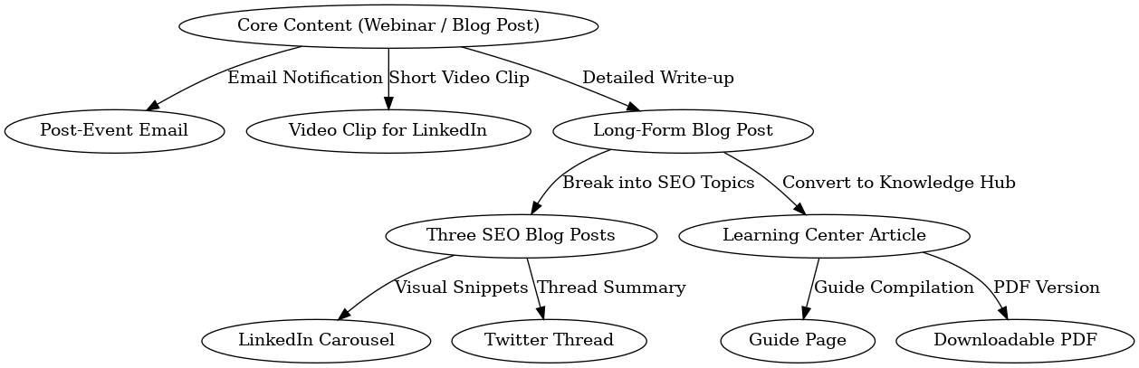

Step 3: Create (or Transform) the Content
Time to roll up your sleeves and make the repurposed content pieces you planned. This stage is where you actually create the new format (or modify the original content) for each of your repurposing targets. It’s often the most time-consuming step, but also the most creative. Here’s how to tackle it efficiently:

Start with the Anchor Content
If you haven’t yet created this week’s main content piece (e.g. you plan to write a new blog or record a new video), do that first. It’s important to have your core content 100% complete before you try to repurpose it​. You want a finished, polished source to work from.
For example, finish writing and proofreading the blog post, or finish recording and editing the video, before you move on. This ensures everything else flows smoothly from accurate material.
Remember, everything in your workflow stems from this single piece​, so give it the attention it deserves.
Pro Tip: if you’re creating a new piece (not just using an old one), try to incorporate elements that will make repurposing easier. For instance, while writing a blog, you might highlight 2-3 key sentences that would make good quotes for social media later. Or if recording a podcast, mention a few stats or tips clearly – those soundbites can become tweet text or graphics. Think ahead!

Transform into the First New Format
Once the original content is ready, take the first repurposing task on your list and get to work. Let’s say your plan is: from a blog post, you want to make an infographic and a short video.
You might tackle the infographic first. This could involve summarizing the blog’s main points, finding icons or images, and laying it out in a tool like Canva. Use templates to save time – no need to design from scratch if design isn’t your forte.
If you’re converting a video into a blog post, the first step would be transcription. Use an AI transcription tool or service to get the raw text​. Then edit that text into an article (add structure, headings, and trim out the “ums” and off-script chatter).
This might feel like a lot, but it’s much faster than writing a brand new post from a blank page. One creator shared that they download their live video, run it through a transcription service (for a small per-minute cost), then just clean up the transcript and add SEO keywords to turn it into a ready-to-publish blog​.
That’s smart repurposing in action! Use AI tools like ChatGPT carefully here as well – for example, you can paste sections of a transcript and ask for a summary or an outline​. Just be ready to fact-check and refine the AI output, as it’s not perfect.

Batch Your Work if Possible
If you have multiple pieces to create, see if you can batch similar tasks together. For example, if you plan to make three quote graphics for three different platforms, do them in one session – you’ll work faster using the same design tool and just swapping text. Or if you need to write captions for five social posts, write them all in one go.
Batching reduces the mental load of switching tasks. Some people even dedicate a whole day to creation: e.g., Content Creation Tuesdays where they handle all production for that week’s repurposing pieces. Do what fits your schedule, but batching is a great time-saver.

Keep the Voice and Quality Consistent
As you create the new pieces, maintain consistency with your brand voice and facts. Since you’re reusing content, it’s easy to get lax, but still proofread everything.
Ensure that any statistics or info from the original piece are correctly represented in the new format. And adapt the tone appropriately – a blog might be a bit formal, whereas when you turn it into a conversational video, you’ll use a more casual tone.
Pro Tip: Don’t hesitate to add a fresh twist when repurposing.
Repurposing doesn’t mean you can’t say anything new – you can update examples, add a new intro or commentary for context, or tailor the message. For instance, if you’re turning a generic blog post into a LinkedIn post, you might preface it with “When I wrote about this on my blog, I was thinking about solopreneurs. But here on LinkedIn, these tips can apply to team leaders too…” Small tweaks like that can make the repurposed content feel specially made for that audience.

Use Templates & Tools
Leverage tools to make creation easier. Some handy ones:
- Design Templates: Canva, Visme, or Piktochart for quick visuals (they have preset sizes for Instagram, Pinterest, etc., and you can drop your text in).
- Video Editing: If you need to trim videos, try tools like Kapwing or VEED.io; one blogger recommends VEED for easily repurposing a long video into shorter clips and adding captions​.
- Audio Editing: Audacity (free) or Descript for extracting audio and cleaning it up. Descript even lets you edit audio by editing text (great for podcasts from transcripts).
- Writing Assistance: If writing isn’t your strong suit or you want to speed it up, you can use AI writing assistants for drafts – e.g., feed the main points to ChatGPT and get a draft of a social post, then edit it to add personality. Always review AI outputs, but it can jumpstart the process.
By the end of Step 3, you should have in hand (or on your computer) all the pieces of content for your repurposing plan: maybe a new blog post file, a series of image files for social media, a video ready to upload, etc.
It can feel like a lot of content, but remember, you don't have to come up with all-new ideas for each piece – they all stem from one idea, which is pretty cool! Take a moment to pat yourself on the back for multiplying your content presence.

Step 4: Distribute and Schedule the Content
With your shiny new repurposed content pieces ready, the next step is to get them out into the world. Distribution is critical – this is where your work pays off by reaching your audience across platforms. Rather than manually posting everything on the fly, we’ll use a systematic approach to schedule and share content throughout the week (or month).

Publish Core Content First
Ensure your main content (the anchor piece) is published or scheduled at its planned time. For example, if it’s a blog post scheduled for Monday morning, double-check it’s ready to go (images in place, SEO done, etc.). If it’s a YouTube video, upload it, add your title/description and set it to public or scheduled. This piece often will be something you link back to from other formats, so it should be accessible when those go live.

Tailor Posts for Each Platform
Before scheduling, write out the actual posts/captions you’ll use on each platform to share or promote the content. Don’t just copy the same text everywhere – craft each to fit the platform’s style (remember to optimize for each channel as discussed).
For instance, the text accompanying a LinkedIn post might be a bit longer and more professional in tone, whereas an Instagram caption might be shorter with some emojis or a personal anecdote. If you’re linking to your blog, some platforms (like Facebook, LinkedIn) prefer you to upload a native image and put the link in the text, while others (Twitter) you can just include the link. These little tweaks matter.
Also, consider hashtags where relevant (Instagram, Twitter). It might sound like extra work, but you can reuse the same core message with slight variations. Think of it like writing headlines or email subject lines – you’re framing the content in the best way for that audience. This step can also be done earlier while creating content, but many prefer to do it now with everything in front of them.

Use Scheduling Tools to Automate Posting
Now load up your Buffer, Hootsuite, or preferred scheduler with all these posts and set them to go out at your chosen times. For example, schedule your Twitter thread on Tuesday at noon, your Instagram carousel Wednesday morning, your LinkedIn article on Thursday, etc., according to the content calendar you mapped.
Scheduling tools let you visually see your week’s posts lined up, which is reassuring. One marketer noted that taking 30 minutes to schedule content in advance can save hours of time and stress during the week​. If you don’t use a scheduling tool, you can still emulate this by setting alarms or calendar events to post manually, but the tool will seriously make life easier (and ensure you don’t forget when life gets busy).

Leverage Platform Features
Some platforms have unique ways to keep content alive longer – use them. For example, Facebook and Instagram Stories can be used to reshare your feed posts or tease new content.
Pinterest can be used to save your blog post (design a nice Pinterest image for it if that’s relevant to your audience).
On Twitter, you might pin the tweet that contains your main content for the week to get extra visibility. Also, consider communities: share your content in a relevant Facebook group or subreddit if it’s helpful (just be mindful of rules against self-promo – frame it as a helpful resource, not spam). These are manual shares but can expand reach.

Email and Cross-Promotion
Don’t forget your email list if you have one. Sending a quick note to your subscribers about your new content (or including it in a weekly roundup email) is a great way to drive initial traffic. Similarly, link between formats. If you published a video, mention in the video description “This was based on our blog post – link in comments/bio” etc., and vice versa (blog can embed the video or link to it). Cross-promoting ensures someone who finds one piece of content can discover the rest. It’s like weaving a net of content that all supports each other.

Monitor as It Goes (lightly)
On the day your content goes out on each channel, keep an eye out for any immediate issues. For instance, ensure that the scheduled tweet actually posted, or that the LinkedIn article formatting looks okay when published.
Usually, scheduling tools are reliable, but it’s good to verify. Also, be ready to interact – if you get comments on the Facebook post or replies to the tweet, try to respond in a timely manner (this boosts engagement and shows there’s a person behind the posts).
At the end of Step 4, your repurposed content is live (or queued up to go live) across the channels you’ve chosen. Congrats – your content is now working overtime for you! By spreading it out, you’ve turned one piece of content into a week (or more) of multi-channel presence. This consistent distribution is what keeps your audience engaged and growing without requiring you to create brand new topics every day.

Step 5: Track Performance and Iterate
The workflow doesn’t end once everything is posted. The final (and ongoing) step is to track how your content performs and use those insights to refine your future repurposing efforts. Over time, this will make your workflow more efficient and effective.

Monitor Key Metrics
Refer back to your tracking system (spreadsheet, Notion table, or even the analytics dashboards) to see the results. For each repurposed piece, note metrics that matter to you. Common ones include:
- Blog post: views, time on page, maybe conversion (if you have a signup or CTA).
- Social posts: likes, shares/retweets, comments, impressions.
- Video: views, watch time, likes, comments.
- Podcast: downloads/plays.
- Email: open rate, click rate (if you linked out).
Write these down after a set period (e.g., one week after posting each, or monthly). This doesn’t have to be super detailed, just enough to gauge what’s resonating.

Identify What Worked Best
Look at the data and ask: Which format got the most engagement or best response? Did the infographic on Instagram take off while the Twitter thread got little love? Or maybe your LinkedIn post got a lot of comments.
Use this info. It might tell you about your audience’s preferences (perhaps they really like videos over text, or vice versa). It also can highlight the content topics that get traction. For example, you repurposed two different blog posts over the past month and one consistently outperformed the other across platforms – that’s a clue that the topic of the first one is hotter.
This kind of insight can inform your next content decisions (maybe do more on that popular topic). By monitoring performance across channels, you can discover what resonates with diverse audiences​.

Engage and Build Relationships
Tracking isn’t just numbers. Check the qualitative feedback too. Read the comments you got on each platform. Sometimes a repurposed piece will spark questions – that’s a great opportunity to reply and even note those questions as ideas for future content.
If someone said “I’d love to know more about X,” maybe your next blog or video can address that. Also, if you mentioned or tagged anyone (say you quoted an influencer in your blog and tagged them on Twitter when sharing), see if they replied or reshared.
Building these interactions can extend the life of your content further (for instance, an expert you mentioned might share your post to their followers, giving you an even bigger audience).

Adjust Your Workflow as Needed
After a cycle or two of repurposing, reflect on how the process went for you. Was there a step that felt cumbersome?
Maybe creating videos every week is too much – so perhaps you do videos monthly and stick to text/image formats weekly.
Or you might find you have time to do more, and can add another repurposing task.
Treat your workflow as flexible. The first few times you follow it, take notes on how long things took and any hiccups.
Then refine it. Perhaps you realize you need to start the process earlier (e.g., give yourself two weeks to properly repurpose one really big piece).
Or you might invest in a new tool if you see a bottleneck (for example, if manually scheduling to five platforms is tedious, you might try a tool like Hootsuite that handles all in one go).

Celebrate and Repurpose Again
Finally, don’t forget to occasionally repurpose your repurposed content!
This sounds funny, but here’s what it means: If a particular social post or format did extremely well, use it again in the future. You can directly reshare it after some time (social media moves fast; a great Twitter tip you shared 2 months ago can be tweeted again and feel fresh to those who missed it​).
Or repurpose the concept: maybe your “Top 5 tools” blog that you broke into individual LinkedIn posts can later be compiled into a short PDF guide. There’s almost no end to how you can remix content.
Just be mindful not to become too repetitive in the short term – space things out and always aim to provide value, not spam. If you keep an organized content library, you can cycle through evergreen pieces periodically so new followers or readers get to see them.
By continuously tracking and iterating, your repurposing workflow will get smoother and more impactful. Over a few months, you’ll likely notice you can produce more content in less time, and your traffic/follower numbers responding positively. That’s the compounding effect of smart content repurposing.

Simplified Content Repurposing Workflow
Content repurposing doesn’t have to be overwhelming. If the above detailed breakdown feels like too much to digest, here’s a simplified, step-by-step workflow that highlights the essential actions needed for effective content transformation.
This informative flow chart provides a clear visual guide on how to repurpose content efficiently—from selecting high-performing materials to distributing them across multiple platforms and tracking their success.
By following this streamlined process, you’ll maximize reach, save time, and ensure consistency across different content formats. Let’s dive in!

Step 1: Audit and Choose Content to Repurpose
Review your content library
- Identify high-performing and evergreen content
- Use analytics tools (Google Analytics, social insights) to find content that received the most traffic, engagement, or shares
- Mark these as repurpose candidates
Pick an “Anchor” content piece
- Choose one long-form content as the main source (e.g., blog post, video, podcast)
- Decide which platform and audience the content is best suited for
Update & Refresh (if needed)
- Check for outdated information or broken links
- Polish with new insights, examples, and visuals before repurposing

Step 2: Plan Your Repurposing Strategy
Brainstorm repurposing formats
- List potential repurposed formats (social posts, videos, infographics, email, etc.)
- Match formats with platforms (e.g., Instagram for visuals, LinkedIn for articles)
Create a repurposing checklist
- Example workflow: “Blog post → 3 LinkedIn posts → 1 Twitter thread → 1 short video”
Map out a content calendar
- Spread posts throughout the week for maximum impact
Select tools and resources
- Canva for graphics, Descript for video editing, AI tools for summaries

Step 3: Create & Transform Content
Start with Anchor Content
- Finalize main content first (blog, video, or podcast)
Convert into other formats
- Turn blog → social posts, short clips, infographics
- Turn video → transcript, blog, social snippets, audio clips
Batch process for efficiency
- Write multiple captions, graphics, or clips in one sitting

Step 4: Distribute and Schedule Content
- Publish the main content (blog, video, or podcast)
- Customize and schedule repurposed versions across platforms
- Use social media scheduling tools (Buffer, Hootsuite, Trello)
- Cross-promote content (link between formats, email updates)

Step 5: Track Performance & Iterate
Monitor analytics
- Google Analytics for blog traffic
- Social insights for engagement (likes, shares, comments)
Identify best-performing formats
- Prioritize content types that resonate most with the audience
Adjust workflow
- Double down on effective content types
- Optimize posting schedules
Repurpose again!
- Re-share successful posts after a few months
- Repurpose top content into new evergreen formats
The Flow Chart for the Entire Workflow
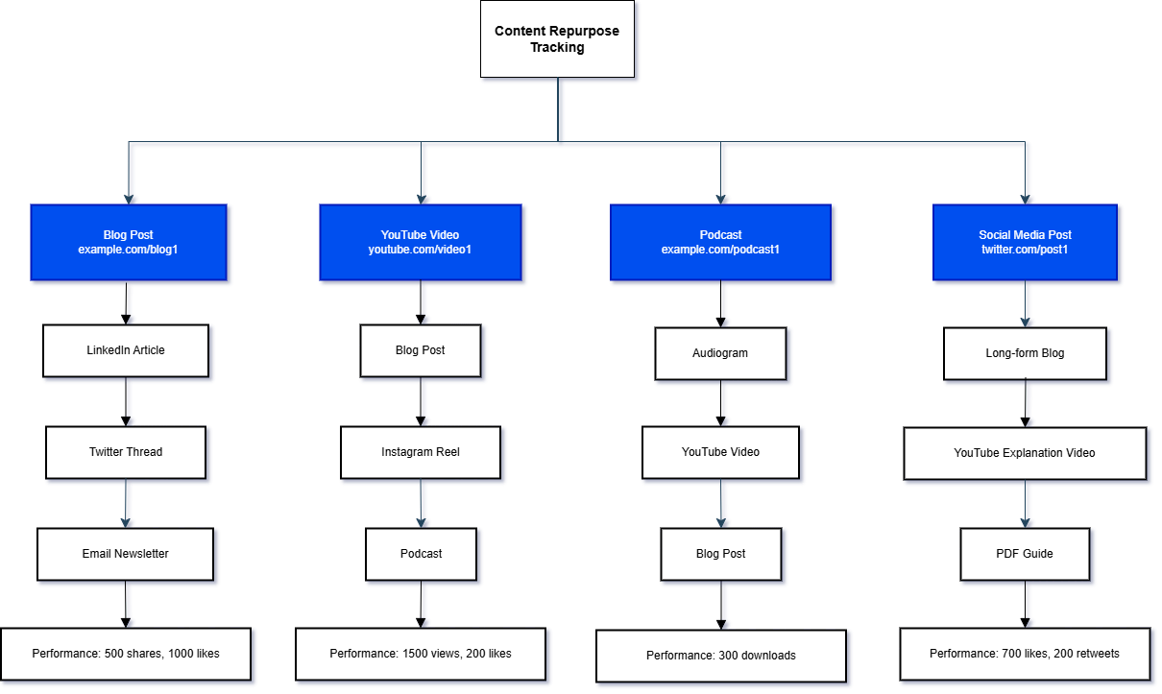
Content Repurpose Tracking (example)
Content Type | Original Content URL | Repurposed Version 1 | Repurposed Version 2 | Repurposed Version 3 | Performance Metrics (Engagement, Views, Shares)
Blog Post | example.com/blog1 | LinkedIn Article | Twitter Thread | Email Newsletter | 500 shares, 1000 likes
YouTube Video | youtube.com/video1 | Blog Post | Instagram Reel | Podcast | 1500 views, 200 likes
Podcast | example.com/podcast1 | Audiogram | YouTube Video | Blog Post | 300 downloads
Social Media Post | twitter.com/post1 | Long-form Blog | YouTube Explanation Video | PDF Guide | 700 likes, 200 retweets

