Pro Blog Setup Blueprint
Detailed Setup, Performance Enhancement, and Monetization Tactics
COPYRIGHT NOTICE
Copyright © 2025 Teo Chin Tee. All rights reserved.
Published by Peter Teo | BloggerSuccessBlueprint.com.
This product and its contents are protected under copyright law.
No part of this publication — including but not limited to text, graphics, templates, designs, videos, audios, or any other content — may be reproduced, distributed, transmitted, stored in a retrieval system, or shared in any form or by any means (electronic, mechanical, photocopying, recording, or otherwise) without the prior written permission of the publisher, except in the case of brief quotations used in reviews, scholarly works, or as otherwise permitted under applicable copyright law.
This product is licensed for individual use only. Unauthorized copying, sharing, distribution, resale, or reproduction is strictly prohibited and constitutes a violation of international copyright laws.
For licensing or permission requests, please contact:
support@bloggersuccessblueprint.com

LEGAL DISCLAIMER
The information contained in this product is provided by BloggerSuccessBlueprint.com, operated by Teo Chin Tee (also known as Peter Teo), for general informational and educational purposes only.
It is not intended to serve as professional, legal, financial, business, health, or medical advice, and should not be relied upon as such.
While every effort has been made to ensure the accuracy and reliability of the information at the time of publication, the author and publisher make no representations or warranties of any kind, express or implied, about the completeness, accuracy, suitability, or availability of the information, products, services, or related graphics contained within this product for any purpose.
Any reliance you place on such information is strictly at your own risk.
Use or misuse of this product and its contents is at your own discretion. The author and publisher disclaim any liability for any loss, damage, injury, or disruption caused — directly or indirectly — by errors, omissions, or reliance on the information provided herein.
The inclusion of links to external websites or third-party tools does not imply endorsement, affiliation, or guarantee of their content or services.
Individual results will vary based on effort, circumstances, and market conditions. No income claims or performance guarantees are made.
By using this product, you acknowledge that you have read, understood, and agreed to these terms and conditions.

Need help or have questions?
Contact: support@bloggersuccessblueprint.com
Visit: www.bloggersuccessblueprint.com

Welcome to The Pro Blog Setup Blueprint—your ultimate guide to taking your blog from beginner to pro!
Whether you're just starting out or looking to scale, this guide will provide you with all the detailed steps you need to set up a high-performance blog, optimize your site, and maximize your monetization potential.
In this blueprint, we’ll walk you through every essential element of building a blog that performs well and earns money. From advanced site setup to performance optimization, and most importantly, strategies for monetization, this guide is designed to ensure your blog not only thrives but also turns a profit.
With actionable tips, pro-level tactics, and step-by-step instructions, you’ll learn how to enhance your blog’s speed, improve its user experience, and implement advanced monetization techniques.
By the end of this guide, you’ll have a fully optimized blog ready to attract visitors and generate revenue.
Get ready to level up your blogging game—let’s dive in!

Step 1: Choose and Register a Domain Name

Why is this important?
Your domain name is like your blog's address on the internet. It’s the first impression people will have of your site and helps set the tone for your brand.
Picking a good domain name is essential because it’s something your audience will remember and return to. A memorable domain name can also improve your blog's credibility and searchability.

What will you do in this step?
In this step, we will choose a unique and brandable domain name, then register it so that you own it.

Step 1.1: Think of a Domain Name
- What to do: Start by brainstorming names for your blog. Think about your blog's purpose and what you want people to know about your content. Is it about food, fashion, sports, or technology? Your domain name should give people a sense of what your blog is about.
- Expert Tip: Choose something that is easy to remember and spell. Avoid using complicated words or long phrases. For example, if your blog is about healthy living, names like HealthyVibes.com or FitLifeWithMe.com would be simple and easy to recall.
- What to avoid:
  - Too long of a name (long names are harder to remember)
  - Numbers and hyphens (they can confuse people when typing it in)
  - Trademarks of other businesses (this can lead to legal issues)

Why is this important?
Picking the right name is crucial because it will be the foundation of your online identity. It represents your blog, and ideally, it will stick in your readers’ minds easily.

Step 1.2: Check Domain Name Availability
- What to do: Now that you have a name in mind, you need to make sure it’s available. You can do this by searching for the domain name using a tool like the one on D9 Hosting.
- How to check:
  - Go to the D9 Hosting website.
  - Look for the Domain Search tool (usually on the homepage).
  - Type in the domain name you want (e.g., HealthyVibes.com) and click Search.
- What happens next:
  - If the domain is available, you’ll see a green checkmark or a message saying "Available!"
  - If it's taken, you’ll get a message saying "Domain not available." Don't worry, though! You can try variations of your name or pick a different domain extension (e.g., .net or .co).

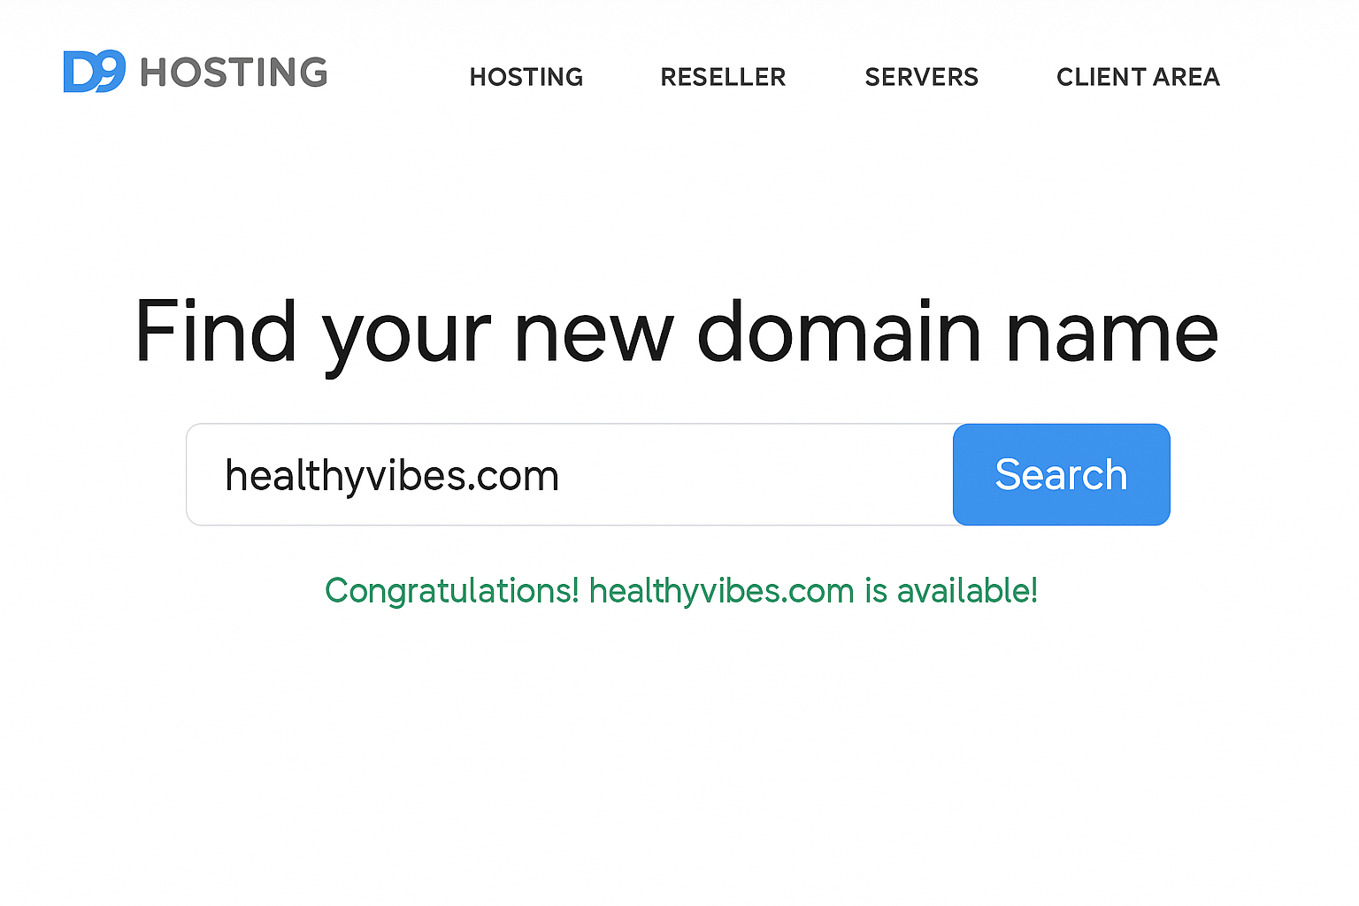

Why is this important?
You can’t have a domain name that someone else is already using, so checking availability ensures your chosen name is yours to keep. It’s like securing your unique space on the internet.

Step 1.3: Register Your Domain Name
- What to do: Once you've found an available domain name, it’s time to register it. Follow these steps:
  - Go back to D9 Hosting and select your domain name.
  - Choose the registration period (usually 1 year, but you can opt for multiple years if you want).
  - Add Domain Privacy Protection (optional but recommended). This hides your personal contact details from the public.
  - Complete the checkout process by entering your payment details.
- What happens next:
  - Once you complete the registration, you’ll receive a confirmation email saying you now own the domain.
  - You’ll also get access to a control panel where you can manage your domain (e.g., update your contact info, renew your domain, or transfer it if needed).

Why is this important?
Registering your domain name officially locks it in for you. It's yours for the duration of the registration, and you’ll need to renew it yearly to keep it.

Step 1.4: Set Up Domain Security
- What to do: Set up Domain Locking to ensure no one can transfer your domain without your permission. This adds an extra layer of security to your domain.
  - Go to your domain management dashboard.
  - Look for the Domain Locking option and turn it on.
- Expert Tip: Use a strong password for your account and enable two-factor authentication if available. This will help prevent unauthorized access.

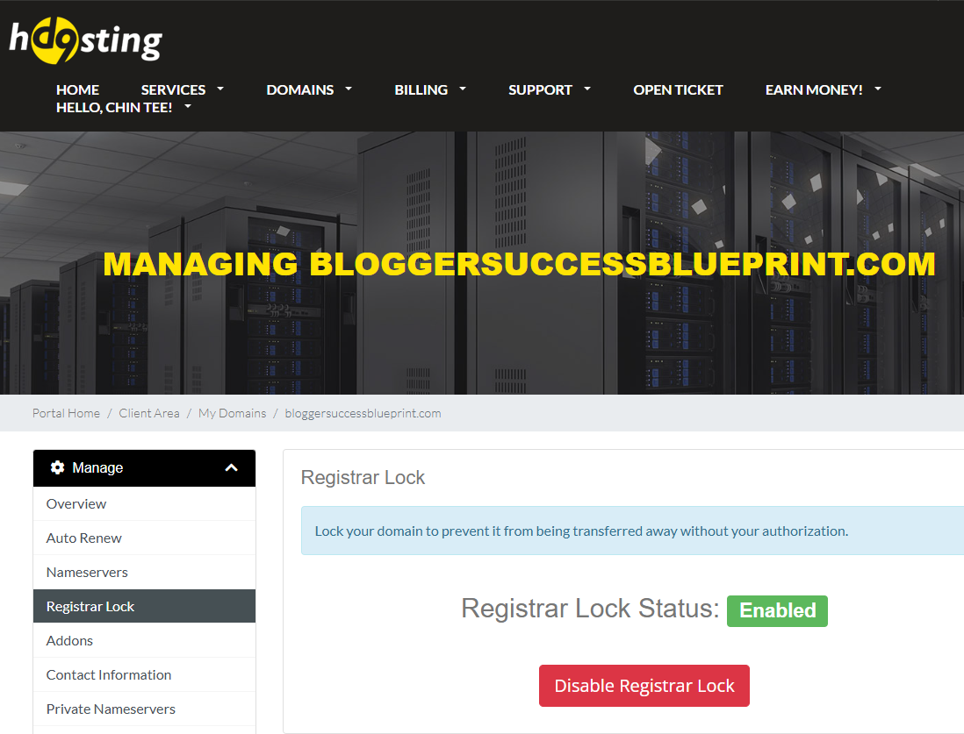

Why is this important?
Securing your domain name is vital to protect your online business from being hijacked. Without security measures, someone could transfer your domain and take control of your blog.

Verification and Self-Assessment
- Verify your domain: Double-check that your domain name is registered and that you received a confirmation email.
- Compare with the Example: Is your domain name simple, short, and memorable? Try to visualize what it will look like on your blog header.
- Self-Check: Do you feel confident that your domain name is unique, easy to remember, and properly secured?

Congratulations! You’ve secured your domain name! 🎉 Now, you’re ready to move on to setting up your hosting.

Step 2: Sign Up for Hosting

Why is this important?
Your hosting provider stores all the files for your website, making it accessible to everyone online. Without hosting, your blog won’t be visible on the internet. By signing up for hosting, you're renting space on the web where your blog will live.

Step 2.1: Choose a Hosting Plan
What to do: When you visit D9 Hosting's website, you’ll see a variety of hosting plans. As a beginner, the Shared Hosting plan is perfect because it’s affordable and user-friendly. Here's how to choose:
  - Go to D9 Hosting's Hosting page.
  - Review the available hosting options and pick Shared Hosting.
  - Pick the D9 One or D9 Max plan for now. You can always upgrade later as your blog grows.
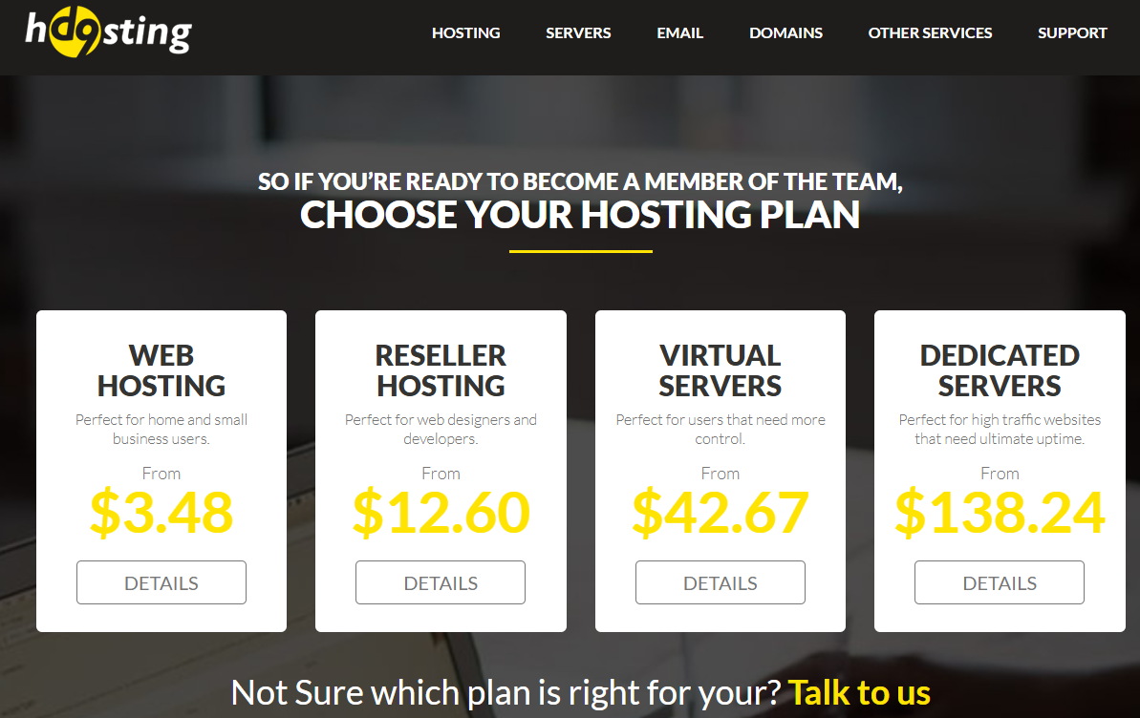
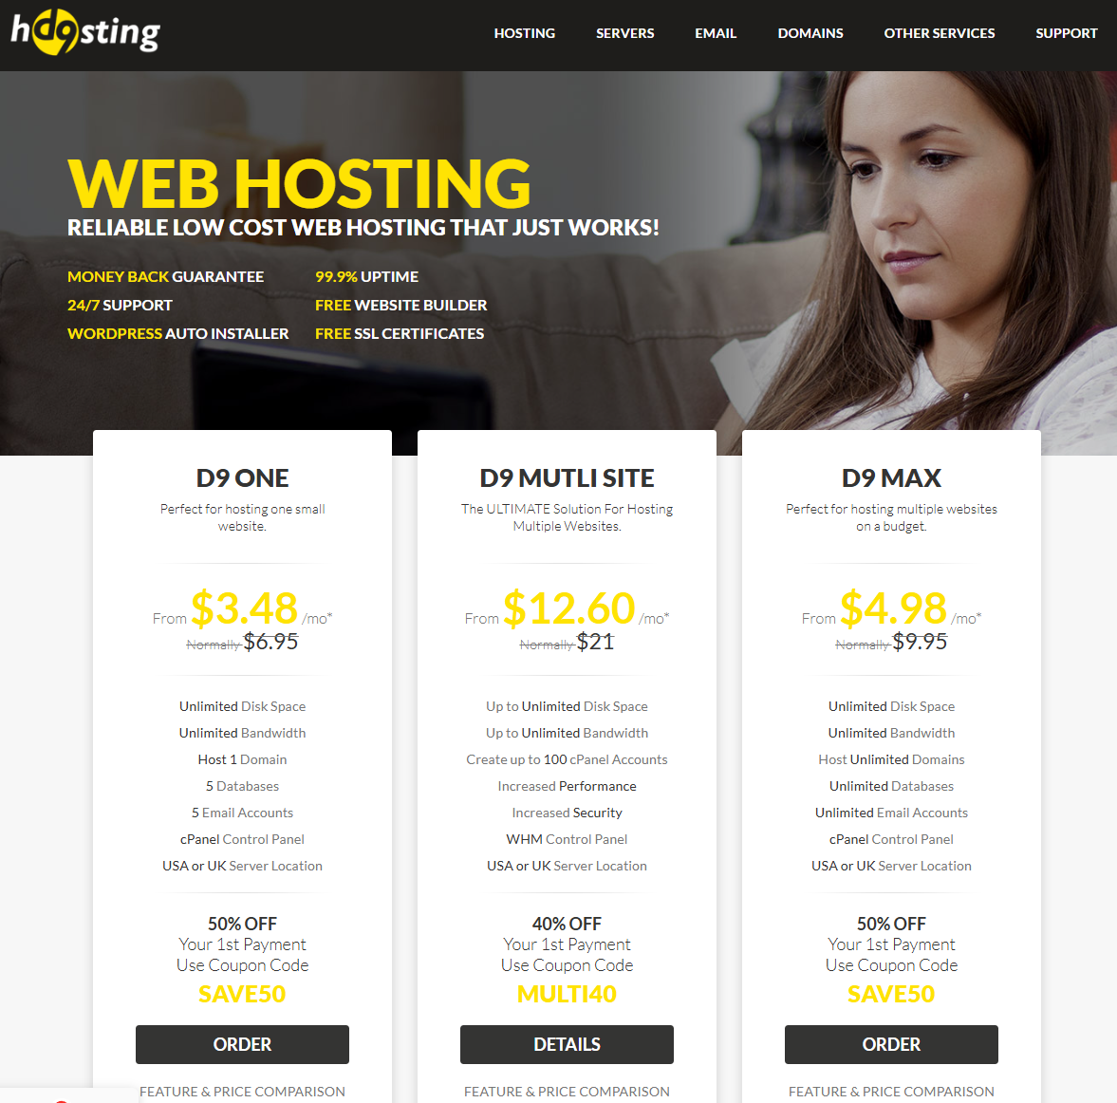

Why is this important?
Shared Hosting is great for beginners because it’s the most cost-effective option. You share server space with other websites, which helps keep the price low. As your blog grows and attracts more traffic, you can always upgrade to a better plan.

Step 2.2: Create Your Hosting Account
- What to do: Once you’ve selected your hosting plan, you’ll need to create an account. Follow these steps:
  - Click on the Sign Up or Get Started button on the hosting plan page.
  - Fill in your personal details, like your name, email address, and password. Make sure to choose a strong password!
  - Enter your billing details (credit card, PayPal, etc.).
  - Review the terms and conditions, and click Create Account or Proceed.

Why is this important?
Setting up an account gives you access to your hosting control panel, where you’ll manage everything related to your website—like email accounts, security settings, and more.

Step 2.3: Link Your Domain to the Hosting Account
- What to do: If you’ve already purchased a domain (as covered in Step 1), you need to connect it to your hosting. Follow these steps:
  - After logging into your D9 Hosting account, go to your Account Dashboard.
  - Look for an option called Manage Domains or Domain Settings.
  - Enter your domain name (the one you registered in Step 1).
  - Find the Nameservers section and update it with the D9 Hosting nameservers (you’ll get these from your hosting provider if you can’t find them).
  - Save your changes.

Why is this important?
Linking your domain to your hosting ensures that when people type in your domain (e.g., www.HealthyVibes.com), they’ll be directed to your blog hosted on D9 Hosting.
Below the example to update Nameserver at NameCheap with D9 Hosting nameservers
Changing the DNS for your domain is a straightforward process that involves the following steps:
1. Log in to your Namecheap account.

2. From the left sidebar, select Domain List and click on the Manage button next to your domain:

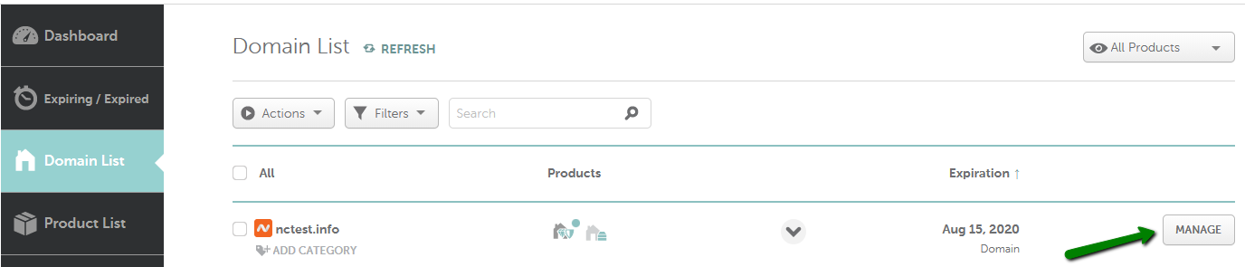

3. In the Nameservers section, select your preferred option from the drop-down menu and click on the green checkmark to save the changes:

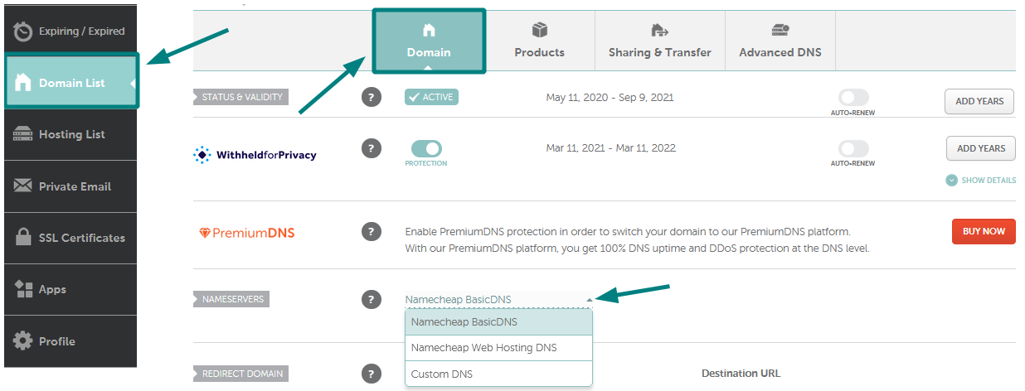

NOTE: Nameservers are part of the Domain Name System (DNS) database that acts as a directory for devices and the IP addresses attached to them. When registering nameservers, an IP address is assigned to them, and unregistered nameservers cannot work correctly with some domains.
- CustomDNS: If you want to point your domain to custom nameservers (for example, your Personal DNS servers or third-party hosting nameservers), fill in the nameservers provided by your hosting or third-party DNS provider and click on the green checkmark to save the changes:
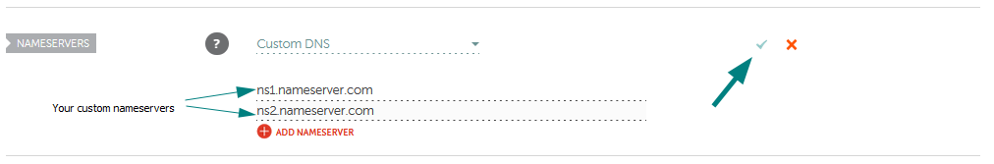
NOTE: Enter the nameservers in the ns1.example.tld format. If you were provided with both the nameservers and IP addresses, only the nameservers should be inserted as custom nameservers.
- For the case of d9, you shall update it as provided by d9: ns5.d9hosting.com, ns6.d9hosting.com.
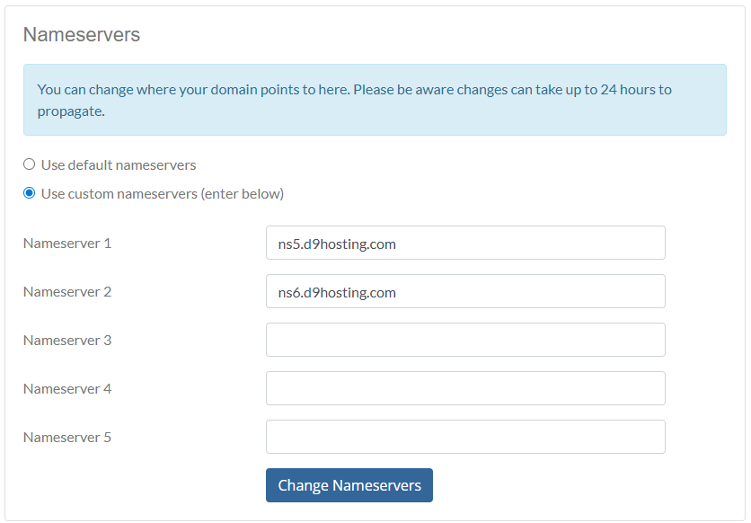

Step 2.4: Set Up Your Hosting Features (Optional)
- What to do: Once your account is active, you’ll be able to access your cPanel, which is your hosting control panel. Here’s what you can do:
  - Create an email address for your blog (e.g., contact@healthyvibes.com). This will make your blog look more professional.
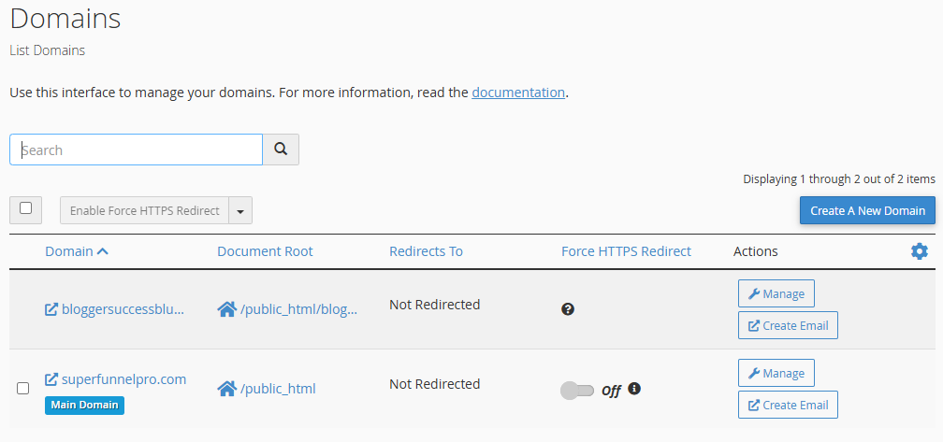
  - Set up an SSL certificate: An SSL certificate ensures your blog is secure. It turns your URL from http:// to https://, which is essential for protecting your visitors' data.
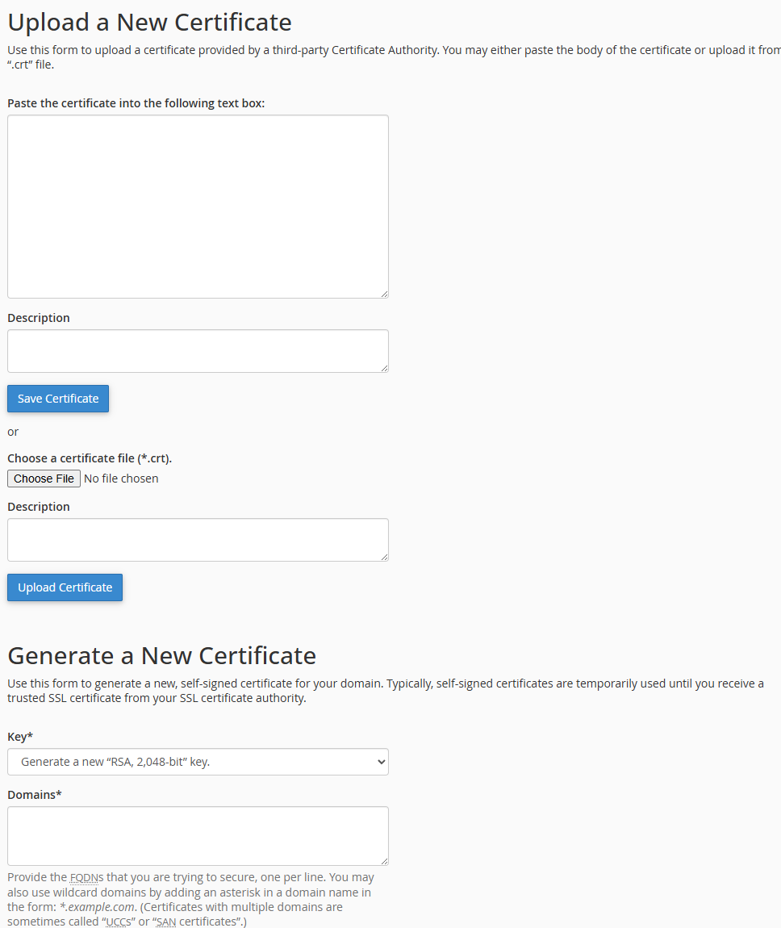
  - Backup your website: Some hosting plans offer automatic backups, which can save your site if something goes wrong.

Why is this important?
Setting up these features helps secure your blog and adds a layer of professionalism, making it easier for visitors to trust your site.

Verification and Self-Assessment
- Verify your hosting account: After following the steps, check if you’ve received a confirmation email from D9 Hosting saying that your account is active.
- Compare with the Example: Look for the cPanel link in your hosting account dashboard. It should be easy to find.
- Self-Check: Do you feel confident about connecting your domain to your hosting account? If not, you can always go back and double-check the steps!

Congratulations! You’ve successfully set up your hosting account and linked it to your domain. Now your blog has a home on the internet!

Step 3: Install WordPress via cPanel
Welcome to Step 3! Now that you've signed up for hosting and connected your domain, it's time to install WordPress. Don’t worry if you’re new to this—I'll break down each part so you can follow along without any confusion.

Step 3.1: Access cPanel
Why this step matters: cPanel is your control panel for managing your website. Think of it as your website’s command center. It’s where you’ll control all the technical stuff, like installing WordPress and setting up emails.
What to do:
- Log in to your D9 Hosting account.
- Once logged in, look for the cPanel option in your account dashboard. It should be easy to find, usually located in the main dashboard or under “Manage” for your hosting plan.
- Click on cPanel. This will take you to a new page where you can manage all aspects of your website.
Pro Tip: If you can’t find cPanel right away, don’t panic! Just look for something like "Website" or "Hosting" in your account, and you should see the cPanel link. It might also be called “Control Panel.”

Step 3.2: Locate Softaculous
Why this step matters: Softaculous is a powerful app that helps you install WordPress with just a few clicks. Instead of manually downloading and uploading files (which can be confusing), Softaculous makes it easy.
What to do:
- Once you’re in cPanel, look for Softaculous Apps Installer. It’s usually located in the Software section.
- Click on Softaculous Apps Installer—this will take you to a page where you can see a list of popular apps that can be installed on your website.
Visual Aid:
Imagine this as a giant “App Store” for your website. WordPress will be one of the top options!

Step 3.3: Install WordPress
Why this step matters: WordPress is the software that will power your blog. It’s like the engine that makes everything run smoothly. Installing WordPress is easy with Softaculous, and once it’s installed, you’ll be able to start customizing and adding content to your site.
What to do:
- In Softaculous, search for WordPress in the search bar or look for it under the “Blogs” section.
- Click on WordPress to open the installation page.
- On the installation page, click the Install Now button. This starts the installation process.
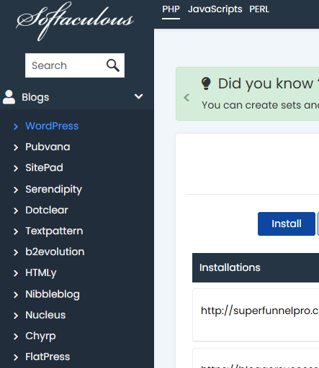

Step 3.4: Choose Your Installation Settings
Why this step matters: Here’s where you’ll set up the basics of your site. You’ll choose whether you want your site to have “http” or “https” (for security), link it to your domain, and set up your login info. These settings are crucial because they determine how your site is accessed and how you’ll log in.
What to do:
- Choose Protocol:
  - You’ll see an option to choose http:// or https://. If your hosting plan offers an SSL certificate (which is a good thing!), choose https://. This adds extra security to your site.
- Select Your Domain:
  - Under the Domain field, make sure the dropdown shows your newly registered domain (e.g., yourdomain.com). This ensures your WordPress site is connected to the correct domain.
- In Directory:
  - Leave this field blank if you want your blog to be the main website (i.e., at www.yourdomain.com).
  - If you want to install WordPress in a subfolder (e.g., www.yourdomain.com/blog), you can enter “blog” or any name here.
- Admin Username and Password:
  - Create a strong username and password for your WordPress login. Make sure it’s something memorable but secure. Write these down somewhere safe, because you’ll need them to log into your WordPress dashboard.
- Site Name and Description:
  - Site Name: This is the title of your blog. It’s what visitors will see when they land on your site.
  - Site Description: Write a short description of what your blog is about. This will help visitors understand the focus of your site.
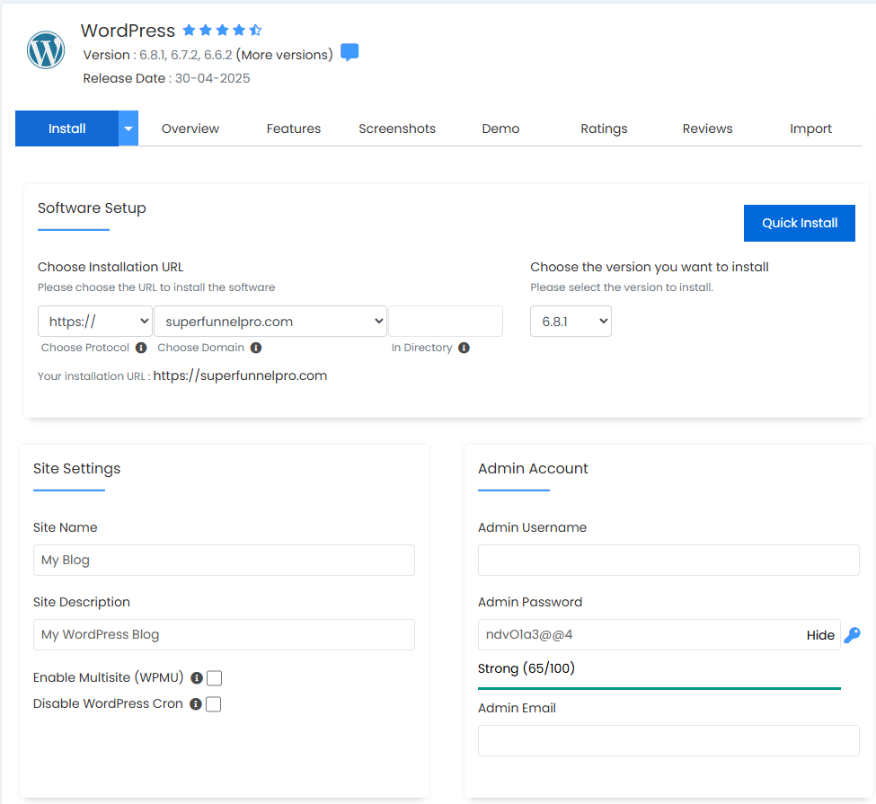

Step 3.5: Complete Installation
Why this step matters: Once the settings are configured, this is the final step to make your WordPress site go live! After you hit "Install," Softaculous takes care of the technical details, and you’re all set.
What to do:
- After filling in the settings, click Install. Softaculous will begin the process of installing WordPress.
- Wait a few minutes for the process to complete. Don’t worry if it takes a bit of time; it’s setting everything up for you in the background.

Step 3.6: Access Your WordPress Site
Why this step matters: This is the moment you’ve been waiting for—your WordPress site is live, and you can start customizing it to make it your own!
What to do:
- Once the installation is complete, you’ll see a success message with a link to your new WordPress site.
- To log in to your WordPress dashboard, go to yourdomain.com/wp-admin (replace "yourdomain.com" with your actual domain).
- Use the admin username and password you created earlier to log in to the WordPress admin panel.

Recap and Self-Check
- Have you logged into cPanel successfully? ✅
- Did you locate Softaculous in your cPanel? ✅
- Did you follow the steps to install WordPress and choose the correct settings (protocol, domain, admin username)? ✅
- Can you log into your WordPress dashboard using the credentials you created? ✅
If everything looks good, you’re ready to move on to the next step! If you’re unsure about any part, feel free to ask for clarification. I’m here to help!
Pro Tip: If you don’t see your site immediately after installing WordPress, give it a minute. Sometimes, it can take a few moments for everything to fully load.

Step 4: Log Into Your WordPress Dashboard
Welcome to Step 4! You're getting closer to making your blog your own. Now that WordPress is installed, we’re going to dive into your WordPress Dashboard. This is where the magic happens! It’s where you’ll manage your blog’s posts, pages, themes, and everything else. Let’s make sure you feel comfortable and confident navigating it.

Step 4.1: Access WordPress Login
Why this step matters: To start managing your blog, you need to log into WordPress. The dashboard is your control center, where all your blog’s settings and content are stored. This is where you’ll do everything from writing blog posts to customizing your site’s design.
What to do:
- Open your web browser (like Chrome or Safari).
- In the address bar, type www.yourdomain.com/wp-admin (replace "yourdomain.com" with your actual domain name).
Example: If your domain is myawesomeblog.com, you would type myawesomeblog.com/wp-admin.
Important: The /wp-admin part is essential. It’s the special URL that leads you to your WordPress admin area.
- Hit Enter to go to the login page. This is the page where you’ll type in the username and password you created earlier during the WordPress installation process.
- Enter your admin username and password, then click the Log In button.
Tip: Be sure to type your login details carefully! If you forget them, you can reset them through the "Lost your password?" link on the login page.
Pro Tip: Bookmark the login page so you can easily return to it later! This will save you time whenever you want to update or manage your blog.

Step 4.2: Familiarize Yourself with the Dashboard
Why this step matters: The WordPress Dashboard might look a bit overwhelming at first, but it’s actually simple once you get used to it. Knowing where everything is will make your blogging journey much smoother, and you’ll be able to navigate through the different sections quickly.
What to do:
- Once you’re logged in, you’ll land on the WordPress Dashboard. You’ll see a lot of options, but don’t worry—we’ll break them down for you.
- Here’s what you’ll see on the left-hand side of the screen (this is called the Navigation Menu):
  - Posts: This is where you’ll create, edit, and manage your blog posts. Whenever you write a new article, it will appear here.
  - Pages: This section lets you create static pages for your website, like your About page or Contact page.
  - Appearance: This is where you can choose and customize your blog theme (how your site looks). You can also add widgets and adjust your site’s design.
  - Plugins: This is where you can add new features to your site. You’ll install plugins here for things like SEO, security, and contact forms.
  - Settings: Here’s where you can adjust important settings for your website, like your site’s title, tagline, time zone, and more.
- Visual Aid: Imagine this menu as the controls of a car—each section helps you steer your blog in the right direction!
- The Main Area of the dashboard shows you notifications about your site’s activity, such as new comments, pending updates, or stats about your posts.
- The Top Bar shows important site information and quick links, like logging out, viewing your site, and accessing your profile.
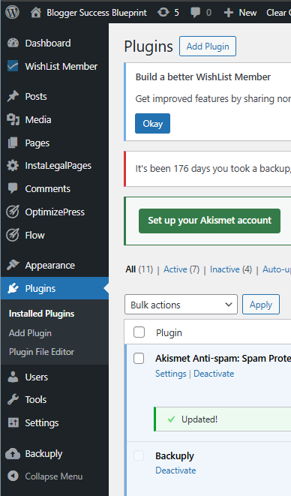
Pro Tip: Take a few minutes to click around each section. Familiarizing yourself with the layout now will save you time later!

Step 4.3: Adjust Your Profile
Why this step matters: Your WordPress profile helps you manage your personal settings, such as updating your password and adding a bio. This is your personal space within WordPress, so let’s make sure it reflects who you are.
What to do:
- On the left side of the screen, find and click on Users in the navigation menu. Then select Your Profile.
- Update Your Personal Information:
  - You’ll see options to update your name, nickname, and display name. This is how your name will appear on your posts and pages. Feel free to adjust it if you want it to show your full name or a different name.
- Change Your Password:
  - If you want to change your password, scroll down to the Account Management section, where you can click Generate Password. A strong password is important for your site’s security, so be sure to choose something secure.
- Write Your Bio:
  - Scroll down a bit more to find the Biographical Info section. Here, you can write a brief introduction about yourself. This could be a short paragraph about who you are, what your blog is about, or anything you’d like visitors to know about you.
- When you’re done making changes, scroll down and click Update Profile to save your changes.
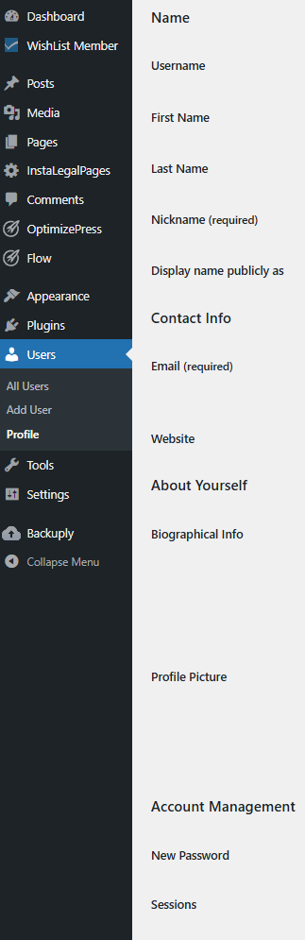
Pro Tip: A good bio can make your blog feel more personal and help your readers connect with you. You could even add a fun fact or something unique about yourself to stand out!

Recap and Self-Check
- Did you successfully log in to your WordPress dashboard?
✅ Double-check by going to www.yourdomain.com/wp-admin and logging in.
- Have you familiarized yourself with the main sections of the dashboard?
✅ Take a moment to click around the Posts, Pages, Appearance, and Plugins sections to see where everything is.
- Have you updated your profile with your personal info, password, and bio?
✅ If you’ve made changes, don’t forget to click Update Profile at the bottom.

Congratulations!
You’ve successfully logged into your WordPress dashboard and adjusted your profile. You're now one step closer to making your blog truly yours! How do you feel?

Step 5: Pick a Theme for Your Blog
Welcome to Step 5! Now that you’ve logged into your WordPress dashboard, it’s time to make your blog look amazing. In this step, we’re going to choose a theme for your blog. Think of a theme as your blog’s outfit—it’s how your site looks to visitors. A good theme helps visitors feel comfortable, understand what your blog is about, and navigate it easily.

Step 5.1: Go to Appearance > Themes
Why this step matters: The Appearance section is where you’ll manage everything related to your blog’s design. Themes are the foundation of your blog’s look and feel, so it’s essential to pick one that matches your style and your blog's purpose.
What to do:
- In your WordPress Dashboard, on the left-hand side, find and click on Appearance.
- Under Appearance, click on Themes.
This will take you to the page where you can browse, install, and activate themes for your site.
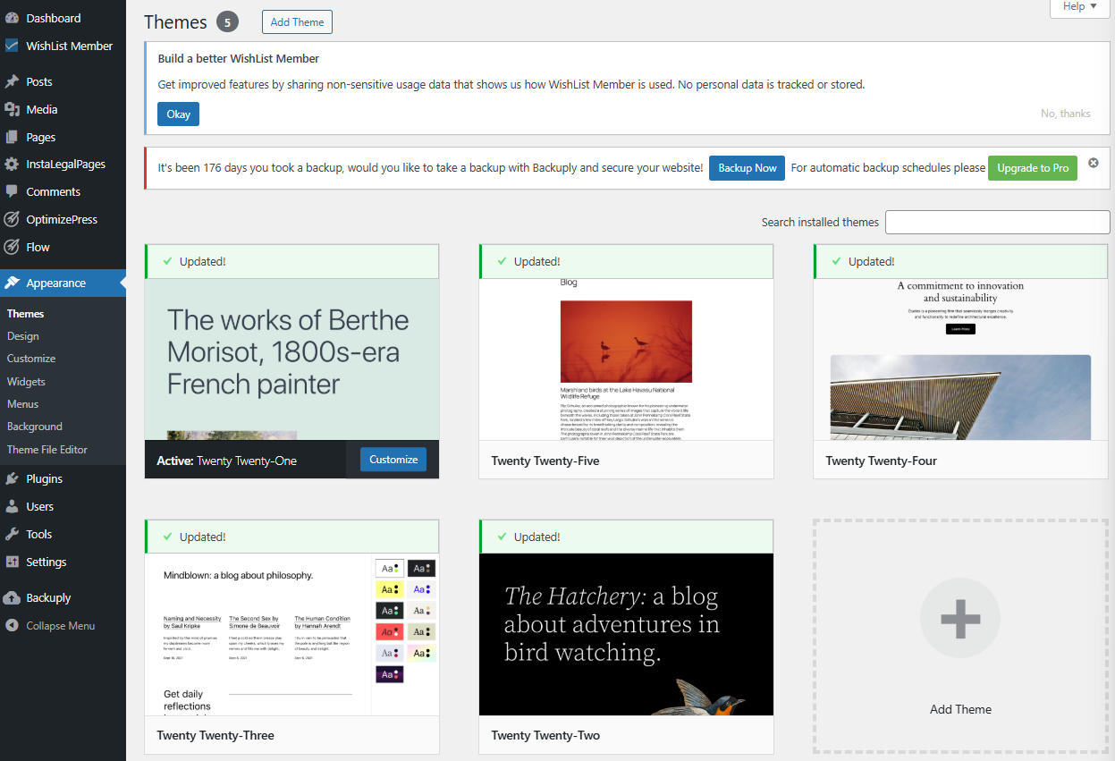
Pro Tip: This section also lets you change your theme at any time, so don’t worry if you’re not 100% sure about your first choice. You can always try another theme later!

Step 5.2: Browse Free Themes or Search for Premium Themes
Why this step matters: WordPress gives you access to a ton of free themes. These are perfect if you’re just starting and want something simple. You can also choose premium (paid) themes if you want more customization options and a more professional look.
What to do:
- On the Themes page, you’ll see a section called Add New. Click on it to browse themes.
- You can search for themes using keywords that match your blog’s niche or style. For example, if your blog is about travel, you might search for “travel blog theme” to see themes that fit your needs.
  - Free themes: These are available right away and easy to install. They’re perfect if you’re just starting and need something simple.
  - Premium themes: These often come with more customization options and support. If you’re willing to pay for extra features, you can search for premium themes outside of WordPress (e.g., on theme marketplaces like ThemeForest or Elegant Themes).
- Browse the themes that catch your eye. You can click on any theme to preview it before deciding if you like it.
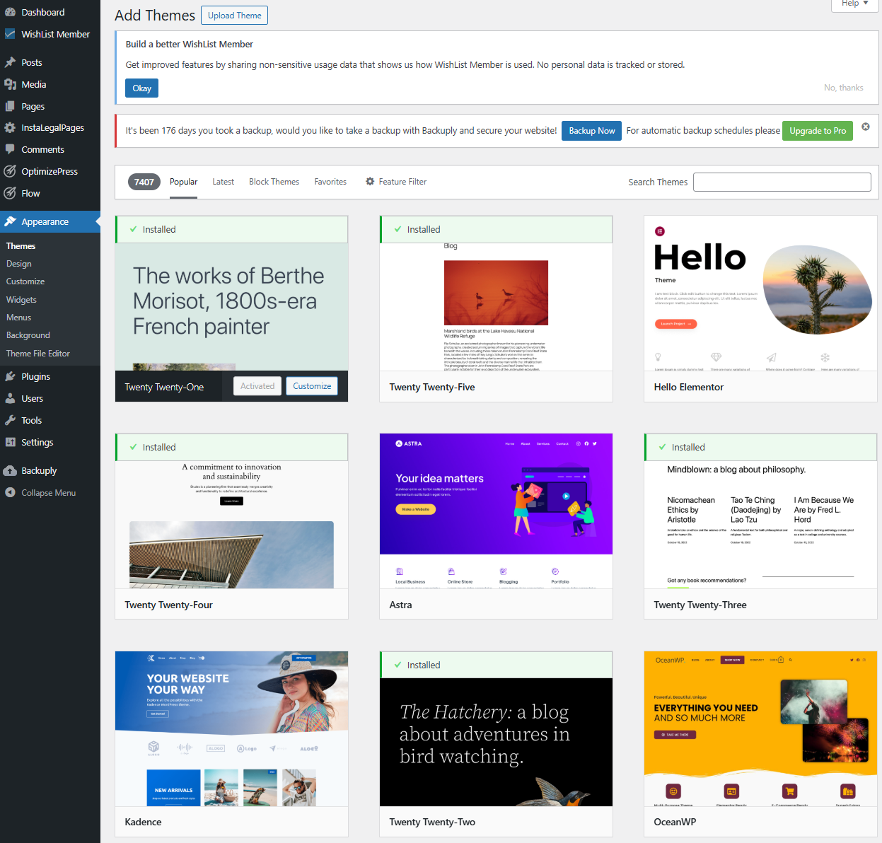
Pro Tip: Look for themes that are responsive, which means they’ll look great on both desktop and mobile devices. In today’s world, many people browse the web on their phones, so mobile-friendliness is essential!

Step 5.3: Install and Activate a Theme
Why this step matters: Installing and activating a theme is how you make it live on your site. After you activate the theme, it’s ready for you to start customizing.
What to do:
- Once you find a theme you like, click the Install button that appears when you hover over it.
- After the theme is installed, click Activate. This will apply the theme to your website, and your blog will now have its new look!
Pro Tip: If you’re unsure about the theme, you can always preview it before activating. WordPress lets you see how your site will look with the theme installed, so you can check if it fits your style before making it official.

Step 5.4: Customize Your Theme
Why this step matters: Customizing your theme is where the fun happens! This step lets you adjust your blog’s colors, fonts, logo, and layout to make it truly yours. You’ll want your blog to have a unique look that fits your personal style or the theme of your blog.
What to do:
- After activating your theme, go to Appearance in the left sidebar, and click Customize. This opens the Theme Customizer, where you can tweak everything.
- In the customizer, you’ll find several options:
  - Site Identity: Upload your blog’s logo (or skip it if you don’t have one yet) and set your site title and tagline (this appears on your homepage and helps tell visitors what your blog is about).
  - Colors: Change the primary color of your blog to match your style. You can pick a color scheme that fits your theme (e.g., a bright, fun color for a travel blog or a more muted, professional color for a business blog).
  - Fonts: Choose fonts that are easy to read and fit your blog’s personality. You can adjust the size, style, and color of text on your pages.
  - Menus: Set up your navigation menus so visitors can easily find your most important pages (like your About page, Contact page, and Blog).
  - Widgets: Add extra features to your sidebar, like a search bar, recent posts, or a social media feed.
- Once you’re happy with your changes, click Publish to save them.
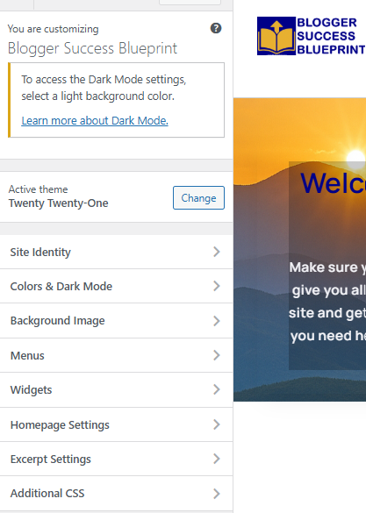
Pro Tip: Customize your theme slowly. It’s okay to take your time and adjust things one step at a time. This way, you’ll be happy with the final look!

Recap and Self-Check
- Did you find and install a theme that suits your blog’s style?
✅ Go to Appearance > Themes, and check if your selected theme is installed and activated.
- Did you customize your theme (colors, fonts, logo, etc.) to match your style?
✅ Go to Appearance > Customize, and confirm that you’ve made the desired changes to personalize your site.
- Are you happy with how your blog looks so far?
✅ If you feel satisfied, congratulations! If not, don’t hesitate to go back and tweak the design. WordPress makes it easy to adjust the look anytime.
Fantastic job!
You’ve just given your blog its first visual identity. You’re making great progress! Let me know how you’re feeling, and if you're ready, we can move on to the next step—or feel free to ask if you need any clarification!
Do you like this personality?

Step 6: Create Essential Pages for Your Blog
Welcome to Step 6! Now that your blog looks great, it’s time to make sure you have the important pages that every blog needs. Think of these pages like the foundation of your blog’s home—they help visitors understand who you are, how they can contact you, and provide the legal details for your site.
These pages will make your blog feel complete, professional, and trustworthy to your readers.

Step 6.1: Add Essential Pages
Why this step matters: These pages give your blog the structure it needs. Each of them serves a different, but important purpose. Without them, your blog may feel incomplete or untrustworthy. Plus, some of these pages are legally required, especially if you plan to make money from your blog.
What to do:
- In your WordPress Dashboard, click on Pages on the left-hand side.
- Then click Add New to create a new page.
Now, let's break down the pages you’ll need to create:

Step 6.2: Create an About Page
Why this step matters: The About Page is where you introduce yourself to your readers. It tells them who you are, what your blog is about, and why they should stick around. It builds trust and connection with your audience.
What to do:
- Title your page: Type “About” in the page title field.
- Write your introduction:
  - Introduce yourself. Tell your readers who you are and what inspired you to start this blog. You might include your hobbies, interests, or professional background.
  - Explain what your blog is about. Describe the type of content visitors will find on your blog (e.g., travel tips, tech reviews, healthy recipes).
  - Let your readers know why they should follow your blog. This could be because you offer expert advice, entertaining stories, or helpful resources.
- When you’re done, click Publish to make your About Page live.
Pro Tip: Don’t forget to make it personal and relatable. The more authentic you are, the more your readers will connect with you!

Step 6.3: Create a Contact Page
Why this step matters: The Contact Page gives visitors a way to reach out to you. Whether they have questions, business inquiries, or feedback, this page is the place for them to contact you directly.
What to do:
- Title your page: Type “Contact” in the page title field.
- Provide contact information:
  - You can list your email address or a phone number (if you’re comfortable sharing it).
  - If you prefer to have visitors send a message through a contact form, you can use a plugin like Contact Form 7 to easily add one.
- To add a form:
  - Install Contact Form 7 by going to Plugins > Add New, searching for it, and clicking Install and Activate.
  - After activation, go to Contact > Add New, create a form, and then copy the form shortcode.
  - Paste the shortcode into your Contact page where you want the form to appear.
- When you’re finished, click Publish to make your Contact Page live.
Pro Tip: If you’re using a contact form, make sure to check the settings and test the form to ensure it works properly.

Step 6.4: Create Privacy Policy and Terms of Service Pages
Why this step matters: Privacy Policy and Terms of Service pages are legally required for many blogs, especially those with affiliate links, ads, or any user data collection (like email signups). These pages inform your visitors about how you protect their privacy and what they can expect from using your site.
What to do:
- Create a Privacy Policy Page:
  - Title the page “Privacy Policy.”
  - Write a clear explanation about how you handle visitors’ personal information, cookies, and third-party services (such as email marketing or ads).
  - You can use online tools like Privacy Policy Generator (search for it) to create a policy specific to your blog.
- Create a Terms of Service Page:
  - Title the page “Terms of Service.”
  - This page should outline the rules and guidelines for using your site, such as prohibited behaviors, disclaimers, and limitations of liability.
  - You can also find Terms of Service generators online to make this easier.
- After creating both pages, click Publish to make them live.
Pro Tip: If you plan to run ads, sell products, or collect emails, it’s best to make sure your Privacy Policy is clear and up to date to stay compliant with regulations like GDPR.

Step 6.5: Create a Blog Page
Why this step matters: Your Blog Page is where all your posts will be listed for visitors to read. This is a central page where people can find all of your blog articles in one place.
What to do:
- Create the page:
  - Title the page “Blog.”
  - You don’t need to add content to this page yet—just leave it blank for now.
- Set the Blog Page as Your Homepage:
  - After creating the page, go to Settings > Reading.
  - Under Your homepage displays, choose A static page.
  - In the Homepage dropdown, select the page you just created for your blog.
  - In the Posts page dropdown, select the “Blog” page.
  - Click Save Changes.
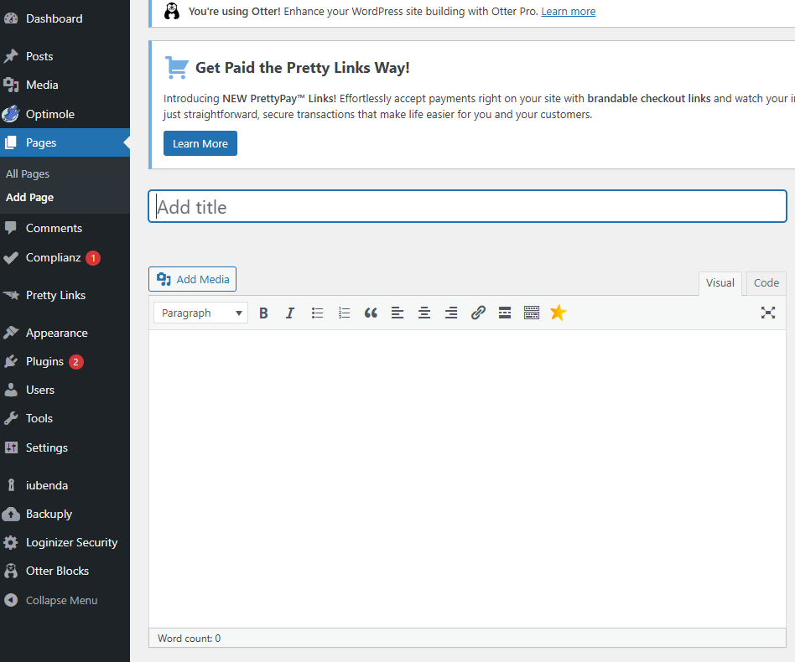
Pro Tip: Setting up a dedicated Blog Page helps keep your website organized, making it easier for visitors to find your posts.

Recap and Self-Check
- Did you create an About page with an introduction to yourself and your blog?
✅ Go to Pages > All Pages and check if your About page is listed.
- Did you create a Contact page with your contact info or a contact form?
✅ Check that your Contact page is set up and live. Test the contact form if you added one!
- Did you create a Privacy Policy and Terms of Service page?
✅ Ensure these pages are live and cover the necessary legal points.
- Did you set up a dedicated Blog page to display your posts?
✅ Visit your site’s homepage and check if the blog posts are appearing correctly.
Great job! You’ve just set up the essential pages for your blog. Now your blog looks more professional and ready for visitors. How are you feeling? Ready to move on to the next step, or do you need further clarification on any part? Let me know!

Step 7: Write Your First Blog Post
Congratulations on reaching Step 7! This is the exciting part: you’re going to write and publish your very first blog post. Your blog is now up and running, and it’s time to fill it with amazing content that your readers will love. Let’s walk through this step by step, so you can confidently create a post that shines!

Want to level up your writing?
For step-by-step guidance on creating blog posts that attract attention and keep readers engaged, check out these resources inside your Member’s Area:
- Blogger’s Success Toolkit → Chapter 2: Crafting Sticky Blog Headlines and Chapters 3–4: Content Creation Guidance
Learn the proven frameworks for writing irresistible titles and creating content that connects.
- 30-Day Blogging Authority Challenge → Daily Prompts for Consistent Writing & Publishing
Turn knowledge into habit. The toolkit shows you the principles, while the Challenge keeps you accountable with daily action.
Use them together: start with the Toolkit to master the “why” and “how,” then lean on the Challenge to build momentum and consistency.

Step 7.1: Go to Posts > Add New
Why this step matters: This is where you start creating content! The Posts section in WordPress is where all your blog posts will live. By clicking Add New, you’re starting a fresh post that you can work on.
What to do:
- In your WordPress Dashboard, find and click on Posts in the left-hand menu.
- Click on the Add New button. This will open a new page where you can begin writing your blog post.
Pro Tip: Think of this as opening a blank page in a notebook, but with tons of cool tools (like formatting and images) ready for you to use!

Step 7.2: Enter Your Post’s Title and Start Writing the Content
Why this step matters: The title is the first thing your readers will see, so it needs to grab their attention. The content is where you’ll share your ideas, advice, or stories. This step is your chance to express yourself and deliver value to your readers.
What to do:
- Title your post: At the top of the page, there’s a field labeled Add Title. This is where you’ll type in the title of your blog post. Make sure it’s clear, catchy, and tells readers what the post is about.
Example: "10 Easy Ways to Boost Your Productivity" or "A Beginner's Guide to Starting a Blog".
- Start writing your content: Below the title, there’s a large space where you can start typing your blog post. This is your visual editor, and it works like a word processor (like Google Docs or Microsoft Word).
  - Type your introduction to grab the reader’s attention.
  - Add body paragraphs to explain your main ideas or share your tips, stories, or advice.
Pro Tip: Start with an engaging introduction to hook your readers. Make it interesting, so they’re excited to keep reading. If you’re writing a list (like “10 Tips…”), make sure to break each tip into its own section with clear headings.

Step 7.3: Format Your Post
Why this step matters: Formatting makes your blog post easier to read and more visually appealing. Using headings, bullet points, and images helps organize your content and keeps readers engaged.
What to do:
- Add headings:
  - Highlight the text you want to turn into a heading.
  - In the toolbar at the top of the editor, click on the Paragraph dropdown (it says "Paragraph" by default) and choose Heading 1, Heading 2, or Heading 3, depending on the level of importance.
  - Use Headings for sections like "Introduction", "Main Content", or "Conclusion" to break up your post and make it easier to skim.
- Add paragraphs:
  - Write in short paragraphs (2-4 lines) to make it easier to read. No one likes big blocks of text!
- Add images and links:
  - To make your post more interesting, add images. To do this, click the Add Media button above the editor, then upload your image. Make sure the image is relevant to the topic and not too large.
  - Add links to other helpful pages, articles, or resources. For example, link to related blog posts or external sites that back up your information.
Pro Tip: Use bulleted or numbered lists to make your content scannable. Most readers skim through articles, so breaking things into easy-to-digest points helps keep them engaged.

Step 7.4: Add Categories and Tags
Why this step matters: Categories and tags are important for organizing your content and improving SEO (search engine optimization). Categories help group similar topics together, while tags are like keywords that describe the specific details of your post.
What to do:
- Add a category: On the right-hand side of your screen, you’ll see a section called Categories. You can either choose an existing category or create a new one.
Example categories might be "Blogging Tips," "Productivity," or "Travel Guides."
- Add tags: Below Categories, you’ll see the Tags section. Tags are like keywords that describe your post.
Example tags might include “time management,” “writing tips,” or “beginner blogging.” These will help your readers find more related content on your site.
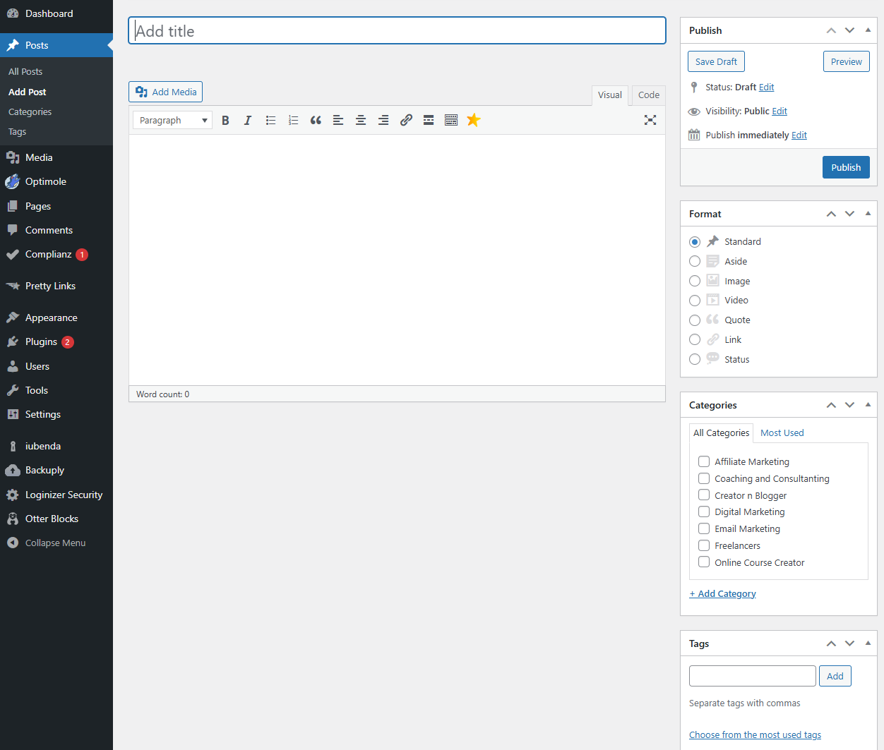
Pro Tip: Choose relevant categories and tags to help your readers find similar posts easily. Use only a few tags per post—too many can be confusing!

Step 7.5: Publish Your Post
Why this step matters: Publishing is the moment when your hard work is shared with the world! Once you click Publish, your post will go live, and everyone can read it.
What to do:
- When you’re ready, look at the top-right corner of your screen and click the Publish button.
You might see the word Publish or Schedule (if you want to post later). If you're ready now, click Publish.
- Once published, your post will go live on your blog! You can then view it by clicking on View Post.
Pro Tip: Before publishing, always proofread your post for spelling or grammar mistakes. Reading it out loud can help catch things that sound off or unclear.

Recap and Self-Check
- Did you choose a catchy and clear title for your blog post?
✅ Make sure your title reflects the content of your post and is interesting enough to grab readers' attention.
- Did you write your content and break it into readable sections with headings?
✅ Use headings, short paragraphs, and bullet points to organize your content.
- Did you add images and links to make your post more engaging?
✅ Use images to make your post visually appealing and add links to related articles or resources.
- Did you add categories and tags to organize your content for readers?
✅ Choose a category and add tags that describe your post’s main topics.
- Did you publish your post and view it live?
✅ Go to your blog and check that your post looks great and is accessible to readers.
Well done! You’ve just written and published your first blog post. How awesome is that? Now, your blog is truly coming to life. Let me know how you’re feeling, and if you're ready to move on to the next step, or if you'd like to fine-tune anything before we proceed.

Step 8: Set Up Navigation Menus
Welcome to Step 8! Now that your blog has some awesome content, it’s time to make it easier for visitors to navigate. A navigation menu is like a map for your website—it helps users find important pages and posts quickly. In this step, we’ll create a menu that will guide your visitors to your most important pages.

Step 8.1: Create a Menu
Why this step matters: Creating a menu is essential because it provides your readers with easy access to important parts of your blog, like your About page, Contact page, and Blog page. It helps them navigate your website with ease, making their experience better.
What to do:
- In your WordPress Dashboard, go to Appearance in the left-hand menu.
- Click on Menus. This will take you to the menu editor page where you can create and manage your menus.
- At the top of the page, click Create a New Menu. You will be prompted to give your menu a name.
  - You can name it Main Menu or something similar, to keep things simple.
- Once you’ve named your menu, click Create Menu. Now you’re ready to add pages and categories to it!
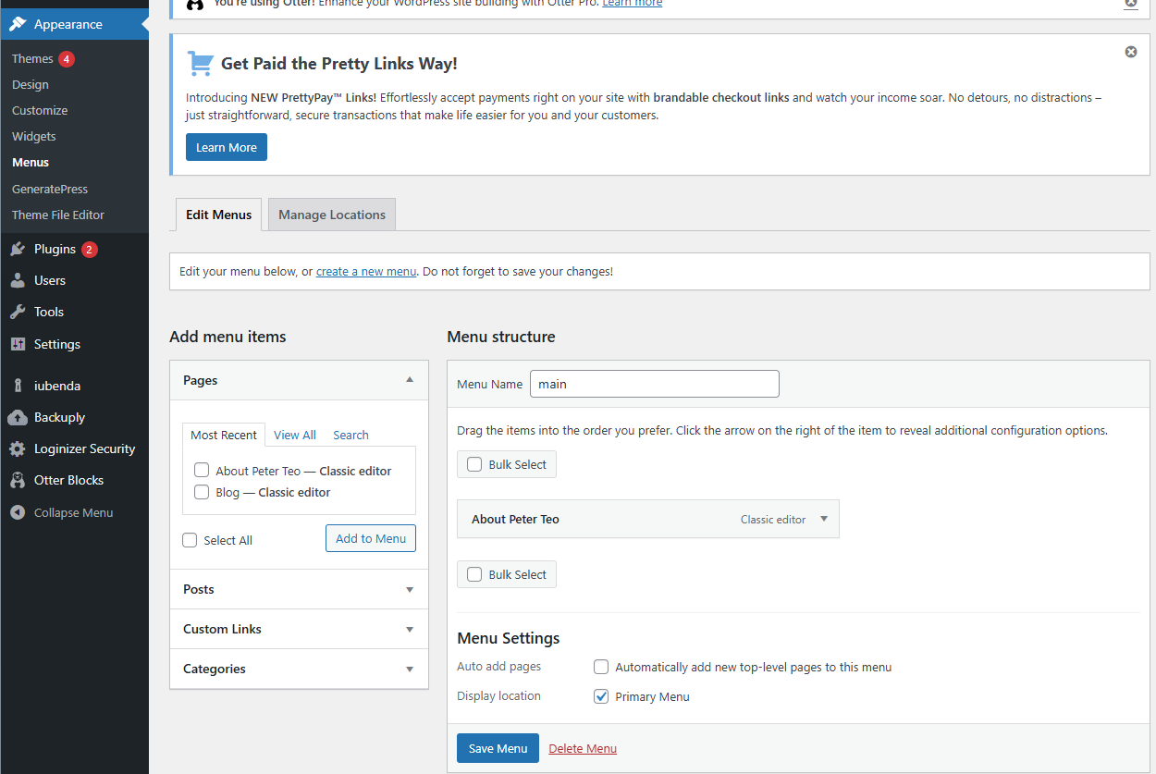

Step 8.2: Add Pages and Categories
Why this step matters: By adding important pages and categories to your menu, you make it easy for visitors to find what they’re looking for. Categories allow visitors to quickly browse content related to a specific topic, while pages give them access to essential information about you and your blog.
What to do:
- Add pages to your menu: On the left side, you’ll see a list of your Pages. Check the boxes next to the pages you want to add to your menu, such as:
  - About: Introduces you and your blog.
  - Contact: Lets visitors reach out to you.
  - Blog: Displays all of your blog posts.
- After checking the boxes, click the Add to Menu button. The selected pages will appear on the right side in your menu editor.
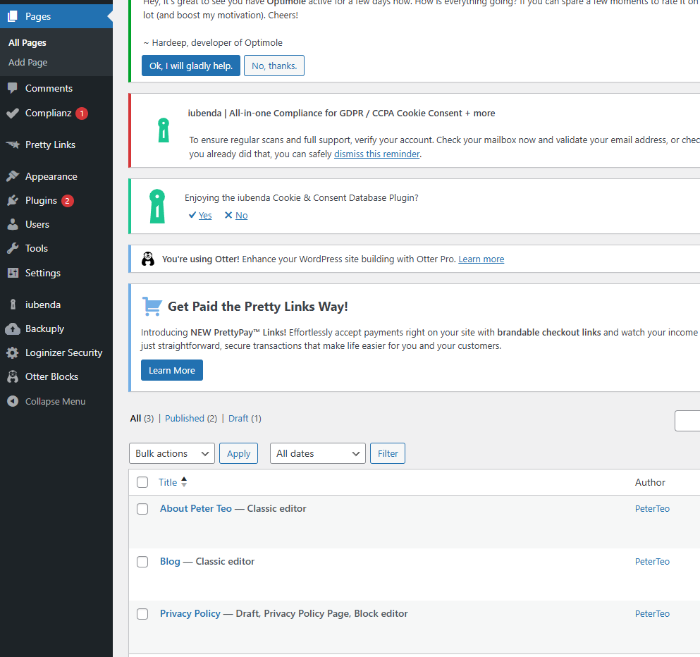
- Add categories to your menu (optional):
  - If you have categories set up (like "Travel," "Productivity," or "Tech Tips"), you can also add them to the menu.
  - In the left column, click on Posts>> Categories and check the boxes next to the categories you want to add to the menu.
  - Click Add to Menu.
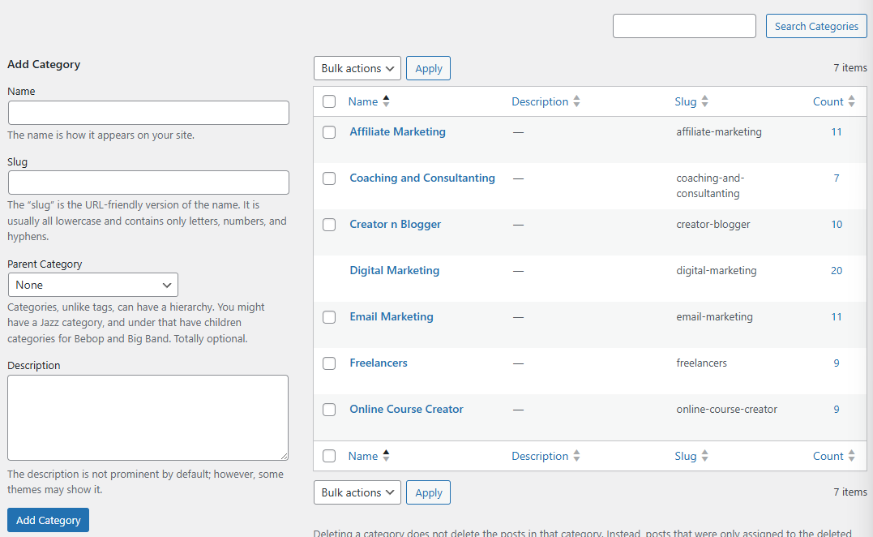
Pro Tip: Adding categories is a great way to help your visitors find content they’re interested in, based on topics. Don’t overdo it—stick to the most relevant categories to avoid cluttering your menu.

Step 8.3: Assign the Menu to a Location
Why this step matters: After creating your menu, you need to decide where it will appear on your site. WordPress gives you different locations, such as the Header (top of the page), Footer (bottom of the page), or Sidebar (side of the page). Choosing the right location ensures that your visitors can easily find the menu no matter where they are on your site.
What to do:
- Scroll down to the Menu Settings section.
- You’ll see different options for where your menu can appear. Most themes have locations like:
  - Primary Menu (Header): This is the main menu at the top of your site.
  - Footer Menu: This is a menu that appears at the bottom of your website.
  - Sidebar Menu: This is a menu that can appear on the side of your website.
- Select a location for your menu. For most websites, it’s best to choose the Primary Menu (Header) so that visitors can easily see it when they first arrive.
- After selecting the location, click Save Menu to save your changes.

Step 8.4: View and Test Your Menu
Why this step matters: Once you’ve added your menu to your site, you want to make sure it’s working properly. You need to check that all the links are clickable and lead to the right pages. This ensures that your readers can easily find the content they want.
What to do:
- After saving your menu, go to the front-end of your blog (the actual site, not the admin dashboard).
- Look for your menu at the top (Header), bottom (Footer), or side (Sidebar) of the page, depending on where you chose to display it.
- Test the links by clicking on each one. Make sure they lead to the correct pages or categories.

Recap and Self-Check
- Did you create a new menu in WordPress?
✅ Go to Appearance > Menus, and make sure your menu is listed there.
- Did you add important pages and categories to the menu?
✅ Check that pages like About, Contact, and Blog, as well as categories, are in the menu.
- Did you assign your menu to a location (e.g., Header, Footer, Sidebar)?
✅ Verify that the menu appears in the correct spot on your blog.
- Did you test the menu to ensure it’s working properly?
✅ Go to your site and test each link to make sure they lead to the correct page.
Awesome work! You’ve just set up your blog’s navigation menu. Your readers will now have an easier time finding important pages and posts, making your blog even more user-friendly.
How do you feel about the process? Ready to move on to the next step, or would you like to tweak anything first? Let me know!

Step 9: Customize Your Blog's Settings
Welcome to Step 9! You’ve made amazing progress, and now it’s time to fine-tune your blog’s settings to make it truly your own.
Customizing these settings will help make your blog easier to use for both you and your readers, and ensure that your blog is set up properly for search engines and readability.

Step 9.1: Set Your Site Title, Tagline, and Timezone
Why this step matters: These settings help define your blog’s identity and ensure it’s clear what your blog is about. Your Site Title is like your blog’s name, and your Tagline is a short description of what your blog offers. Setting the Timezone ensures your posts are published at the right time and are aligned with your local time zone.
What to do:
- In your WordPress Dashboard, go to Settings in the left-hand menu and click on General.
- You’ll see three important settings here:
  - Site Title: This is the main name of your blog. Make sure it reflects your blog’s theme or purpose. For example, if you have a cooking blog, you might name it “Delicious Dishes.”
  - Tagline: This is a short description of your blog. Think of it as a subtitle. It should explain what your blog is about in one sentence. For example, "Simple recipes for busy people."
  - Timezone: Make sure your timezone is set correctly, so your posts appear at the right time. Choose your city or the closest city in your timezone. This will make scheduling and publishing your posts easier.
- Once you've filled in these fields, scroll down and click Save Changes.
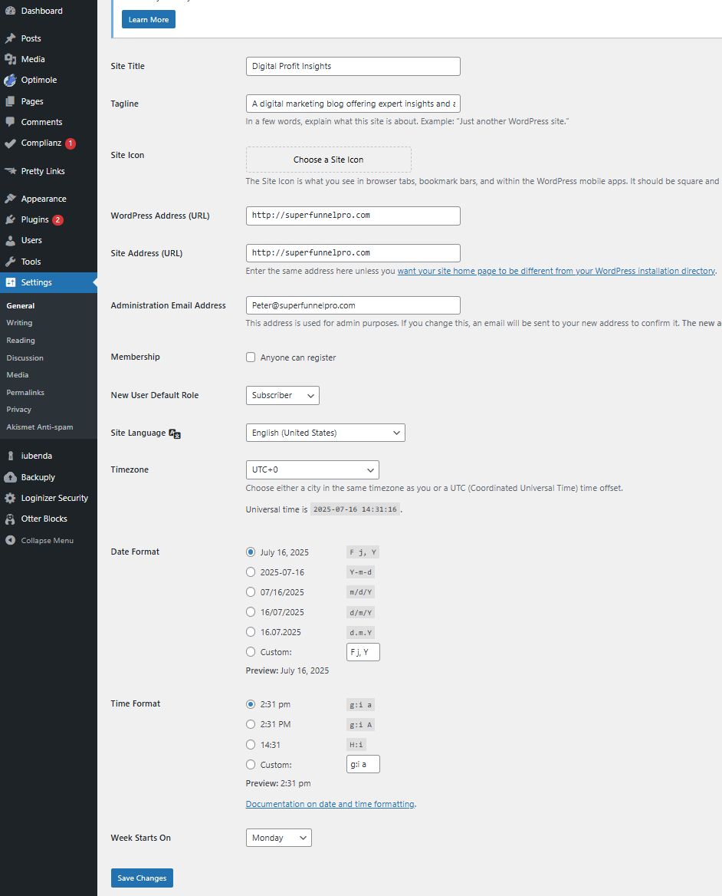
Pro Tip: Keep your Site Title and Tagline simple and clear. This helps visitors quickly understand what your blog is about.

Step 9.2: Set Your Homepage
Why this step matters: Your homepage is the first page visitors see when they arrive at your site. By default, WordPress will show your latest blog posts on the homepage, but you can also choose to display a static page (like an About page or welcome page) instead. This step lets you choose which layout works best for you.
What to do:
- Go to Settings in the left-hand menu and select Reading.
- You’ll see an option called Your homepage displays:
  - Your latest posts: This is the default setting. It shows your most recent blog posts in a list format.
  - A static page: If you want your homepage to feature something other than blog posts (like an About page or a custom welcome page), select this option.
    - In the dropdowns, select the page you want as your homepage and another page for your blog posts (usually, you’ll select the "Blog" page you created earlier).
- After selecting your preference, click Save Changes.
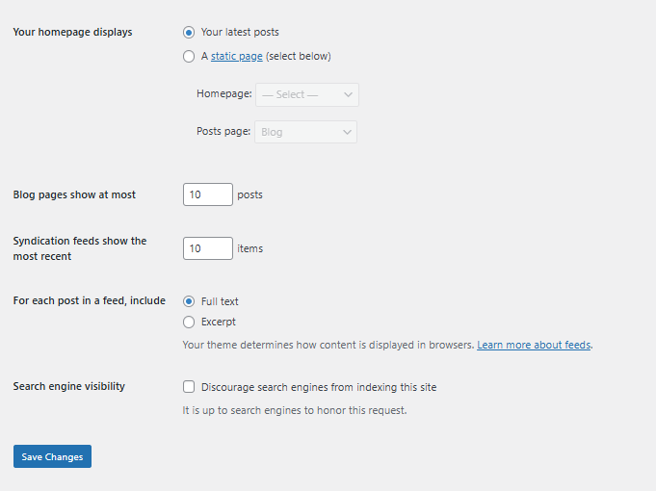
Pro Tip: If you’re creating a personal blog, showing your latest posts on the homepage can keep things fresh and dynamic. But if you’re building a business blog or portfolio, a static homepage might work better.

Step 9.3: Set Permalink Structure
Why this step matters: Permalinks are the permanent URLs for your blog posts and pages. You want to choose a permalink structure that’s clean, easy to read, and SEO-friendly. The default structure isn’t ideal, but WordPress lets you change it to something better.
What to do:
- Go to Settings and click on Permalinks.
- You’ll see several options for how your URLs can be structured:
  - Plain: This is the default and looks like: www.yourdomain.com/?p=123. It’s not very friendly for people or search engines.
  - Day and name or Month and name: These options add the date to your URL, which isn’t bad but can make your URLs longer than necessary.
  - Post name: This is the best option for most blogs! It gives your posts clean, easy-to-read URLs, like www.yourdomain.com/my-first-post. This structure is simple, SEO-friendly, and looks great.
- Select Post name.
- Scroll down and click Save Changes.
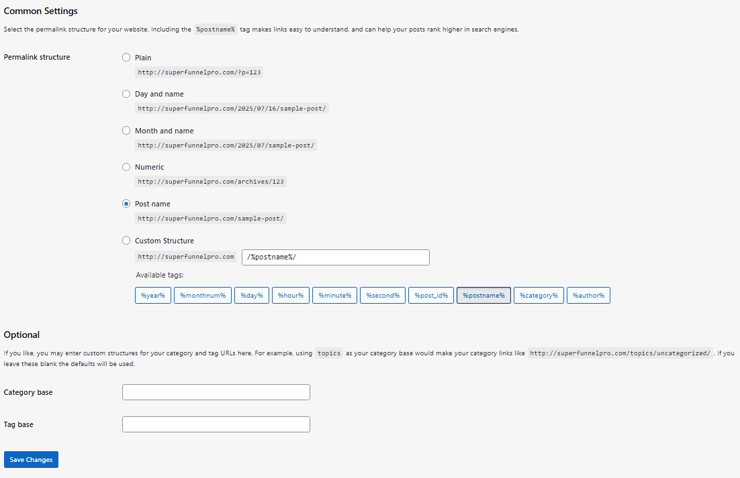
Pro Tip: Using the Post name structure is great for SEO (search engine optimization) because it makes your URLs more descriptive. For example, instead of www.yourdomain.com/?p=123, you’ll have www.yourdomain.com/how-to-start-a-blog, which tells both people and search engines what the post is about.

Recap and Self-Check
- Did you set your Site Title, Tagline, and Timezone?
✅ Go to Settings > General, and check that your Site Title, Tagline, and Timezone are set to your preferences.
- Did you choose how you want your homepage to display?
✅ Go to Settings > Reading, and check if you’re using Latest posts or a Static page for your homepage.
- Did you select the Post Name permalink structure for SEO-friendly URLs?
✅ Go to Settings > Permalinks, and confirm that Post name is selected.
Great job! You've just customized some of the most important settings for your blog. This ensures your blog looks professional and is easy to navigate.
How are you feeling about the process so far? Ready to move on to the next step, or do you want to adjust anything before continuing? Let me know!

Step 10: Install Essential Plugins
Welcome to Step 10! Now that your blog is taking shape, it's time to add some extra power to it by installing plugins. Plugins are like super tools that add new features and functionality to your website. Whether it’s improving SEO (so more people can find your blog), protecting your site from spam, or adding a contact form, plugins help make your blog even better.

Step 10.1: Go to Plugins > Add New
Why this step matters: The Plugins section is where you’ll find tools that will help your blog do more than just show posts. From improving your blog’s visibility on search engines to stopping unwanted comments, installing plugins is an essential step in making your blog work smoothly.
What to do:
- In your WordPress Dashboard, find and click on Plugins in the left-hand menu.
- After clicking on Plugins, click on Add New at the top of the page. This will take you to a page where you can search for, install, and activate plugins.

Step 10.2: Search for Essential Plugins
Why this step matters: Not all plugins are created equal, and it’s important to install the ones that will help your blog succeed. In this step, we’ll install a few essential plugins that will give your blog important features like better SEO, spam protection, and a contact form.
What to do:
- Yoast SEO (for search engine optimization):
  - In the search bar, type “Yoast SEO.” This plugin will help you optimize your blog posts so search engines like Google can find them more easily.
- Akismet Anti-Spam (for spam protection):
  - In the search bar, type “Akismet.” This plugin helps block spammy comments from showing up on your blog, keeping things clean and professional.
- Contact Form 7 (for adding a contact form):
  - In the search bar, type “Contact Form 7.” This plugin allows you to add a simple contact form to your site, so visitors can get in touch with you easily.
Pro Tip: It’s always a good idea to install plugins that improve your site’s performance and usability. Yoast SEO and Akismet are two of the most popular and reliable plugins.

Step 10.3: Install and Activate Plugins
Why this step matters: Installing and activating plugins is how you add those awesome tools to your blog. After you install them, you can start using them to improve your site.
What to do:
- Once you’ve found a plugin in the search results (like Yoast SEO or Akismet), click the Install Now button next to it.
- After the plugin is installed, the Install Now button will change to Activate. Click Activate to turn the plugin on and start using it on your blog.
- Repeat the same process for any other plugins you want to install (e.g., Akismet and Contact Form 7).
Pro Tip: Don’t overdo it with plugins. Too many plugins can slow down your website. Stick with the essential ones for now, and only add more when you need specific features.

Step 10.4: Configure Your Installed Plugins
Why this step matters: After activating the plugins, you’ll often need to configure them to make them work the way you want. This can include things like setting up your SEO preferences, choosing which types of comments to block with Akismet, or customizing your contact form.
What to do:
- Yoast SEO:
  - Once activated, Yoast SEO will appear in your dashboard as a new option. Click on SEO in the left-hand menu to start configuring it. Follow the prompts to set up basic SEO settings.
  - Pro Tip: Yoast SEO provides a helpful configuration wizard that guides you step-by-step in setting things up.
- Akismet Anti-Spam:
  - When you activate Akismet, it will ask you to connect it to an API key. You can get this key by signing up for an Akismet account. After that, just paste the key into the settings to start blocking spam comments.
  - Once connected, Akismet will automatically block most spammy comments without you needing to do anything further!
- Contact Form 7:
  - After activating, you’ll see a new Contact option in the dashboard. Click on it to create a new form. You can then copy the shortcode provided and paste it into your Contact Page to add the form to your site.

Recap and Self-Check
- Did you install and activate the Yoast SEO plugin?
✅ Go to SEO > General to make sure it’s activated and configured.
- Did you install and activate the Akismet Anti-Spam plugin?
✅ Check under Akismet to confirm it’s activated and connected to your API key.
- Did you install and activate the Contact Form 7 plugin?
✅ Go to Contact in your dashboard to ensure the form is set up correctly.
- Have you configured the plugins?
✅ Make sure Yoast SEO, Akismet, and Contact Form 7 are set up properly to work on your blog.
Awesome job! You’ve just added essential tools to your blog that will help you optimize for search engines, protect against spam, and make it easier for visitors to contact you.
How are you feeling about this process? Ready to move on to the next step, or would you like to adjust anything first? Let me know!

Step 11: Write and Publish More Content
Welcome to Step 11! Now that your blog is set up with essential pages and plugins, it's time to start creating content that will attract and engage your readers. This step will guide you through planning, writing, and publishing blog posts regularly, so your blog stays fresh, informative, and easy to find in search engines.

Step 11.1: Create a Content Plan
Why this step matters: Having a content plan is like having a roadmap for your blog. It helps you stay organized and focused, ensuring that you consistently produce valuable content for your readers. A content plan also ensures that you cover topics that your audience will love and that align with your blog’s goals.
What to do:
- Decide on the topics or categories you'll cover regularly:
Think about what interests you and what your audience might want to learn about. Here are some example topics or categories:
  - How-to guides: Step-by-step instructions on a particular topic (e.g., "How to Start a Blog").
  - Listicles: Posts that list tips, resources, or ideas (e.g., "10 Must-Have Tools for Bloggers").
  - Personal stories or experiences: Share your journey or lessons learned (e.g., "What I Learned from Starting My Blog").
- Brainstorm ideas:
Write down at least 5-10 blog post ideas under each category. This way, you’ll never run out of things to write about!
Example: If you’re running a travel blog, you might write posts like:
  - "Top 5 Destinations for a Weekend Getaway"
  - "How to Pack Light for a 7-Day Vacation"
- Schedule your posts:
Choose how often you want to publish. A good starting point is one post per week. You can always adjust based on your schedule and the time you have for writing.
Pro Tip: Use a content calendar to plan out your posts for the upcoming month. This will help you stay organized and consistent with your writing.

Step 11.2: Write Consistent Posts
Why this step matters: Writing consistently helps you build momentum, keep your readers coming back for more, and improve your SEO (search engine optimization). Regular posts will also show your audience that you’re committed to providing valuable content.
What to do:
- Start with a catchy title:
Your title is the first thing readers will see, so make it compelling! It should give them a reason to click.
Example: Instead of "Travel Tips," try something more specific like "5 Budget Travel Tips for First-Time Travelers."
- Write your content:
  - Introduction: Start with a hook that grabs your reader’s attention. This could be a question, a surprising fact, or a personal anecdote.
  - Body: Break your content into sections with headings. This makes it easier to read and understand.
  - Conclusion: Summarize the main points and encourage your readers to take action, whether that’s commenting, sharing, or checking out another post.
- Aim for regular posting:
Try to write at least one post per week. If that’s too much, start with every two weeks and adjust as you get more comfortable. The key is consistency!
Pro Tip: Keep your posts reader-friendly by writing in short paragraphs, using bullet points, and adding images to break up the text.

Step 11.3: Optimize for SEO
Why this step matters: SEO (Search Engine Optimization) helps your blog posts show up in search engine results like Google. By optimizing your posts, you make it easier for people to find your blog and read your content.

Resource Spotlight: Step-by-Step SEO Mastery
For step-by-step guidance on mastering SEO, check out these resources inside your Member’s Area:
- Blogger’s Success Toolkit → Chapter 4: Mastering SEO Basics
A beginner-friendly guide that breaks down SEO into simple, actionable steps. Perfect if you’ve ever felt overwhelmed by “techy” SEO advice.
How to use them effectively:
Start with the Toolkit to understand the why and how behind SEO fundamentals. Then, apply what you’ve learned consistently across your posts to build lasting search traffic.
Remember: SEO isn’t about quick wins—it’s about stacking small improvements that compound over time.

What to do:
- Install and use Yoast SEO (or another SEO plugin):
  - Yoast SEO is an easy-to-use plugin that helps you optimize your posts for search engines. If you haven’t installed it yet, go to Plugins > Add New, search for "Yoast SEO," install it, and activate it.
- Optimize your content with keywords:
  - Keywords are the words or phrases that people are likely to search for in Google. For example, if you write a post about budget travel, keywords might be “budget travel tips” or “how to travel on a budget.”
  - Use Yoast SEO to help you find the best keywords and include them in important places like the title, headings, and throughout the body of your post.
- Write a Meta Description:
  - Yoast SEO lets you add a meta description—a short summary (about 150 characters) of your post. This description appears under the title in search engine results.
  - Make it clear and include your target keyword so readers know exactly what they’ll get.
- Add alt text to images:
  - When you add images to your post, make sure to include alt text that describes the image. This helps with SEO and ensures your site is accessible to everyone, including people using screen readers.
Pro Tip: Don’t stuff your content with too many keywords. Focus on writing naturally and make sure your post is helpful and engaging. Yoast SEO will give you a score on how well you've optimized your post—aim for a green score!

Recap and Self-Check
- Did you create a content plan with topics or categories you want to focus on?
✅ Check if you’ve brainstormed enough ideas for your first few posts.
- Did you write a blog post with a clear title, engaging introduction, helpful content, and a strong conclusion?
✅ Make sure your posts are broken down with headings and easy-to-read paragraphs.
- Did you optimize your post with Yoast SEO and target keywords?
✅ Check that your post has the right keywords, a meta description, and alt text for images.
Great job! You’ve just written and optimized your first blog post. You’re well on your way to building a successful blog that’s easy for readers to find and enjoy. How do you feel about the process? Ready to move on to the next step, or would you like to fine-tune anything first? Let me know!

Step 12: Promote Your Blog
Welcome to Step 12! You’ve set up your blog, written your first posts, and made sure everything is running smoothly. Now, it's time to promote your blog so more people can find and enjoy your content. Promotion is key to growing your audience and keeping them engaged, so let’s dive into some powerful strategies you can use to get your blog noticed.

Resource Spotlight: Mastering Blog Promotion & Engagement
Want to get more eyes on your content and build a loyal audience? Head to your Member’s Area and dive into these resources:
- Blogger’s Success Toolkit → Chapter 5: Promotion Strategies
Learn the core promotion fundamentals—how to get your blog seen without overwhelm.
- Blogger’s Success Accelerator System → Audience Engagement Blueprint
Take it to the next level with advanced engagement strategies designed to turn casual visitors into loyal fans.
How to use them effectively:
Start with the Toolkit to nail the foundations of promotion—the why and how behind getting traffic. Once you’re confident with the basics, layer on the Accelerator’s advanced strategies to deepen engagement and keep your readers coming back.
Remember: Consistency is the secret weapon. Promotion isn’t a one-time event—it’s the heartbeat that keeps your blog alive and growing.

Step 12.1: Share on Social Media
Why this step matters: Social media is one of the most powerful tools for promoting your blog and connecting with a larger audience. By sharing your blog posts on platforms like Facebook, Twitter, Instagram, and LinkedIn, you increase your blog's visibility and drive traffic to your site.
What to do:
- Choose your platforms:
  - Facebook: Great for connecting with friends, family, and sharing posts in groups related to your niche.
  - Twitter: Perfect for short, catchy updates and sharing links to your blog posts.
  - Instagram: Excellent for sharing visual content like images and stories with links to your posts.
  - LinkedIn: Best for professional blogs or posts related to business, career, or industry topics.
- Create a post on each platform:
  - When you publish a new blog post, share the link on your social media accounts with a brief description.
  - Include a catchy caption or question to encourage engagement (e.g., "What’s your favorite travel destination? Check out my latest post on the top 10 places to visit!").
- Use hashtags:
  - Hashtags help people discover your content. Use relevant ones for your blog’s topic. For example, if your blog is about fitness, try hashtags like #FitnessTips or #HealthyLifestyle.
  - Pro Tip: Don’t overuse hashtags—stick to a few relevant ones (5-10 is usually perfect).
- Post regularly:
  - Try to share your blog posts consistently on social media. You can use scheduling tools like Buffer or Hootsuite to plan and automate your posts, so you don’t have to manually post every time.

Step 12.2: Start Building an Email List
Why this step matters: Building an email list is one of the most effective ways to keep in touch with your readers. When people subscribe to your blog, they’ll receive notifications about new posts, updates, or exclusive content you offer. Email marketing helps turn casual visitors into loyal readers and keeps your audience engaged.

Resource Spotlight: Build Your Email List & Lead Magnet
- Blogger’s Success Toolkit → Chapter 6: Email Marketing Strategies
Your starting point for list building. This chapter walks you through the fundamentals of growing your list, writing engaging emails, and building real connections with your readers. Perfect for beginners who want a clear, confidence-boosting roadmap.
- Blogger’s Success Accelerator System → Email Marketing Mastery Module + Inbox Rescue Card
Take your email marketing to the next level with pro-level strategies for automation, inbox deliverability, and advanced engagement tactics. These tools ensure your messages actually land—and get read—by the right people.
How to Use Them Together:
- Start with the Toolkit → Build your foundation. Learn how to set up your list, craft emails that feel personal, and connect with your audience.
- Graduate to the Accelerator → Add sophistication with automation flows, deliverability boosters, and proven engagement hacks that scale your list and sales.
Think of it like driving: the Toolkit gets you confident on local roads, while the Accelerator trains you for the fast lane—where growth and profits really accelerate.
What to do:
- Install an email plugin:
  - To start building your email list, you need an email marketing plugin. Two popular choices are MailChimp and ConvertKit.
  - Go to Plugins > Add New in your WordPress dashboard.
  - Search for MailChimp or ConvertKit, click Install, and then click Activate.
- Create a subscription form:
  - After installing the plugin, follow the plugin’s setup instructions to create a sign-up form that visitors can fill out to subscribe to your blog.
  - Place the sign-up form in a prominent location on your site (e.g., in the sidebar or as a pop-up). You can also add it to the footer or at the end of your blog posts.
- Offer an incentive:
  - People are more likely to subscribe if they get something in return. Offer a freebie such as an ebook, checklist, or exclusive content when they sign up.
  - Example: "Sign up for my email list and get a free guide to blogging for beginners!"
- Start sending emails:
  - Once you’ve got a list of subscribers, you can start sending them newsletters or notifications about new blog posts. Tools like MailChimp or ConvertKit make it easy to design beautiful emails and schedule them to go out at specific times.
Pro Tip: Keep your email content valuable and relevant. Send useful tips, updates, and exclusive content that your readers will appreciate. Don’t overwhelm them with too many emails—1-2 emails per week is a good starting point.

Step 12.3: Engage with Your Audience
Why this step matters: Engaging with your audience builds relationships and loyalty. When you respond to comments, messages, and emails, you show your readers that you care about their opinions and value their input. This helps build a community around your blog.
What to do:
- Respond to comments:
  - After you publish a post, take the time to read and reply to the comments left by readers. Thank them for their feedback, answer their questions, or even join in on discussions.
  - This shows that you’re an active part of the community and encourages other readers to comment as well.
- Reply to messages and emails:
  - If readers send you emails or messages via social media, try to reply as quickly as possible. Answering questions, offering advice, or even just saying “thank you” goes a long way in building a connection.
- Encourage discussions:
  - At the end of each post, ask readers a question or invite them to share their opinions.
Example: "What’s your favorite tip from this post? Leave a comment below and let’s chat!"
- Show appreciation:
  - Thank your readers for their support and make them feel valued. You can even highlight loyal readers or share their comments or stories on your blog or social media.
Pro Tip: Always be genuine in your responses. Engaging with your audience shouldn’t feel like a chore—it’s an opportunity to build lasting relationships and create a loyal community.

Recap and Self-Check
- Did you share your blog posts on social media?
✅ Make sure you’re regularly posting on platforms like Facebook, Twitter, Instagram, and LinkedIn.
- Have you started building an email list with a sign-up form and incentive?
✅ Check that your email sign-up form is visible on your site and you’re offering something valuable for subscribers.
- Are you engaging with your readers through comments, messages, and emails?
✅ Respond to your audience’s questions, comments, and feedback to build a loyal community around your blog.
Fantastic work! You’re now promoting your blog, building an email list, and engaging with your readers—everything you need to grow a successful blog. How do you feel? Ready to move on to the next step, or do you need help fine-tuning your promotion strategy? Let me know!

Step 13: Monitor and Improve Your Blog’s Performance
Welcome to Step 13! You’ve done a fantastic job setting up your blog and creating awesome content. Now it’s time to take things to the next level by monitoring your blog’s performance. This means checking how many people are visiting, what they’re reading, and how you can make your blog even better.
In this step, we’ll show you how to use Google Analytics to track your website traffic and understand what’s working well. With this information, you can improve your blog and grow your audience even more!

Step 13.1: Install Google Analytics
Why this step matters: Google Analytics is a free tool that gives you valuable information about your website's visitors, like how many people visit your blog, where they come from, and what posts they read the most. This data will help you understand what’s working and where you can improve.
What to do:
- Sign up for Google Analytics:
  - Go to Google Analytics and sign in with your Google account. If you don’t have one, you’ll need to create a Google account first.
  - Once you’re signed in, click Start for free to set up your account.
  - Follow the prompts to create a new property for your blog. This is where you’ll track your website’s data.
- Add your website details:
  - You’ll be asked to fill in information about your blog, such as your blog’s name, website URL, and the country you’re in. This information helps Google track the right data for your blog.
- Get your tracking code:
  - After you’ve set up your property, Google will provide a tracking ID. This is a special code that tracks your website’s data.
  - Copy this code, and keep it handy!
- Install the tracking code on your WordPress site:
  - There are several ways to add the Google Analytics tracking code to your WordPress blog. One of the easiest ways is to use a plugin like MonsterInsights:
    - Go to Plugins > Add New in your WordPress dashboard.
    - Search for MonsterInsights and click Install Now. After installation, click Activate.
    - After activating the plugin, go to Insights > Settings and follow the setup process to connect your Google Analytics account to your WordPress blog.
- Pro Tip: If you’re comfortable with code, you can also add the tracking code directly to your blog’s header.php file in your theme settings. But using a plugin like MonsterInsights makes it much easier!

Step 13.2: Track Website Traffic and User Behavior
Why this step matters: Once Google Analytics is set up, you can start tracking important metrics to see how your blog is performing. For example, you’ll be able to see:
- How many people are actually stopping by your blog → Your traffic numbers tell you if your promotion efforts are working or need a boost.
- Where your visitors are coming from → Are they finding you through Google, social media, or other blogs? Knowing this helps you double down on what’s working.
- Which posts get the most love → Spot your top-performing content so you can create more of what your audience clearly wants.
- How long visitors hang around → A quick bounce means they didn’t find what they needed. A longer stay means you’ve got their attention—and trust.

What to do:
- Check your traffic overview:
  - Go to your Google Analytics dashboard and you’ll see a traffic overview. This shows how many people are visiting your blog over the past week, month, or any time range you choose.
- Look at user behavior:
  - In the Behavior section of Google Analytics, you can see which pages and posts are getting the most visits. This tells you what your audience finds most interesting.
  - You can also see how long visitors stay on each page, which helps you understand how engaging your content is.
- Review your sources of traffic:
  - Under Acquisition > All Traffic > Channels, you can see where your visitors are coming from. Are they finding your blog through social media? Are they searching for your blog on Google? This information helps you figure out where to focus your promotional efforts.
Pro Tip: If you notice that a certain post is getting a lot of traffic, consider writing more content around that topic! If a post isn’t doing well, think about how you could improve it or update it.

Step 13.3: Use the Insights to Improve
Why this step matters: The data you get from Google Analytics is a goldmine for improving your blog. It helps you see what’s working, what isn’t, and what you can do better. By focusing on high-performing topics and improving weaker areas, you can grow your blog faster and engage your audience better.
What to do:
- Focus on high-performing content:
  - Look for blog posts that are getting a lot of traffic. Can you create similar content that your audience might enjoy?
  - If a certain topic or type of post (like how-to guides or listicles) is popular, consider writing more in that style.
- Improve low-performing content:
  - If some posts are not getting much traffic, take a closer look. Could the post use better keywords? Could you make the title more appealing or add more helpful information?
  - You can also update older posts to keep them fresh and relevant. Google loves updated content!
- Optimize for traffic sources:
  - If you’re getting most of your visitors from social media, keep promoting your content on those platforms.
  - If search engines are a major source of traffic, work on improving your SEO (Search Engine Optimization) to bring even more people to your blog.
Pro Tip: Use the data from Google Analytics to experiment with new content strategies. Try posting at different times of day, creating content around popular keywords, or sharing on new social media platforms.

Recap and Self-Check
- Did you install Google Analytics on your blog?
✅ Go to Google Analytics and check if your blog’s data is being tracked.
- Are you tracking website traffic and user behavior?
✅ Look at your traffic overview, user behavior, and traffic sources in Google Analytics.
- Are you using the insights to improve your content?
✅ Focus on high-performing posts, update older content, and optimize your traffic sources.
Great job! You’re now tracking your blog’s performance and using data to improve your content and grow your audience. You’re one step closer to becoming a blogging pro!
How do you feel about the process? Ready to move on to the next step, or do you need more help with Google Analytics? Let me know!

Final Word: Your Blog, Built Right From Day One
The truth is, most bloggers stumble in the setup stage—not because they lack passion, but because the tech feels overwhelming. The good news? You don’t have to figure it out alone. With the Pro Blog Setup Blueprint, every step is mapped out, so you can launch with clarity, confidence, and zero guesswork.
Your blog isn’t just another website—it’s your online home, your stage, your platform to share ideas and build an audience that trusts you. Setting it up right from day one means less fixing later and more focus on what matters: creating, connecting, and growing.
Your next step? Dive into your Member’s Area and grab the step-by-step resources waiting for you. Start with the Toolkit for your foundation, then use the Accelerator to fuel your growth. The sooner you set up your blog correctly, the sooner it starts working for you—24/7, even while you sleep.
Don’t wait until “someday.” Today is the perfect day to set up your blog the smart way.

