Visual Funnel Map for Bloggers
COPYRIGHT NOTICE
Copyright © 2025 Teo Chin Tee. All rights reserved.
Published by Peter Teo | BloggerSuccessBlueprint.com.
This product and its contents are protected under copyright law.
No part of this publication — including but not limited to text, graphics, templates, designs, videos, audios, or any other content — may be reproduced, distributed, transmitted, stored in a retrieval system, or shared in any form or by any means (electronic, mechanical, photocopying, recording, or otherwise) without the prior written permission of the publisher, except in the case of brief quotations used in reviews, scholarly works, or as otherwise permitted under applicable copyright law.
This product is licensed for individual use only. Unauthorized copying, sharing, distribution, resale, or reproduction is strictly prohibited and constitutes a violation of international copyright laws.
For licensing or permission requests, please contact:
support@bloggersuccessblueprint.com

LEGAL DISCLAIMER
The information contained in this product is provided by BloggerSuccessBlueprint.com, operated by Teo Chin Tee (also known as Peter Teo), for general informational and educational purposes only.
It is not intended to serve as professional, legal, financial, business, health, or medical advice, and should not be relied upon as such.
While every effort has been made to ensure the accuracy and reliability of the information at the time of publication, the author and publisher make no representations or warranties of any kind, express or implied, about the completeness, accuracy, suitability, or availability of the information, products, services, or related graphics contained within this product for any purpose.
Any reliance you place on such information is strictly at your own risk.
Use or misuse of this product and its contents is at your own discretion. The author and publisher disclaim any liability for any loss, damage, injury, or disruption caused — directly or indirectly — by errors, omissions, or reliance on the information provided herein.
The inclusion of links to external websites or third-party tools does not imply endorsement, affiliation, or guarantee of their content or services.
Individual results will vary based on effort, circumstances, and market conditions. No income claims or performance guarantees are made.
By using this product, you acknowledge that you have read, understood, and agreed to these terms and conditions.

Need help or have questions?
Contact: support@bloggersuccessblueprint.com
Visit: www.bloggersuccessblueprint.com

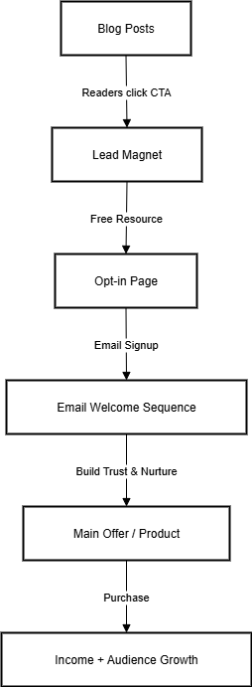

Ever feel like you’re juggling too many pieces of your online business—your blog, email list, offers—and you’re not sure how it all fits together?
That’s exactly why I created this Visual Funnel Map for Bloggers.
It’s a one-page roadmap that shows you the “big picture” of how each part of your blogging business connects to the next.
Think of it like your GPS for growth—you’ll always know where your readers are headed and what step comes next.

How to Use It
- Start at the Blog → This is where readers first discover you through posts, stories, or search engines.
- Offer a Lead Magnet → Place a freebie (like a checklist or guide) in your posts to give readers a reason to subscribe.
- Send Them to Your Opt-in Page → Keep it simple: headline, benefit, and a sign-up form.
- Nurture With Emails → Your welcome sequence builds trust and shows your value.
- Make Your Offer → After trust is built, guide them toward your product, service, or affiliate recommendation.
- Grow & Repeat → More readers → more subscribers → more customers → more income.
Use this funnel map as a daily reminder. Print it, save it to your desktop, or even stick it on your wall. Every time you feel lost, glance at it and ask: “Where am I leading my readers next?”

Final Word
This map is your shortcut to clarity.
No guesswork. No confusion. Just a straight line from “random blog visitor” to “loyal subscriber” to “happy customer.”
Keep it handy—you’ll be amazed how much easier decisions become when you can literally see your business model on one page.
Remember: growth isn’t magic—it’s a system. And now, you’ve got the map.

